Table of Contents

UNITED STATES

SECURITIES AND EXCHANGE COMMISSION
Washington, D.C. 20549

SCHEDULE 14A

Proxy Statement Pursuant to Section 14(a) of the

Securities Exchange Act of 1934

Filed by the Registrant ☒ Filed by a party other than the Registrant ☐

Check the appropriate box:

- Preliminary Proxy Statement

- Confidential, for Use of the Commission Only (as permitted by Rule 14a-6(e)(2))

☒Definitive Proxy Statement

- Definitive Additional Materials

- Soliciting Material Under Rule 240.14a-12

REGENCY CENTERS CORPORATION

(Name of Registrant as Specified In Its Charter)

(Name of Person(s) Filing Proxy Statement, if other than the Registrant)

Payment of Filing Fee (Check the appropriate box):

- No fee required.

- Fee paid previously with preliminary materials.

- Fee computed on table in exhibit required by Item 25(b) per Exchange Act Rules 14a-6(i)(1) and 0-11.

Table of Contents
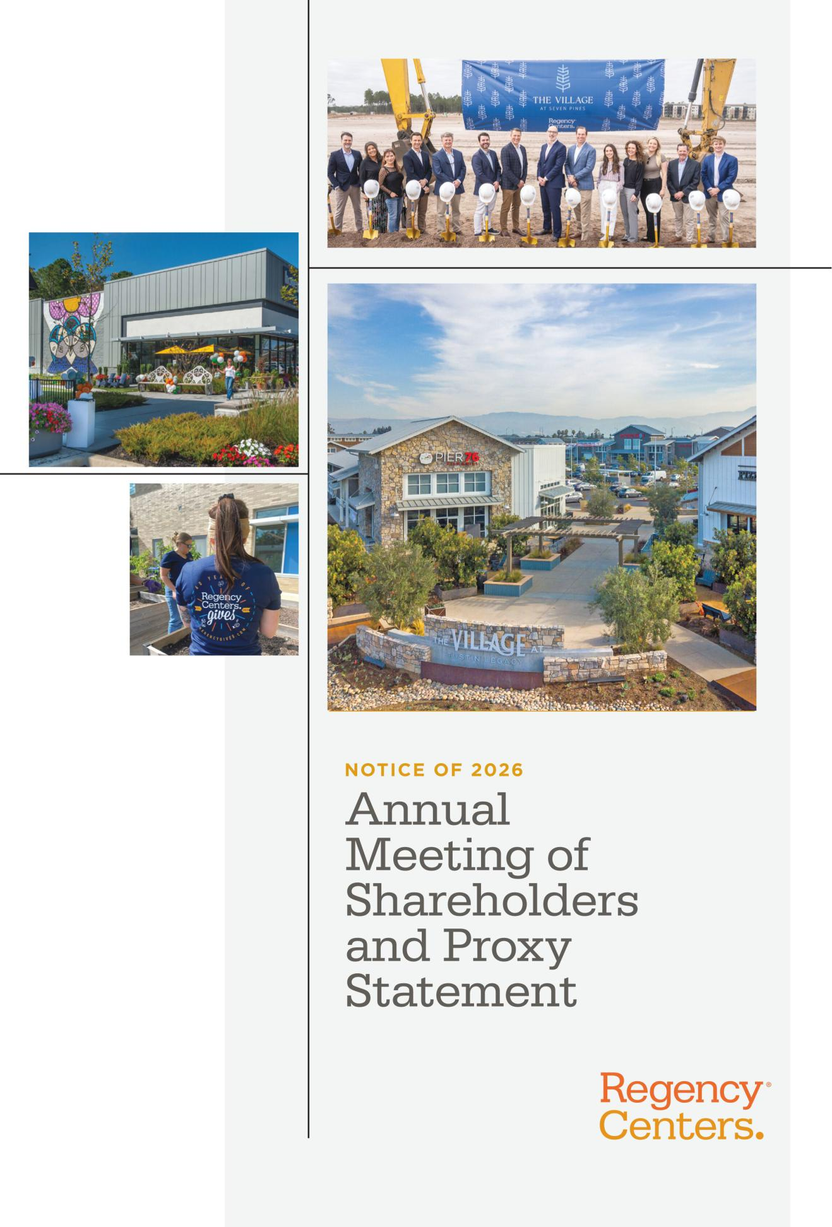

Table of Contents

Notice of 2026 Annual Meeting of Shareholders

To Our Shareholders:

Notice is hereby given that the 2026 Annual Meeting of Shareholders (the “Annual Meeting”) of Regency Centers Corporation will be held exclusively online at www.virtualshareholdermeeting.com/REG2026 on Wednesday, May 6, 2026, beginning at 8:00 A.M., Eastern Time.

The meeting will be held for the following purposes:

- To elect as directors the 11 nominees named in the attached proxy statement, to serve until the 2027 Annual Meeting of Shareholders and until their successors have been duly elected and qualified.

- To approve, in a non-binding vote, an advisory resolution approving the company’s executive compensation for fiscal year 2025.

- To ratify the appointment of KPMG LLP as the Company’s independent registered public accounting firm for fiscal year 2026.

- To transact such other business as may properly come before the meeting or any adjournments or postponements thereof.

The accompanying proxy statement more fully describes these matters.

Shareholders of record at the close of business on March 13, 2026 will be entitled to notice of the Annual Meeting and any adjournments or postponements thereof, and to vote on the matters above.

The Annual Meeting will be virtual-only and held exclusively online. The platform for the virtual Annual Meeting includes functionality that affords authenticated shareholders comparable meeting participation rights and opportunities as they would have at an in-person meeting. Instructions to access and log-in to the virtual Annual Meeting are provided under “What are the procedures for attending and participating in the virtual Annual Meeting?” on page 57 in the accompanying proxy statement.

By Order of the Board of Directors,
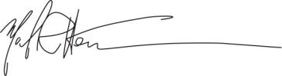

Michael R. Herman

Senior Vice President,

General Counsel and Secretary

Dated: March 25, 2026

2026 ANNUAL MEETING INFORMATION:


DATE: Wednesday, May 6, 2026

TIME: 8:00 A.M., Eastern Time

The Annual Meeting will be exclusively online at

www.virtualshareholdermeeting.com/REG2026.

You are eligible to vote if you were a shareholder of record at the close of business on March 13, 2026.

HOW TO VOTE:

Your vote is important. Even if you plan to attend the virtual Annual Meeting, we encourage you to vote your shares before the meeting by one of the methods described below to ensure they are counted. Shareholders of record have until 11:59 P.M, Eastern Time on May 5, 2026 to vote, by use of any of the following options:

BY INTERNET PRIOR TO MEETING

www.proxyvote.com

BY INTERNET DURING MEETING

www.virtualshareholdermeeting.com/

REG2026

BY PHONE PRIOR TO MEETING Call 1.800.690.6903

BY MAIL PRIOR TO MEETING

Complete, sign and return proxy card in the postage-paid envelope

To vote or participate in the virtual meeting, you must have the control number that appears on your Notice of Internet Availability of Proxy Materials or proxy card.

Our Board of Directors is soliciting proxies to be voted at the Annual Meeting on May 6, 2026 and at any adjournments or postponements thereof. We expect that this proxy statement and form of proxy will be mailed and made available to shareholders beginning on or about March 25, 2026.

Important notice regarding the availability of proxy materials for the Annual Meeting of Shareholders to be held on Wednesday, May 6, 2026: The Proxy Statement for the 2026 Annual Meeting of Shareholders and 2025 Annual Report to Shareholders are available at: https://investors.regencycenters.com.

REGENCY CENTERS | 2026 PROXY STATEMENT | i

Table of Contents

| Table of Contents

Table of Contents

Notice of Annual Meeting of Shareholders |  |  |  |  |  |  |  |  |  |  |  |  |  |  |  |  |  |  |  |  |  |  |  |  |  |  |  |  |  |  |  | i
Table of Contents |  |  |  |  |  |  |  |  |  |  |  |  |  |  |  |  |  |  |  |  |  |  |  |  |  |  |  |  |  |  |  | ii
Proxy Summary |  |  |  |  |  |  |  |  |  |  |  |  |  |  |  |  |  |  |  |  |  |  |  |  |  |  |  |  |  |  |  | 1
 | Election of Directors |  |  |  |  |  |  |  |  |  |  |  |  |  |  |  |  |  |  |  |  |  |  |  |  |  |  |  |  |  |  | 8
 | Our Director Nominees |  |  |  |  |  |  |  |  |  |  |  |  |  |  |  |  |  |  |  |  |  |  |  |  |  |  |  |  |  |  | 8
 | Director Nominee Qualifications |  |  |  |  |  |  |  |  |  |  |  |  |  |  |  |  |  |  |  |  |  |  |  |  |  |  |  |  |  |  | 8
 |  |  |  |  |  |  |  |  |  |  |  |  |  |  |  |  |  |  |  |  |  |  |  |  |  |  |  |  |  |  |  | 9
 | Corporate Governance |  |  |  |  |  |  |  |  |  |  |  |  |  |  |  |  |  |  |  |  |  |  |  |  |  |  |  |  |  |  | 16
 | Corporate Governance Guidelines |  |  |  |  |  |  |  |  |  |  |  |  |  |  |  |  |  |  |  |  |  |  |  |  |  |  |  |  |  |  | 16
 | Director Independence |  |  |  |  |  |  |  |  |  |  |  |  |  |  |  |  |  |  |  |  |  |  |  |  |  |  |  |  |  |  | 16
 | Board Leadership Structure |  |  |  |  |  |  |  |  |  |  |  |  |  |  |  |  |  |  |  |  |  |  |  |  |  |  |  |  |  |  | 16
 | Role of Independent Lead Director |  |  |  |  |  |  |  |  |  |  |  |  |  |  |  |  |  |  |  |  |  |  |  |  |  |  |  |  |  |  | 16
 | Meetings of Board of Directors |  |  |  |  |  |  |  |  |  |  |  |  |  |  |  |  |  |  |  |  |  |  |  |  |  |  |  |  |  |  | 17
 | Executive Sessions of Independent Directors |  |  |  |  |  |  |  |  |  |  |  |  |  |  |  |  |  |  |  |  |  |  |  |  |  |  |  |  |  |  | 17
 | Board Membership |  |  |  |  |  |  |  |  |  |  |  |  |  |  |  |  |  |  |  |  |  |  |  |  |  |  |  |  |  |  | 17
 | Succession Planning and Board Refreshment |  |  |  |  |  |  |  |  |  |  |  |  |  |  |  |  |  |  |  |  |  |  |  |  |  |  |  |  |  |  | 17
 | Director Nominee Selection Process |  |  |  |  |  |  |  |  |  |  |  |  |  |  |  |  |  |  |  |  |  |  |  |  |  |  |  |  |  |  | 18
 | Director Candidate Nominations through Proxy Access |  |  |  |  |  |  |  |  |  |  |  |  |  |  |  |  |  |  |  |  |  |  |  |  |  |  |  |  |  |  | 18
 | Limits on Board Service |  |  |  |  |  |  |  |  |  |  |  |  |  |  |  |  |  |  |  |  |  |  |  |  |  |  |  |  |  |  | 19
 | Board Self-Assessment and Evaluation |  |  |  |  |  |  |  |  |  |  |  |  |  |  |  |  |  |  |  |  |  |  |  |  |  |  |  |  |  |  | 19
 | Risk Oversight |  |  |  |  |  |  |  |  |  |  |  |  |  |  |  |  |  |  |  |  |  |  |  |  |  |  |  |  |  |  | 20
 | Standing Committees |  |  |  |  |  |  |  |  |  |  |  |  |  |  |  |  |  |  |  |  |  |  |  |  |  |  |  |  |  |  | 21
 | Executive Committee |  |  |  |  |  |  |  |  |  |  |  |  |  |  |  |  |  |  |  |  |  |  |  |  |  |  |  |  |  |  | 22
 | Code of Business Conduct and Ethics |  |  |  |  |  |  |  |  |  |  |  |  |  |  |  |  |  |  |  |  |  |  |  |  |  |  |  |  |  |  | 22
 | Related Party Transactions |  |  |  |  |  |  |  |  |  |  |  |  |  |  |  |  |  |  |  |  |  |  |  |  |  |  |  |  |  |  | 23
 | Compensation of Directors |  |  |  |  |  |  |  |  |  |  |  |  |  |  |  |  |  |  |  |  |  |  |  |  |  |  |  |  |  |  | 24
 | Advisory Approval Of The Company’s Executive |  |  |  |  |  |  |  |  |  |  |  |  |  |  |  |  |  |  |  |  |  |  |  |  |  |  |  |  |  |  | 25
 | Compensation
 | Executive Compensation Highlights |  |  |  |  |  |  |  |  |  |  |  |  |  |  |  |  |  |  |  |  |  |  |  |  |  |  |  |  |  |  | 25
 | Compensation Discussion and Analysis |  |  |  |  |  |  |  |  |  |  |  |  |  |  |  |  |  |  |  |  |  |  |  |  |  |  |  |  |  |  | 26
 | Letter from Our Compensation Committee Chair |  |  |  |  |  |  |  |  |  |  |  |  |  |  |  |  |  |  |  |  |  |  |  |  |  |  |  |  |  |  | 26
 | Our Named Executive Officers |  |  |  |  |  |  |  |  |  |  |  |  |  |  |  |  |  |  |  |  |  |  |  |  |  |  |  |  |  |  | 28
 | Our Compensation Philosophy |  |  |  |  |  |  |  |  |  |  |  |  |  |  |  |  |  |  |  |  |  |  |  |  |  |  |  |  |  |  | 28
 | Oversight of Compensation |  |  |  |  |  |  |  |  |  |  |  |  |  |  |  |  |  |  |  |  |  |  |  |  |  |  |  |  |  |  | 29
 | 2025 Say on Pay Results and Shareholder Engagement |  |  |  |  |  |  |  |  |  |  |  |  |  |  |  |  |  |  |  |  |  |  |  |  |  |  |  |  |  |  | 29
 | Targeted Level of Compensation |  |  |  |  |  |  |  |  |  |  |  |  |  |  |  |  |  |  |  |  |  |  |  |  |  |  |  |  |  |  | 29



Compensation Committee Actions & Decisions |  |  |  |  |  |  |  |  |  |  |  |  |  |  |  |  |  |  |  |  |  |  |  |  |  |  |  |  |  |  |  | 31
Elements of Compensation |  |  |  |  |  |  |  |  |  |  |  |  |  |  |  |  |  |  |  |  |  |  |  |  |  |  |  |  |  |  |  | 31
Recoupment/Clawback Policies |  |  |  |  |  |  |  |  |  |  |  |  |  |  |  |  |  |  |  |  |  |  |  |  |  |  |  |  |  |  |  | 37
Risk Consideration in Our Compensation Program |  |  |  |  |  |  |  |  |  |  |  |  |  |  |  |  |  |  |  |  |  |  |  |  |  |  |  |  |  |  |  | 37
Compensation Committee Interlocks and Insider |  |  |  |  |  |  |  |  |  |  |  |  |  |  |  |  |  |  |  |  |  |  |  |  |  |  |  |  |  |  |  | 37
Participation |  |  |  |  |  |  |  |  |  |  |  |  |  |  |  |  |  |  |  |  |  |  |  |  |  |  |  |  |  |  |  | 37
Stock Ownership Policy |  |  |  |  |  |  |  |  |  |  |  |  |  |  |  |  |  |  |  |  |  |  |  |  |  |  |  |  |  |  |  | 38
Policy Prohibiting Hedging and Pledging of Our Stock |  |  |  |  |  |  |  |  |  |  |  |  |  |  |  |  |  |  |  |  |  |  |  |  |  |  |  |  |  |  |  | 38
Deductibility of Compensation |  |  |  |  |  |  |  |  |  |  |  |  |  |  |  |  |  |  |  |  |  |  |  |  |  |  |  |  |  |  |  | 38
Compensation Committee Report |  |  |  |  |  |  |  |  |  |  |  |  |  |  |  |  |  |  |  |  |  |  |  |  |  |  |  |  |  |  |  | 39
Executive Compensation |  |  |  |  |  |  |  |  |  |  |  |  |  |  |  |  |  |  |  |  |  |  |  |  |  |  |  |  |  |  |  | 40
Summary Compensation Table |  |  |  |  |  |  |  |  |  |  |  |  |  |  |  |  |  |  |  |  |  |  |  |  |  |  |  |  |  |  |  | 40
Grants of Plan-Based Awards |  |  |  |  |  |  |  |  |  |  |  |  |  |  |  |  |  |  |  |  |  |  |  |  |  |  |  |  |  |  |  | 40
Outstanding Equity Awards |  |  |  |  |  |  |  |  |  |  |  |  |  |  |  |  |  |  |  |  |  |  |  |  |  |  |  |  |  |  |  | 42
Options Exercises and Stock Vested in 2025 |  |  |  |  |  |  |  |  |  |  |  |  |  |  |  |  |  |  |  |  |  |  |  |  |  |  |  |  |  |  |  | 43
Summary of Our Non-Qualified Deferred |  |  |  |  |  |  |  |  |  |  |  |  |  |  |  |  |  |  |  |  |  |  |  |  |  |  |  |  |  |  |  | 43
Compensation Plans |  |  |  |  |  |  |  |  |  |  |  |  |  |  |  |  |  |  |  |  |  |  |  |  |  |  |  |  |  |  |  | 43
Potential Payments Upon Termination or Change-in- |  |  |  |  |  |  |  |  |  |  |  |  |  |  |  |  |  |  |  |  |  |  |  |  |  |  |  |  |  |  |  | 44
Control |  |  |  |  |  |  |  |  |  |  |  |  |  |  |  |  |  |  |  |  |  |  |  |  |  |  |  |  |  |  |  | 44
Pay versus Performance Table |  |  |  |  |  |  |  |  |  |  |  |  |  |  |  |  |  |  |  |  |  |  |  |  |  |  |  |  |  |  |  | 47
Pay versus Performance Descriptive Disclosure |  |  |  |  |  |  |  |  |  |  |  |  |  |  |  |  |  |  |  |  |  |  |  |  |  |  |  |  |  |  |  | 50
CEO Pay Ratio |  |  |  |  |  |  |  |  |  |  |  |  |  |  |  |  |  |  |  |  |  |  |  |  |  |  |  |  |  |  |  | 51
Audit Committee Report |  |  |  |  |  |  |  |  |  |  |  |  |  |  |  |  |  |  |  |  |  |  |  |  |  |  |  |  |  |  |  | 52
Ratification Of Appointment Of KPMG LLP As The |  |  |  |  |  |  |  |  |  |  |  |  |  |  |  |  |  |  |  |  |  |  |  |  |  |  |  |  |  |  |  | 53
Company’s Independent Registered Public
Accounting Firm
Beneficial Ownership |  |  |  |  |  |  |  |  |  |  |  |  |  |  |  |  |  |  |  |  |  |  |  |  |  |  |  |  |  |  |  | 54
Beneficial Ownership of Principal Shareholders |  |  |  |  |  |  |  |  |  |  |  |  |  |  |  |  |  |  |  |  |  |  |  |  |  |  |  |  |  |  |  | 54
Beneficial Ownership of Directors and Executive Officers |  |  |  |  |  |  |  |  |  |  |  |  |  |  |  |  |  |  |  |  |  |  |  |  |  |  |  |  |  |  |  | 55
Shareholder Proposals and Communications with the |  |  |  |  |  |  |  |  |  |  |  |  |  |  |  |  |  |  |  |  |  |  |  |  |  |  |  |  |  |  |  | 56
Board of Directors
Frequently Asked Questions Regarding Our Annual |  |  |  |  |  |  |  |  |  |  |  |  |  |  |  |  |  |  |  |  |  |  |  |  |  |  |  |  |  |  |  | 57
Meeting
Appendix A — Definitions and Reconciliations of |  |  |  |  |  |  |  |  |  |  |  |  |  |  |  |  |  |  |  |  |  |  |  |  |  |  |  |  |  |  |  | A-1
GAAP and Non-GAAP Financial Measures


ii | REGENCY CENTERS | 2026 PROXY STATEMENT

Table of Contents

Table of Contents |

Forward-Looking Statements

Certain statements in this document regarding anticipated financial, business, legal or other outcomes including business and market conditions, outlook and other similar statements relating to Regency’s future events, developments, or financial or operational performance or results, are “forward-looking statements” made pursuant to the safe harbor provisions of the Private Securities Litigation Reform Act of 1995 and other federal securities laws. These forward-looking statements are identified by the use of words such as “may,” “will,” “could,” “should,” “would,” “expect,” “estimate,” “believe,” “intend,” “forecast,” “project,” “plan,” “anticipate,” “guidance,” and other similar language. However, the absence of these or similar words or expressions does not mean a statement is not forward-looking. While we believe these forward-looking statements are reasonable when made, forward-looking statements are not guarantees of future performance or events and undue reliance should not be placed on these statements. Although we believe the expectations reflected in any forward-looking statements are based on reasonable assumptions, we can give no assurance these expectations will be attained, and it is possible actual results may differ materially from those indicated by these forward-looking statements due to a variety of risk factors, including, without limitation, risk factors relating to:

- The Current Economic and Geopolitical Environment

- Pandemics or Other Health Crises

- Operating Retail-Based Shopping Centers

- Real Estate Investments

- The Environment Affecting Our Properties

- Corporate Matters

- Our Partnerships and Joint Ventures

- Funding Strategies and Capital Structure

- Information Management and Technology

- Taxes and the Parent Company’s Qualification as a real estate investment trust (“REIT”)

- The Company’s Stock,

as more specifically described in “Item 1A. Risk Factors” of the Company’s most recent Annual Report on Form 10-K (the “Annual Report”). When considering an investment in our securities, you should carefully read the risk factors described in Item 1A and consider these risks, together with all other information in our Annual Report, Quarterly Reports on Form 10-Q (the “Quarterly Reports”), and our other filings with and submissions to the Securities and Exchange Commission (“SEC”). If any of the events described in the risk factors actually occur, our business, financial condition or operating results, as well as the market price of our securities, could be materially adversely affected. Forward-looking statements are only as of the date they are made, and Regency undertakes no duty to update its forward-looking statements, whether as a result of new information, future events or developments or otherwise, except as and to the extent required by law.

Certain forward-looking and other statements in the Annual Report, Quarterly Reports, or other locations, such as on our corporate website, may also contain references to various corporate responsibility or environmental, social, and governance (“ESG”) standards and frameworks, which are used or followed by certain of our investors. These standards and frameworks are often reliant on third-party information or methodologies that are subject to evolving expectations and practices, and our approach to and discussion of these matters may continue to evolve as well. For example, our disclosures may change due to changes in the expectations of our investors, the requirements of these standards and frameworks, availability of information, our business, applicable governmental law or policies, or other factors, some of which may be beyond our control.

REGENCY CENTERS | 2026 PROXY STATEMENT | iii

Table of Contents


Proxy Summary

In this proxy statement, the terms “we,” “our,” “us,” “the Company,” “Regency Centers,” and “Regency” refer to Regency Centers Corporation. In this proxy summary, we present an overview of information that you will find throughout this proxy statement. As this is only a summary, we strongly encourage you to read the entire proxy statement for more information about these topics prior to voting.

Voting Matters

The following table summarizes the proposals to be voted on prior to or at our 2026 Annual Meeting of Shareholders of Regency Centers and the voting recommendations of our Board of Directors (our “Board”) with respect to each proposal.

 | BOARD’S VOTING | PAGE
PROPOSAL | RECOMMENDATION | REFERENCE
Proposal 1: | FOR Each Nominee | 8
Election of our Board’s 11 nominees for director to each serve for a one-year term.
Proposal 2: | FOR | 25
Advisory approval of the Company’s executive compensation for 2025.
Proposal 3: | FOR | 53
Ratification of appointment of KPMG LLP as our independent registered public accounting firm for 2026.

About Regency Centers

Regency Centers is a fully integrated real estate company and self-administered and self-managed real estate investment trust that began its operations as a publicly-traded REIT in 1993. The Company conducts substantially all of its operations, and owns, directly or indirectly, substantially all of its assets. Our business consists of acquiring, developing, owning, and operating income-producing retail real estate principally located in suburban trade areas with compelling demographics within the United States of America. Regency has been an S&P 500 Index member since 2017. We are a preeminent national owner, operator, and developer of neighborhood and community shopping centers. Our portfolio includes thriving properties merchandised with highly productive grocers, restaurants, service providers, and best-in-class retailers that connect with their neighborhoods, communities, and customers.

Our Core Values

At Regency Centers, we have lived our Core Values for more than 60 years by successfully meeting our commitments to our people, our customers, our communities and our shareholders. We hold ourselves to this high standard every day. We believe our exceptional culture will continue to set Regency apart into the future through our unwavering dedication to these beliefs:
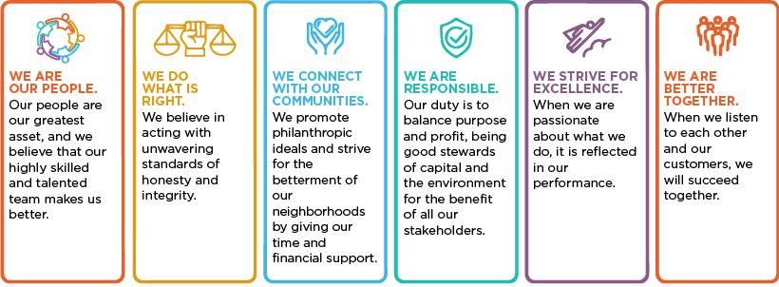

REGENCY CENTERS | 2026 PROXY STATEMENT | 1

Table of Contents

| Proxy Summary

Excellence in Operational Performance and Financial Management

Regency Centers continues to create value for our shareholders through our exceptional financial and operational performance, high-quality portfolio, strong balance sheet, superior asset management, unique development capabilities, and a talented team located across more than 25 offices nationwide. During 2025, our team had an exceptionally strong operational year, and was able to execute on several acquisition opportunities and development and redevelopment projects, to further enhance our sector-leading portfolio of over 480 properties in top trade areas around the country.

2025 Business Highlights


Operational Excellence

- Executed over 8 million square feet of new and renewal leases

- Achieved blended rent spreads of 11% on a cash basis and 21% on a straight-lined basis on comparable new and renewal leases

- Ended 2025 with a same-property near-record leased rate of 96.5% and grew shop (<10K square feet) occupancy 70 basis points year-over-year to a record leased rate of 94.2%


 Balance Sheet Stability

- Trailing 12-Month Net Debt & Preferred Stock-to-Operating EBITDAre⁽¹⁾ of 5.1x at year-end

- Greater than $1.4 billion of available capacity on our unsecured credit facility at year-end 2025

- Maintains ‘A’ credit ratings from both Moody’s (A3 with a ‘Stable’ outlook) and S&P Global (A-with a ‘Stable’ outlook)


Investment Activity

- Started approximately $318 million of development and redevelopment projects, with nearly $600 million of projects in process at year-end

- Acquired high-quality shopping centers totaling approximately $538 million, at Regency’s share

Dividend Growth & Cash Flow

- Generated significant cash flow from operations and free cash flow after dividend and capital expenditures

- Increased our quarterly common stock dividend by over 7% year-over-year in 4Q25 to $0.755 per share

- Dividend CAGR (compound annual growth rate) of nearly 4% since 2014

(1) See Appendix A for reconciliations of Generally Accepted Accounting Principles (“GAAP”) to non-GAAP measures.

10-Year Total Shareholder Return (2016 – 2025)

Regency Outperformed Peers by ~19%
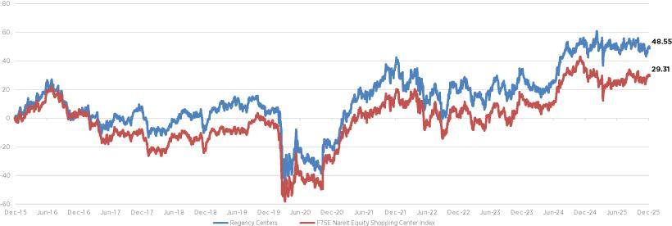

2 | REGENCY CENTERS | 2026 PROXY STATEMENT

Table of Contents

Proxy Summary |

Excellence in Corporate Governance

Corporate Governance Highlights

Our Board and senior management are committed to best-in-class corporate governance. Following are some of our most important governance practices and policies:


Board Structure and Independence

✓ Separate Chairman of the Board (Chair) and Chief Executive Officer (CEO)

✓ Independent Lead Director

✓ 9 of 11 nominated directors are independent; Audit, Compensation, and Nominating and Governance committees each entirely comprised of independent directors

✓ Executive sessions of independent directors held at every regular Board and Committee meeting ✓ Board member diversity across a range of attributes ✓ No familial relationships among Board members

✓ Limits on other board service to prevent “overboarding”

✓ Demonstrated track record of thoughtful, effective succession planning and Board refreshment; the average tenure of our independent directors is currently six years

Shareholder

Rights

✓ Annual election of directors

✓ Majority voting standard for uncontested director elections

✓ Annual say-on-pay advisory vote

✓ During 2025, engaged with shareholders representing approximately 80% of our common stock ownership ✓ Shareholders representing 10% of outstanding common stock can call special meeting

✓ Proxy access: shareholders owning 3% of our common stock for at least 3 years may nominate up to 25% of board members ✓ No “poison pill” in effect

Board

Oversight

✓ Structured oversight of the Company’s corporate strategy and risk management allocated among full Board and Committees

✓ Our Board is responsible for the oversight of our overall Corporate Responsibility strategy, initiatives and business alignment, and has delegated to our Nominating and Governance Committee oversight of Regency’s Corporate Responsibility program and objectives

✓ Robust Board and senior management succession planning

✓ Annual self-assessment of Board and Board committee performance

✓ Ethics and compliance program oversight by Nominating and Governance Committee

✓ Cybersecurity and artificial intelligence (“AI”) policy oversight by a combination of our Board and Audit Committee, respectively ✓ Nominating and Governance Committee oversight of political contributions (de minimis amounts in 2025) ✓ Code of Business Conduct and Ethics applicable to all directors, officers and employees

Executive

Compensation

✓ Annual incentives for our named executive officers (NEOs) based primarily on financial performance

✓ Long-term incentives for NEOs largely based on relative total shareholder return (TSR), to foster alignment with shareholders ✓ Stock ownership policy for directors and senior management

✓ Prohibition of hedging and pledging Company stock by officers and directors ✓ Annual risk assessment of executive compensation programs

✓ Clawback policies beyond what is required by SEC rules covering all officers

REGENCY CENTERS | 2026 PROXY STATEMENT | 3

Table of Contents

| Proxy Summary

Our Board of Directors at a Glance

Below is an overview of some of the key attributes of our eleven nominees for election as directors at the 2026 Annual Meeting of Shareholders.

Additional information can be found in the skills matrix and biographies for each Board member under Proposal One: Election of Directors.
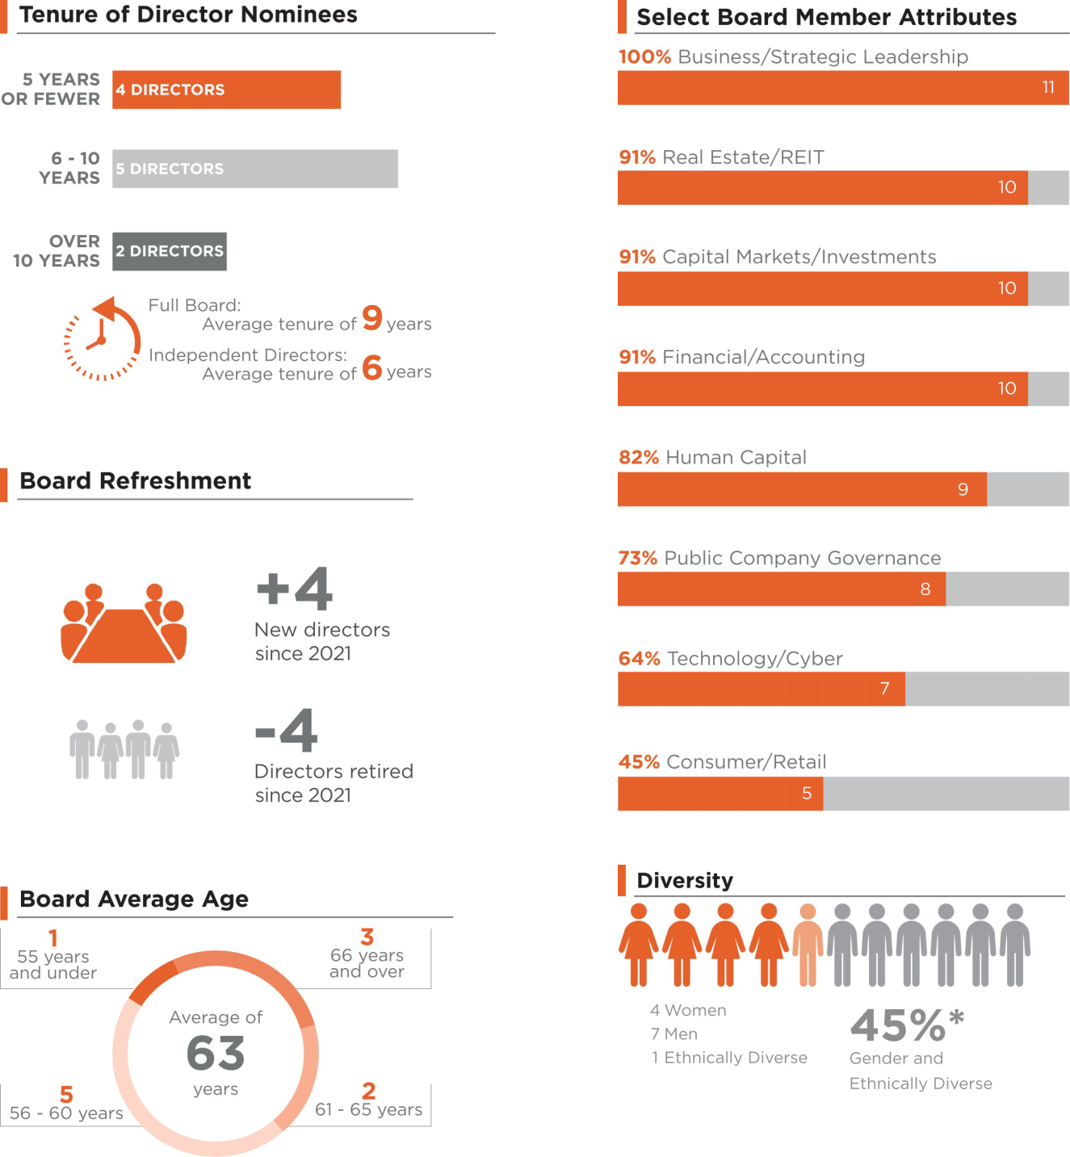

* Mr. Simmons self-identifies as African American. Mss. Campbell, Evens, Klein and Palmer self-identify as female.

4 | REGENCY CENTERS | 2026 PROXY STATEMENT

Table of Contents

Proxy Summary |

Excellence in Corporate Responsibility

Regency’s Core Values, including the importance that we place on corporate responsibility, are at the foundation of who we are and what we do. We believe that acting responsibly is strategic to value creation for our investors, the long-term resiliency and sustainability of our assets and business, the interests of our shareholders and other key stakeholders, and the protection of the environment. Our Corporate Responsibility program is built on four pillars: our people, our communities, ethics and governance, and environmental stewardship, and is guided by our focus on three overarching concepts: long-term value creation for our shareholders and key stakeholders, the importance of maintaining and nurturing our culture, and protecting and enhancing Regency’s brand and reputation.

Our Corporate Responsibility Pillars
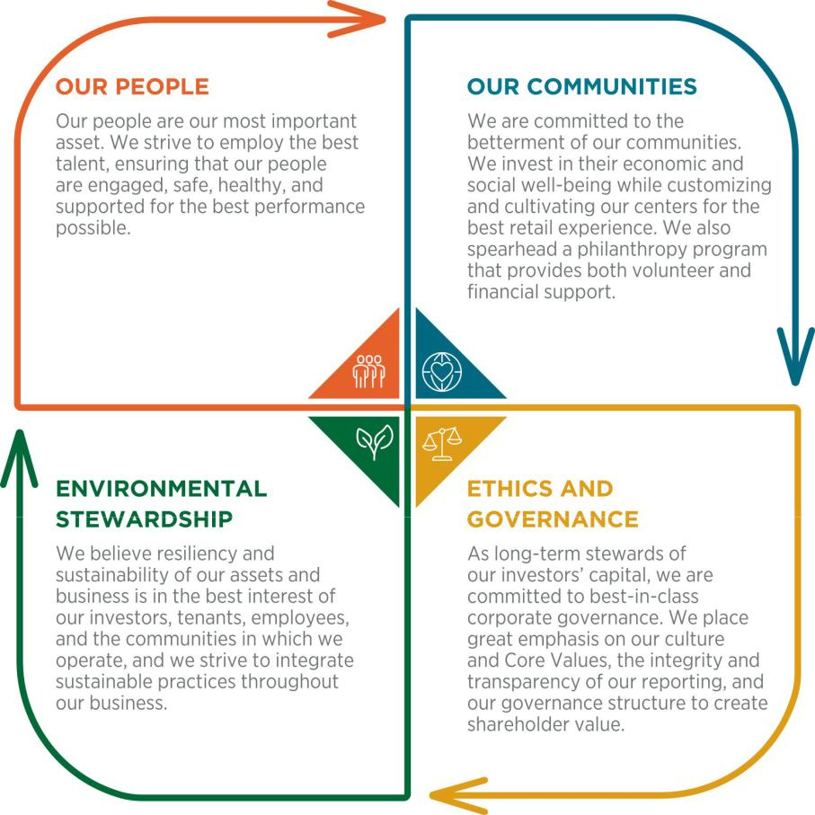

Corporate Responsibility Oversight and Alignment with Business Strategy

Our Board is responsible for the oversight of our corporate responsibility strategy, initiatives, and business alignment, and has delegated to our Nominating and Governance Committee oversight of Regency’s Corporate Responsibility program and objectives. Our Corporate Responsibility Committee is comprised of senior leaders of management from key areas of our business and is tasked with working with management’s Executive Committee (which is made up of the Company’s four most senior officers) to ensure that our corporate responsibility strategies and near-and long-term objectives are embedded throughout our business decisions, processes, and activities for the benefit of our shareholders and key stakeholders. Our President and CEO, Lisa Palmer, has ultimate senior management responsibility for our Corporate Responsibility program, through her oversight of our Corporate Responsibility Committee and the leadership of our management’s Executive Committee.

REGENCY CENTERS | 2026 PROXY STATEMENT | 5

Table of Contents

| Proxy Summary

In 2025, the Board’s Nominating and Governance Committee, and our full Board, were briefed regularly on our Corporate Responsibility program and objectives, including strategic sustainability and employee and community engagement initiatives, performance against metrics and targets, sustainability reporting, and the evolving landscape of expectations and practices among our investors and key stakeholders.

Corporate Responsibility Highlights
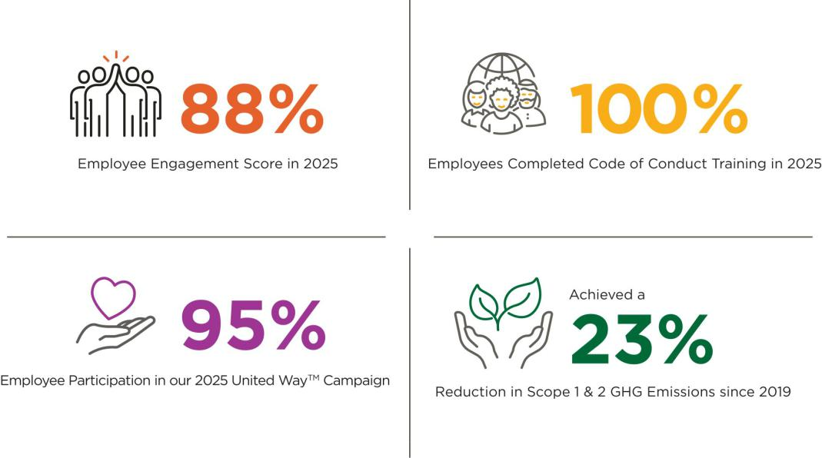

Our Approach to Corporate Responsibility Reporting and Disclosure

We routinely engage with our investors and other stakeholders to better understand their expectations and reflect on their priorities. We understand that our investors and other stakeholders expect disclosure of corporate responsibility-related information relevant to the performance, ongoing resilience and sustainability of our assets and business, and we remain committed to disclosure that is transparent, accurate, and aligned with our Core Values. Our dedication to the four pillars of our program helps to ensure that we continue to hold ourselves to our high standards of integrity and accountability in our corporate responsibility reporting and initiatives. In May 2025, we issued our annual Corporate Responsibility Report, which, as preferred by many of our investors, was prepared in accordance with the Global Reporting Initiative (“GRI”) standard and aligned with the United Nations Sustainable Development Goals, Sustainability Accounting Standards Board (“SASB”) and Task Force on Climate-related Financial Disclosures (“TCFD”) frameworks. To access our Corporate Responsibility Report, along with our other corporate responsibility reports and policies, including our strategy, goals, quantitative metrics and performance, visit our website at https://www.regencycenters.com/corporate-responsibility.

The content on our website, including our Corporate Responsibility reports and other information related to corporate responsibility, is not incorporated by reference into this proxy statement or any other report or document we file with the SEC, and any references to our website are intended to be inactive textual references only.

6 | REGENCY CENTERS | 2026 PROXY STATEMENT

Table of Contents

Proxy Summary |

Excellence in Stakeholder Engagement

Our year-round active engagement with our shareholders and key stakeholders important to our business success supports and enhances our near- and long-term strategies for value creation.

Stakeholder Group |  |  | Engagement Approach | Topics of Discussion
 |  | • | Transparent information sharing throughout the year via company filings, press | ✓ Company performance
 |  |  | releases, supplemental information packages and investor presentations | ✓ Strategic goals and
 | Shareholders, | • | Direct dialogue through quarterly earnings conference calls | objectives
 | Bondholders | • | In 2025, actively communicated with shareholders representing more than 80% of | ✓ Transparent disclosure
 | & Lenders |  | our common stock ownership | ✓ Corporate governance
 |  | • | One-on-one and group meetings, calls, property tours and Regency-hosted events | ✓ Corporate Responsibility
 |  | • | Interactions facilitated via industry associations and conferences | initiatives
 |  | • | Annual employee engagement surveys and review of results, feedback and action | ✓ Employee engagement,
 |  |  | plans for improvement | productivity, health and
 |  | • | Goal setting annually by each employee with their managers | safety
 |  | • | Direct dialogue through employee review meetings, company-wide town hall | ✓ Corporate Responsibility
 | Employees | • | meetings and question & answer sessions with the Executive Committee | initiatives
 |  | • | Employee task forces and focus groups on Corporate Responsibility initiatives and | ✓ Benefits and
 |  |  | actions, including employee resource groups open to all employees | compensation
 |  | • | Formal third-party reporting mechanisms to raise any ethical and compliance | ✓ Career development and
 |  |  | concerns | training
 | Real Estate | • | Dedicated Real Estate partnership portfolio management team | ✓ Property and joint venture
 | Real Estate | • | Proactive and regular one-on-one dialogue | performance and partner
 | Partners | • | Property tours, monthly financial calls and quarterly business calls | expectations
 |  | • | Extensive tenant resources available 24 hours a day | ✓ Tenant operations
 |  | • | Website with best-in-class marketing resources for the benefit of our tenants and | ✓ Sustainable building
 |  |  | their operations, with a wide range of marketing strategies in an intuitive user | practices
 |  |  | experience | ✓ Improving tenant flexibility
 | Tenants | • | Consistently improving website to provide enhanced shopper experience and drive | and performance
 |  | • | visits via AI-based tools | ✓ Property maintenance
 |  | • | Direct feedback via annual tenant survey and focus groups | ✓ Health and safety
 |  | • | Targeted application of our Merchandising, Placemaking and Connecting strategies | ✓ Health and safety
 |  |  | and initiatives across all properties and on a tenant-by-tenant basis
 |  | • | One-on-one dialogue with local and regional planning agencies, municipal boards, | ✓ Project-specific
 |  | • |  | information
 |  |  | permitting authorities and community groups | information
 |  |  | permitting authorities and community groups | ✓ Community interests and
 | Communities | • | Direct dialogue through open houses and town halls | ✓ Community interests and
 | Communities | • | Significant volunteer activities and philanthropic support | needs
 |  | • | Significant volunteer activities and philanthropic support | ✓ Curated merchandising
 |  | • | AI chatbots deployed on select consumer websites to provide personalized search | ✓ Curated merchandising
 |  |  | responses | and placemaking






REGENCY CENTERS | 2026 PROXY STATEMENT | 7

Table of Contents

| Proposal One: Election Of Directors

Proposal One: Election Of Directors

Our Restated Articles of Incorporation provide for the number of directors to be fixed pursuant to our bylaws, subject to a minimum of three and a maximum of fifteen. As of the date of this proxy statement, our Board has twelve directors. As previously disclosed, C. Ronald Blankenship, our current independent Lead Director, advised the Board that he intended to retire from the Board and would not stand for re-election in 2026. Our Board nominated all other eleven current directors to stand for election at the 2026 Annual Meeting and, assuming that all nominees are elected, our Board will have eleven directors after our Annual Meeting. Other than Mark J. Parrell, who was appointed to the Board effective January 1, 2026, all nominees were elected as directors by the shareholders at the 2025 Annual Meeting. All eleven directors elected at our 2026 Annual Meeting will serve until our 2027 Annual Meeting and until their successors are elected and qualified.

The accompanying proxy card will be voted for the election of each of the Board’s eleven nominees, unless it includes instructions otherwise. Each nominee has consented to stand for election. If any nominee should become unavailable, which we do not currently anticipate, proxies instructing a vote for that nominee may be voted for a substitute nominee selected by our Board or, alternatively, our Board may determine to leave the vacancy temporarily unfilled or reduce the number of directors in accordance with our bylaws.

Information about each of the nominees, including biographies, is set forth below and on the following pages.

OUR BOARD RECOMMENDS A VOTE “FOR” THE ELECTION OF EACH OF ITS NOMINEES.

Our Director Nominees

You are being asked to vote on the election of each of the eleven director nominees listed below. Directors are elected by a majority of votes cast. Each nominee has been determined to be independent, in accordance with applicable Nasdaq Stock Market listing requirements, except for Mr. Stein (Executive Chairman) and Ms. Palmer (President and CEO). Upon election of these directors at the Annual Meeting, the directors shall hold the Board committee memberships and chair positions as follows:

 |  |  |  |  |  |  | Committee Membership
 |  |  |  |  |  |  |  |  | Nominating
 |  |  | Director |  |  |  |  |  | and
 | Name and Primary Occupation | Age | Since |  | Audit |  | Compensation |  | Governance |  | Investment
 | Gary E. Anderson | 60 | 2024
 | Former Chief Operating Officer of Prologis, Inc. | 60 | 2024
 | Bryce Blair | 67 | 2014
 | Principal of Harborview Associates, LLC | 67 | 2014
 | Kristin A. Campbell
 | Former Executive Vice President, General Counsel and Chief ESG Officer of | 64 | 2023
 | Hilton Worldwide Holdings Inc.
 | Deirdre J. Evens
 | Former Executive Vice President and General Manager, IT Asset Lifecycle | 62 | 2018
 | Management of Iron Mountain
 | Thomas W. Furphy | 59 | 2019
 | Chief Executive Officer and Managing Director of Consumer Equity Partners
 | Karin M. Klein | 54 | 2019
 | Founding Partner of Bloomberg Beta
 | Peter D. Linneman | 75 | 2017
 | Principal of Linneman Associates
 | Lisa Palmer | 58 | 2018
 | President and Chief Executive Officer of Regency Centers Corporation | 58 | 2018
 | Mark J. Parrell | 59 | 2026
 | President and Chief Executive Officer of Equity Residential
 | James H. Simmons, III | 59 | 2021
 | Chief Executive Officer and Founding Partner of Asland Capital Partners | 59 | 2021
 | Martin E. Stein, Jr.
 | Executive Chairman of the Board and Former Chief Executive Officer of | 73 | 1993
 | Regency Centers Corporation
 | Member Committee Chair Audit Committee Financial Expert
8 | REGENCY CENTERS | 2026 PROXY STATEMENT

Table of Contents

Proposal One: Election Of Directors |

Director Nominee Qualifications

The following skills matrix and biographies of our nominees contain information regarding each person’s attributes (not including attributes developed and enhanced by virtue of their service on the Company’s Board) and other director positions held currently or at any time during at least the last five years, as well as information regarding involvement in certain legal or administrative proceedings, if applicable. The biographies also reflect the Board Committee memberships the nominees are anticipated to hold upon their election. We believe that each nominee possesses the core competencies expected of all of our directors, namely, independence (except for Mr. Stein and Ms. Palmer), integrity, sound business judgment and the ability and willingness to represent the long-term interests of our shareholders.

ATTRIBUTES


BUSINESS/STRATEGIC LEADERSHIP

“C Suite” experience (CEO, CFO, COO or similar) or sub “C Suite” experience as division president or functional leader within a substantial organization.

REAL ESTATE/REIT

Experience in a significant organization where the ownership, operation and development of real estate is integral to the business; or knowledge and experience in issues facing real estate investment trusts.

CAPITAL MARKETS/INVESTMENTS Experience in equity, debt and capital markets, generally.

CONSUMER RETAIL

Experience in a consumer driven or technology related retailer.

CORPORATE GOVERNANCE/

PUBLIC BOARD

Experience serving as a public company director (other than Regency Centers) and demonstrated understanding of corporate governance standards and practices in public companies.

FINANCIAL/ACCOUNTING*

Experience as a public company senior leader with significant financial responsibilities (e.g. CEO or CFO) or able to qualify as an Audit Committee Financial Expert under SEC rules.

HUMAN CAPITAL

Experience managing a large and diverse workforce with involvement in benefits, compensation and incentive planning, including Board and management succession planning.

TECHNOLOGY/CYBER RISK

Significant experience with or oversight of innovation, technology, information systems and data management.

*All of our directors are “financially literate” as defined by SEC rules.

REGENCY CENTERS | 2026 PROXY STATEMENT | 9

Table of Contents

| Proposal One: Election Of Directors


Gary E.

Anderson

Age: 60

Director Since: 2024

Board Committees

- Compensation (Chair)*

- Investment

Other public company boards

- None

Principal occupation or employment

- Former Chief Operating Officer of Prologis, Inc.

Qualifications

- Extensive experience in real estate operations, development and investment, corporate strategy and capital markets.

Professional Experience:

Mr. Anderson, a graduate of Washington State University, holds an M.B.A. from the Anderson Graduate School of Management at University of California, Los Angeles. Mr. Anderson recently retired as Chief Operating Officer of Prologis, Inc. (NYSE: PLD), a REIT that is a global leader in real estate logistics facility development and operation. Prior to his role as Chief Operating Officer,

Mr. Anderson was the Chief Executive Officer, Europe and Asia, from June 2011 until March 2019. Additionally, Mr. Anderson held various positions from August 1994 to June 2011, including head of the global fund business from March 2009 to June 2011 and President of European operations from November 2006 to March 2009. Mr. Anderson is a member of the Young Presidents’ Organization— Gold and serves on the Board of Directors for Colorado UpLift.

*Mr. Anderson will become Chair of the Compensation Committee after

the 2026 Annual Meeting.

Bryce

Blair

Age: 67

Director Since: 2014

Board Committees

- Investment (Chair)

- Nominating and Governance

Other public company boards

- PulteGroup, Inc.

Principal occupation or employment

- Principal of Harborview Associates, LLC

Qualifications

- Extensive experience in real estate operations, development and investment, the REIT industry, corporate strategy, capital markets and public company governance.

Professional Experience:

Mr. Blair, a graduate of the University of New Hampshire, holds an M.B.A. from Harvard Business School. Mr. Blair serves as the principal of Harborview Associates, LLC, which holds and manages investments in various real estate properties. He serves as a director of PulteGroup, Inc. (NYSE: PHM), one of the largest home builders in the U.S., in which he served as Chairman from 2017 until December 31, 2022. He is a member of the Advisory Board of Navitas Capital, a venture capital firm focused on technology for the real estate sector. Mr. Blair served as Chairman, from 2017 to 2021, and director, from 2013 to 2021, of Invitation Homes, Inc. (NYSE: INVH) He has served as Chairman, from 2002 to 2013, and Chief Executive Officer, from 2001 to 2012, of AvalonBay Communities, Inc. (NYSE: AVB), a real estate investment trust focused on the development, acquisition and management of multi-family apartments. Mr. Blair also serves on the Advisory Board of the Joseph E. Corcoran Boston College Center for Real Estate and Urban Action. He previously served on the Advisory Board of the MIT Center for Real Estate. Prior to the formation of Avalon Properties in 1993, Mr. Blair was a partner with Trammell Crow Residential.

Mr. Blair also previously served as senior advisor to McKinsey and Co. and previously served as a part time faculty member at Boston College. Mr. Blair is a past Chairman of the National Association of Real Estate Investment Trusts (Nareit), where he also served on the Executive Committee and the Board of Governors. He is a past member of Urban Land Institute (ULI) where he served as a Trustee and was past Chairman of the Multi-Family Council. Mr. Blair is a past member of the Young Presidents Organization and a former member of the World Presidents Organization.

10 | REGENCY CENTERS | 2026 PROXY STATEMENT

Table of Contents


Kristin A.

Campbell

Age: 64

Director Since: 2023

Board Committees

- Nominating and Governance (Chair)

- Compensation

Other public company boards

- None

Principal occupation or employment

- Former Executive Vice President, General Counsel and Chief ESG Officer of Hilton Worldwide Holdings Inc.

Qualifications

- Extensive background in legal, compliance, ESG (including business and asset resilience and sustainability), retail, public company governance, real estate and M&A.

Proposal One: Election Of Directors |

Professional Experience:

Ms. Campbell, a graduate of Arizona State University, holds a J.D. from Cornell Law School. She serves as Senior Advisor at BarkerGilmore, a national legal executive search and leadership consulting firm. She served as Executive Vice President, General Counsel and Chief ESG Officer of Hilton Worldwide Holdings Inc. (NYSE: HLT), a global hospitality company from June 2011 until her retirement in September 2023. She led Hilton’s global legal, compliance, government affairs and ESG functions. Prior to Hilton, Ms. Campbell was Senior Vice President, General Counsel and Corporate Secretary for Staples, Inc. from 2007 to 2011, with an overall tenure of 18 years at Staples. Prior to Staples, she worked at several law firms, including Goodwin Procter and Rackemann, Sawyer & Brewster. Ms. Campbell previously served as director of The ODP Corporation from 2016 until it was acquired in December 2025. She is a member of the Advisory Board of Boston University School of Hospitality Administration. Ms. Campbell serves on the board of Crete United, a private national multi-service building solution provider. She previously served on the Advisory Board of New Perimeter.

Deirdre J.

Evens
Lead Director*

Age: 62

Director Since: 2018

Board Committees

- Audit

- Compensation

Other public company boards

- None

Principal occupation or employment

- Former Executive Vice President and General Manager, IT Asset Lifecycle Management of Iron Mountain

Qualifications

- Extensive background in corporate strategy, global risk, addressing technological change, cybersecurity, sales, general management, marketing and human capital

management.

*Ms. Evens will become independent Lead Director after the 2026 Annual Meeting.

Professional Experience:

Ms. Evens, a graduate of Cornell University, served as Executive Vice President and General Manager, IT Asset Lifecycle Management of Iron Mountain, Inc. (NYSE: IRM) from January 2022 until her retirement in December 2023. Prior to that, she served as Executive Vice President and General Manager, North America, Records and Information Management of Iron Mountain from July 2018 to January 2022. Prior to that, she served as its Chief of Operations from January 2018 to June 30, 2018 and as its Chief People Officer and Executive Vice President from July 21, 2015 to January 2018. Prior to her service with Iron Mountain, Ms. Evens served as an Executive Vice President of human resources at Clean Harbors, Inc. (NYSE: CLH) from 2011 to July 2015, overseeing all aspects of human resources and employee development for a global workforce of more than 13,000 employees. From 2007 to 2011, Ms. Evens served as Executive Vice President of Corporate Sales & Business Development for Clean Harbors. Prior to her service with Clean Harbors, Ms. Evens served as Senior Vice President of Member Insight at BJ’s Wholesale Club Holdings, Inc. (NYSE: BJ) from 2006 to 2007 and held a series of positions of increasing responsibility at Polaroid Corporation from 1986 to 2006, including her role as Senior Vice President of Strategy. Ms. Evens is an independent director at CSC ServiceWorks, a private equity firm in North America, and has served as interim Chief Executive Officer since May 2025, an assignment expected to conclude in April 2026.

REGENCY CENTERS | 2026 PROXY STATEMENT | 11

Table of Contents

| Proposal One: Election Of Directors


Thomas W.

Furphy

Age: 59

Director Since: 2019

Board Committees

- Audit

- Investment

Other public company boards

- None

Principal occupation or employment

- Chief Executive Officer and Managing Director of Consumer Equity Partners

Qualifications

- Extensive experience in retail, addressing technological change, AI, cybersecurity, marketing, finance and leadership.


Karin M.

Klein

Age: 54

Director Since: 2019

Board Committees

- Audit (Chair)

- Nominating and Governance

Other public company boards

- None

Principal occupation or employment

- Founding Partner of Bloomberg Beta

Qualifications

- Extensive experience in media, addressing technological change, AI, cybersecurity, investments, finance, accounting, strategy and leadership.

12 | REGENCY CENTERS | 2026 PROXY STATEMENT

Professional Experience:

Mr. Furphy, a graduate of Hartwick College, currently serves as Chief Executive Officer and Managing Director of Consumer Equity Partners, a venture capital and venture development firm. He also serves as Chairman and Chief Executive Officer of Replenium, Inc., a private e-commerce software company. Since July 2023, Mr. Furphy has served as a Luminary (senior advisor) to Accenture, a Dublin company that specializes in information technology services and consulting. Previously, Mr. Furphy served as Vice President of Consumables and AmazonFresh at Amazon.com, Inc. (NASDAQ: AMZN) from 2005 to 2009, where he was responsible for the underlying strategy, development and execution of the company’s grocery and health and beauty businesses. Prior to Amazon,

Mr. Furphy was the founder and Chief Executive Officer of Notiva, a leading provider of web-based trade settlement software for retailers and their trading partners. Prior to Notiva, from 1991 to 1999, he held various senior management roles at Wegmans Food Markets, Inc. Mr. Furphy previously served as Chairman and Chief Executive Officer of Ideoclick, Inc., a full-service ecommerce private agency. He also previously served as a board member of BevyUp, a private digital retail-selling platform, which was acquired by Nordstrom in March 2018. He previously served as a board member of Fairway Group Holdings Corp., a private parent company of Fairway Market, a grocery store operator.

Professional Experience:

Ms. Klein, a graduate of the University of Pennsylvania, holds an M.B.A from the Wharton School of University of Pennsylvania. She serves as the founding partner of Bloomberg Beta, a venture capital firm which invests in technology companies that help businesses work smarter, with a focus on machine intelligence, since 2013. Prior to launching Bloomberg Beta, Ms. Klein was responsible for strategy and business development for Bloomberg L.P. from 2010 to 2013 including serving as head of new initiatives. Prior to Bloomberg, from 2000 to 2010, Ms. Klein served in various roles at Softbank Corp., a multinational telecommunications and technology company, including the role of Director of Corporate Development. Before Softbank, she also held investing and operating roles at several investment companies and co-founded a children’s education business. She serves as member of the Board of Directors of Campus.edu, She previously served as an independent director of Paramount Group, Inc. (NYSE: PGRE), and formerly served as a member of the Board of Trustees of Harvey Mudd College.

Table of Contents

 |  |  | Proposal One: Election Of Directors |
 |  |  | Professional Experience:
 |  | Peter D. | Professional Experience:
 |  | Peter D. | Dr. Linneman holds both an M.A. and a doctorate degree in economics from the
 |  | Linneman | University of Chicago. He served on the Board of Equity One, Inc. from 2000
 |  | Age: 75 | until its merger with Regency in 2017. Dr. Linneman is currently a principal of
 |  | Age: 75 | Linneman Associates, a real estate advisory firm, and affiliated entities. From
 |  | Director Since: 2017 | 1979 to 2011, Dr. Linneman was a Professor of Real Estate, Finance and Public
 |  | Director Since: 2017 | Policy at the Wharton School of University of Pennsylvania and is currently an
 |  |  | Emeritus Albert Sussman Professor of Real Estate. Dr. Linneman previously
 | Board Committees |  | served as a director of AG Mortgage Investment Trust, Inc. (NYSE: MITT),
§ |  | Audit | Equity Commonwealth (NYSE: EQC), Paramount Group, Inc. (NYSE: PGRE),
§ |  | Nominating and Governance | Bedford Property Investors, Inc., Atrium European Real Estate Ltd. and JER
 | Other public company boards |  | Investors Trust, Inc. (OTC Markets: JERTQ), a finance company that acquires
 |  |  | real estate debt securities and loans. He was also Chairman of Rockefeller
§ |  | None
 |  | None | Center Properties Inc.
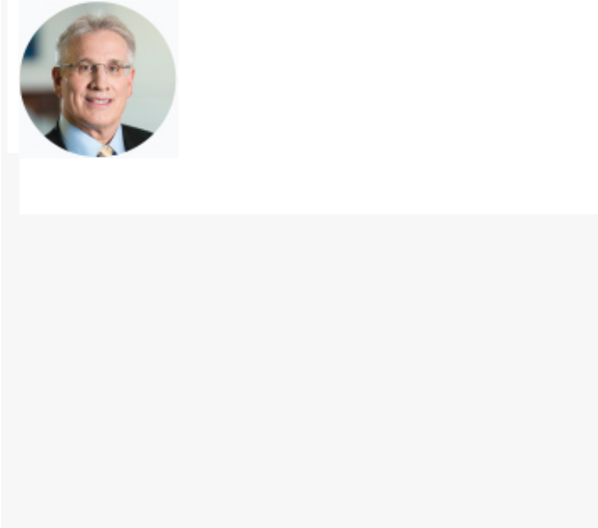
Principal occupation or employment

- Principal of Linneman Associates and affiliated entities

Qualifications

- Extensive experience in financial and business advisory services and investment activity, with a specialty in real estate, and as a member of numerous public and private boards, including many real estate companies.


 | Lisa | Professional Experience:
 | Lisa | Ms. Palmer, a graduate of the University of Virginia, holds an M.B.A. from the
 | Palmer | Wharton School of the University of Pennsylvania. Ms. Palmer became our Chief
 | Age: 58 | Executive Officer on January 1, 2020, and has served as our President since
 | Age: 58 | January 1, 2016 to date. Previously, she served as our Chief Financial Officer
 | Director Since: 2018 | from January 2013 to August 12, 2019. Prior to that, she served as Senior Vice
 | Director Since: 2018 | President of Capital Markets from 2003 until 2013. She served as Senior
 |  | Manager of Investment Services in 1996 and assumed the role of Vice President
 | Board Committees | of Capital Markets in 1999. Prior to joining our Company, Ms. Palmer worked
 | § Investment | with Accenture plc (NYSE: ACN), formerly Andersen Consulting Strategic
 | Other public company boards | Services, as a consultant and financial analyst for General Electric Company.
 | Other public company boards | She serves as a member of the boards of the Jacksonville Branch of the Federal
 | § None
 | § None | Reserve Bank of Atlanta and Brooks Rehabilitation, a private healthcare
 | Principal occupation or employment | organization. She currently also serves an executive member of Nareit, a
 | § Our Chief Executive Officer since January 1, 2020 and | member of ULI, and a member of the Board of Trustees of Innovating Commerce
 | § Our Chief Executive Officer since January 1, 2020 and | Serving Communities (ICSC). She previously served as a director of ESH
 | President since January 1, 2016
 | President since January 1, 2016 | Hospitality, Inc., a subsidiary of Extended Stay America, Inc. and as a director of
 | Qualifications
 | Qualifications | United Way of Northeast Florida.

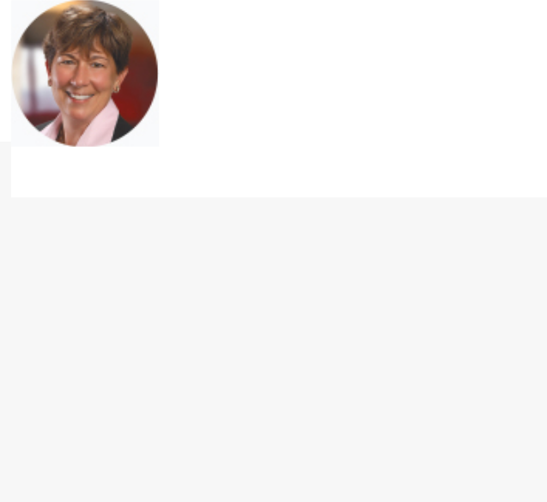
- Extensive knowledge and experience in the shopping center and real estate industries, as well as finance and capital markets, operations, strategy and public company governance.

REGENCY CENTERS | 2026 PROXY STATEMENT | 13

Table of Contents

| Proposal One: Election Of Directors


Mark J.

Parrell

Age: 59

Director Since: 2026

Board Committees

- Audit

- Investment

Other public company boards

- Equity Residential

Principal occupation or employment

- Chief Executive Officer of Equity Residential

Qualifications

- Extensive knowledge and experience in real estate operations and development, capital markets, operations, public company governance, strategy and leadership.
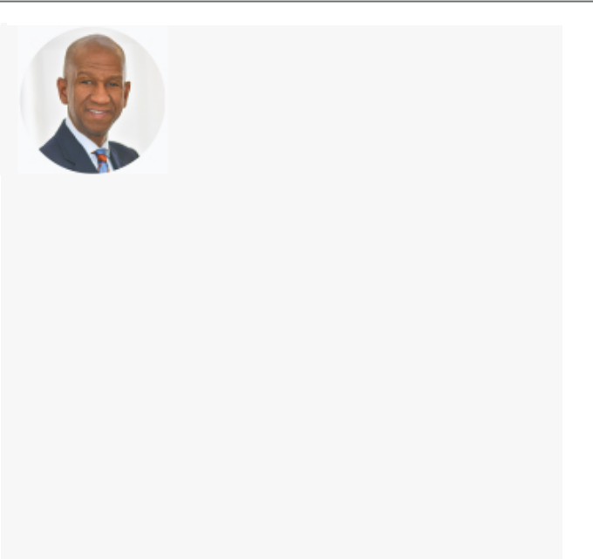

James H.

Simmons, III

Age: 59

Director Since: 2021

Board Committees

- Compensation

- Investment

Other public company boards

- Apollo Asset Backed Credit Company LLC

Principal occupation or employment

- Chief Executive Officer and Founding Partner of Asland Capital Partners

Qualifications

- Extensive knowledge of and experience in real estate development, transactions and operations, capital markets, marketing, strategy and leadership.

14 | REGENCY CENTERS | 2026 PROXY STATEMENT

Professional Experience:

Mr. Parrell, a graduate of the University of Michigan, holds a J.D. from the Georgetown University Law Center. Mr. Parrell is the President, Chief Executive Officer and member of the Board of Trustees of Equity Residential (NYSE: EQR) since January 2019. Mr. Parrell was the Equity Residential’s Executive Vice President and Chief Financial Officer from October 2007 to September 2018 and Senior Vice President and Treasurer of the company from August 2005 to October 2007 and served in various roles in the company’s finance group since September 1999. Mr. Parrell is also active in several business and community service organizations. He currently serves as a board member of the Real Estate Roundtable as well as serving as the First Vice Chair and as a member of the Executive Board of Governors of Nareit. He is a member of the Advisory Board for the Weiser Center for Real Estate at the University of Michigan and is a member of the National Multifamily Housing Council and served as Chair of its Finance Committee in 2015-2016. He is also a member of the Board of Directors and Chair of the Finance Committee of the Greater Chicago Food Depository. Mr. Parrell served as an independent member of the Boards of Directors of various T. Rowe Price mutual funds and exchange traded funds from July 2023 to November 2025. He also served as a member of the Board of Directors and the Audit and Investment Committees of Brookdale Senior Living Inc. (NYSE: BKD), a leading operator of senior living communities throughout the United States from April 2015 to July 2017 and served as a member of the Board of Directors and the Audit Committee of Aviv REIT, Inc. (NYSE: AVIV), a public REIT that specialized in owning post-acute and long-term care skilled nursing facilities and other healthcare properties from March 2013 until April 2015 when Aviv merged into Omega Healthcare.

Professional Experience:

Mr. Simmons, a graduate of Princeton University, holds an M.S. from Virginia Tech and an M.B.A. from Northwestern University. Mr. Simmons currently serves as Chief Executive Officer and Founding Partner of Asland Capital Partners, an institutional investment management platform, serving as head of the investment committee with responsibility for the strategic direction and investment strategy of the firm. Prior to Asland, Mr. Simmons served as a Partner at Ares Management Corporation, a global alternative investment manager, from 2013 to 2018. He also served as a Partner at Apollo Real Estate Advisors L.P. from 2002 to 2013. Prior to Apollo, Mr. Simmons served as Chief Executive Officer and Chief Investment Officer of the Upper Manhattan Empowerment Zone Development Corporation. Mr. Simmons serves as a director of Apollo Asset Backed Credit Company LLC (NYSE: APO). He previously served as a director of Apollo Strategic Growth Capital (NYSE: APSG). He is currently a member of the Princeton University President’s Advisory Council, member of the Board of Trustees for The Dalton School and chair of the Real Estate Executive Council. Mr. Simmons previously served as a director of the Greater Jamaica Development Corporation and a member of Princeton University National Annual Giving Committee.

Table of Contents

Martin E.

Stein, Jr.
Executive Chairman

Age: 73

Director Since: 1993

Board Committees

- Investment

Other public company boards

- FRP Holdings, Inc.

Principal occupation or employment

- Executive Chairman of the Board of Regency Centers Corporation

Qualifications

- Extensive experience in real estate development, acquisitions, financing and operations, the REIT industry, strategic planning, capital markets, human capital and executive compensation.

Proposal One: Election Of Directors |

Professional Experience:

Mr. Stein, a graduate of Washington and Lee University, holds an M.B.A. from Dartmouth College’s Tuck School of Business. Mr. Stein has been our Executive Chairman of the Board since January 1, 2020, having served as a director of the Board since 1993 and its Chairman since 1998. Mr. Stein served as Chief Executive Officer from our initial public offering in 1993 until December 31, 2019. He was our President and Chief Executive Officer from 1993 until 1998 and President of our predecessor real estate division beginning in 1981 and Vice President from 1976 to 1981. He is a director of FRP Holdings, Inc. (NYSE: FRPH), a publicly held real estate company. He served as past Chairman of Nareit, and is a member of ULI, ICSC and the Real Estate Roundtable. Mr. Stein is a former trustee of Washington and Lee University and ULI.

REGENCY CENTERS | 2026 PROXY STATEMENT | 15

Table of Contents

| Corporate Governance

Corporate Governance

Corporate Governance Guidelines

Our Board has adopted Corporate Governance Guidelines (CGGs), which describe the Board’s responsibility for oversight of the business and affairs of the Company as well as for determining director independence and consideration of potential nominees to the Board. Our CGGs are found on the Company’s website at https://investors.regencycenters.com. Our Board, directly and through its Nominating and Governance Committee, regularly reviews changes in law and governmental policy, other developments impacting public companies and best practices in corporate governance, and makes modification to the CGGs, committee charters and other key governance documents, policies and practices as it determines necessary or appropriate.

Director Independence

Our Board has determined that C. Ronald Blankenship, as well as nine of its eleven nominees for director (Gary E. Anderson, Bryce Blair, Kristin A. Campbell, Deirdre J. Evens, Thomas W. Furphy, Karin M. Klein, Peter D. Linneman, Mark J. Parrell, and James H. Simmons, III), or 83% of the current Board, are “independent” as defined by applicable Nasdaq Stock Market listing requirements. The Board annually reviews commercial, familial and charitable relationships of all directors and determines whether each director meet applicable independence tests. To assist in making these determinations, the Board has adopted a set of independence standards, which are set forth in the Company’s CGGs, which meet or exceed the Nasdaq Stock Market listing requirements.

Board Leadership Structure

The roles of Executive Chairman of the Board and Chief Executive Officer are currently separate. Our Board does not have a formal policy on whether the same person should serve in both roles at the same time and periodically reviews and determines the leadership structure that it believes is in the best interest of the Company and its shareholders.

Since January 1, 2020, Mr. Stein has served as Executive Chairman of the Board given his extensive history with the Company and vast knowledge of the real estate industry. Ms. Palmer serves as Chief Executive Officer and as a member of the Board. Pursuant to the CGGs, if the Chairman is also an employee of the Company (as Mr. Stein is, as Executive Chairman), the Board shall elect an independent Lead Director. The independent members of the Board elected Mr. Blankenship to serve as Lead Director until his announced retirement from the Board after the 2026 Annual Meeting, and elected Ms. Evens to serve as Lead Director upon Mr. Blankenship’s retirement from the Board.

Role of Independent Lead Director

The Independent Lead Director serves as the principal liaison between the Executive Chairman of the Board and the independent directors, presides at the executive sessions of independent directors at each Board meeting and other meetings of independent directors, helps lead the Board’s annual self-assessment and evaluation and annual performance evaluation of the Executive Chairman and the Chief Executive Officer, and performs such other duties as may be assigned or requested by the Board. Both the Executive Chairman and the Chief Executive Officer consult routinely with the independent Lead Director on board agendas, substantive board issues and on strategic and significant business issues facing the Company.
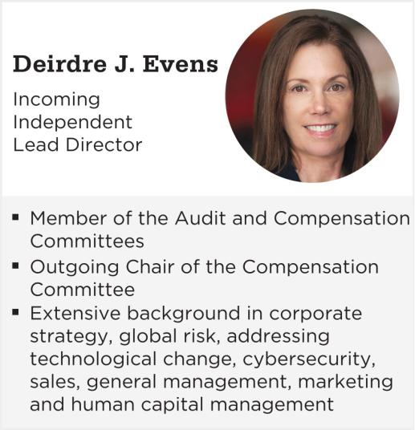

See “Shareholder Proposals and Communications with the Board of Directors” for information on how to communicate with our Lead Director or any of the other independent directors.

16 | REGENCY CENTERS | 2026 PROXY STATEMENT

Table of Contents

Corporate Governance |

Meetings of Board of Directors

Our Board held six meetings during 2025. All directors attended at least 75% of all meetings of the Board and Board committees on which they served during 2025.

Directors are encouraged to attend each Annual Meeting of Shareholders. However, we do not have a formal policy requiring their attendance. Each of the directors that were nominees at the time of the 2025 Annual Meeting were present at the 2025 Annual Meeting.

Executive Sessions of Independent Directors

The independent directors hold regularly scheduled executive sessions of the Board and its committees without senior management or the non-independent directors present. These executive sessions are chaired by the independent Lead Director (at Board meetings) or by the committee chairs (at committee meetings), each of whom are independent directors. The independent directors met in executive session at all of the regularly scheduled Board and committee meetings held in 2025.

Board Membership

The Nominating and Governance Committee assists the Board in establishing criteria and qualifications for potential Board members. The committee identifies individuals who meet such criteria and qualifications and recommends to the Board such individuals as potential nominees for election to the Board.

In addition, after consideration of the skills matrix set forth on page 9, the backgrounds and biographies of each of the Board members, and other considerations in respect of the potential needs of the Board and the Company, the committee seeks attributes in potential new members that will complement and enhance the Board’s existing make-up, while taking into account expected retirements, to best facilitate Board succession, transition and effectiveness. The committee evaluates each individual in the context of the Board as a whole, to recommend a group that can best collaboratively contribute to the success of our Company.

The board has not set term limits on director service, nor has it established a mandatory retirement age, because the Board believes that term limits and/or a mandatory retirement age may deprive the Board and the Company’s shareholders of the contributions of experienced, effective, high-performing directors who have developed valuable expertise and insights into the Company and its business. However, the CGGs provide that the Board considers age 75 or 15 years of board tenure, whichever occurs first, as relevant factors when considering continuing Board nominations and membership.

Succession Planning, Board Refreshment and Diversity of Member Attributes

Our Board believes that a mix of personal and professional attributes among its directors is crucial to effective governance. This mix of competencies, skills, experiences, expertise, perspective, personal backgrounds and tenures (we’ll refer to these collectively as the “attributes” of our Board members and candidates), as well as continuity of the membership of our Board, have been integral over time to the performance of the Board and the success of our Company. To ensure that a mix of attributes and Board membership continuity are maintained and enhanced, our Board has established a succession planning process. A review of the Board succession plan is part of the annual agenda of both the Nominating and Governance Committee and the full Board. The Board has undergone significant, purposeful refreshment over the past several years, such that the average tenure of its nine nominated independent directors is currently six years. This refreshment has resulted in the addition of diverse attributes, fresh perspectives, and a range of new and different experience sets.

The Nominating and Governance Committee and the Board, respectively, continually assess member attribute diversity through its annual succession plan review, annual evaluation of Board structure and composition, and the results of the annual Board and committee performance self-assessment and evaluation process. The committee and the Board believe that fostering Board member attribute diversity best serves the needs of the Company and the interests of its shareholders, by maintaining deep experience and institutional knowledge of the Company and its business while also providing fresh perspectives and new ideas. The committee evaluates each potential director candidate in the context of existing Board members and the Board as a whole to ensure that appropriate diversity attributes and Board culture, perspective and effectiveness will be maintained and enhanced.

REGENCY CENTERS | 2026 PROXY STATEMENT | 17

Table of Contents

| Corporate Governance

Director Nominee Selection Process

Our Nominating and Governance Committee solicits input regarding potential candidates from a variety of sources, including existing directors, senior management and shareholders. From time to time, we have used an executive search firm, especially when helpful in identifying new or different pools of talent for our Board. For instance, in 2025, our Board retained an executive search firm to facilitate the recruitment of a highly qualified candidate for the Board, resulting in the election of Mark J. Parrell in January of 2026, and in 2024, the Board facilitated the recruitment and election of Gary E. Anderson through existing director relationships. Through these and other means, the Board has continually refreshed itself by selecting directors who will be additive to the overall mix of attributes on the Board. The committee evaluates potential candidates based on a variety of factors and also arranges personal interviews by one or more committee members, other Board members and senior management, where appropriate.
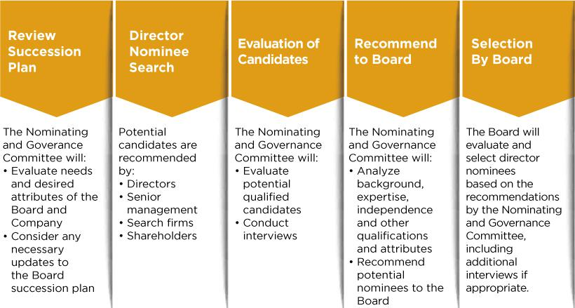

Director Candidate Nominations through Proxy Access

Our bylaws make proxy access available to our shareholders. Under this process, a shareholder or group of up to 20 shareholders of common stock who have owned shares of our common stock equal to at least 3% of the aggregate of our issued and outstanding common shares continuously for at least three years may seek to include director nominees in our proxy materials at our Annual Meeting. The maximum number of director nominees that may be submitted pursuant to these provisions may not exceed 25% of the number of directors then on the Board, with such number to be reduced by the number of individuals that the Board nominates for re-election who were previously elected based upon a nomination pursuant to proxy access or advance notice provisions of our bylaws. To be eligible to use proxy access, such shareholders must satisfy other eligibility, procedure and disclosure requirements set forth in our bylaws.

18 | REGENCY CENTERS | 2026 PROXY STATEMENT

Table of Contents

Corporate Governance |

Limits on Board Service

Our Board does not allow “overboarding”, which refers to a director serving on an excessive number of public company boards. Excessive board commitments can lead to a director being unable to devote sufficient attention to Board matters and appropriately fulfill his or her duties to the Company and its shareholders. Our CGGs limit the number of boards on which our directors and officers can serve and further provide that no more than two active Regency executives may serve on our Board at any time. Our CGGs provide for the following limitations:

 | Maximum Number of
Position | Public Company Boards*
Independent director holding full-time executive position with another company | 2
Independent director who is not a full-time executive | 4
Regency officer | 2**

* Maximum number includes service on Regency’s Board.

- Notwithstanding anything to the contrary in our CGGs, no Regency officer may serve on more than one outside public company board unless a specific exception is made by the Board.

Board Self-Assessment and Evaluation

Annual self-evaluation and assessment of Board performance helps ensure that our Board and its committees function effectively and in the best interest of our shareholders. This process also promotes good governance and helps set expectations about the relationship and interaction between our Board and management. Periodically, the Board may utilize third parties experienced in public company governance and board operations and effectiveness in the self-evaluation and assessment process, and such a process was last used for the Board’s 2024 self-evaluation and assessment. Our Board’s annual self-evaluation and assessment process, which is overseen by our independent Lead Director and Chair of our Nominating and Governance Committee, is reviewed annually. For 2025, the process was structured and carried out as follows:
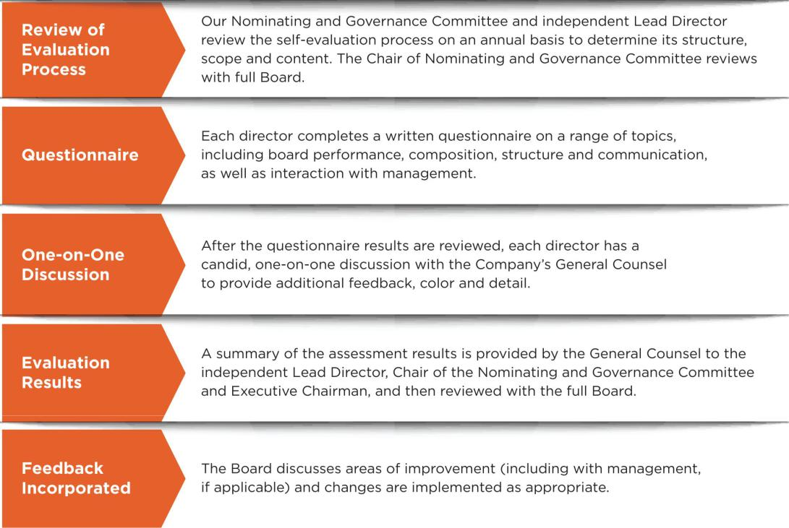

REGENCY CENTERS | 2026 PROXY STATEMENT | 19

Table of Contents

| Corporate Governance

Risk Oversight

Our Board actively oversees material risks that could impact the Company. This oversight is conducted both directly by management and through Board committees. Our Board satisfies its responsibility through receiving reports by each committee chair after each meeting regarding the applicable committee’s considerations and actions, as well as through regular reports directly from officers and management level committees responsible for oversight of particular risks within the Company. Management committees frequently work jointly on issues with overlapping subject matter.


BOARD OF DIRECTORS

Oversees the Company’s most significant risks and ensures that management

responds with appropriate strategic and tactical mitigation plans.

Board Committees


AUDIT

- Has primary responsibility for overseeing financial statements integrity and financial risk for the Company.

- Oversees cybersecurity and AI risk.

COMPENSATION

- Oversees risk associated with our executive compensation programs, policies and practices.

NOMINATING AND

GOVERNANCE

- Oversees corporate governance risk.

- Oversees ethics and compliance program.

- Oversees corporate responsibility program and ESG initiatives.

- Oversees political contributions risk.

INVESTMENT

- Oversees risks associated with capital allocation.

- Oversees risks associated with real estate investments, developments and redevelopments.

Management Committees


EXECUTIVE

- Currently consists of our President and Chief Executive Officer; Executive Vice President and Chief Financial Officer; East Region President and Chief Operating Officer; and West Region President and Chief Investment Officer.

- Receives frequent reporting from each of the management committees listed below, which evaluates and works to mitigate specific areas of risk.

- Provides quarterly updates to the full Board and/or appropriate Board committee, either directly or through the below committees, concerning the strategic, operational and emerging risks to the Company’s ability to achieve its goals, objectives and initiatives, along with updates regarding the mitigation activities underway to address the risks.

REAL ESTATE

Oversees real estate portfolio and investment risk.


MANAGEMENT

Oversees corporate enterprise and operational risk.


 | BUSINESS |  | CORPORATE
 | CONTINUITY |  | RESPONSIBILITY
 | Develops and executes |  | Assesses risks relating to
 | strategies to assess risk |  | business and asset
 | and to recover |  | resiliency and
 | operations, data and full |  | sustainability and leads
 | functionality after any |  | the initiatives of the
 | extended unplanned |  | Company’s corporate
 | business interruption. |  | responsibility program.

CYBER RISK

Assesses and mitigates the risks posed by AI and cybersecurity incidents and cyber-attacks impacting the Company’s data and information systems.

COMPLIANCE

Assesses and mitigates risk associated with the Company’s ethics and compliance program.

BUSINESS

CONTINUITY

Assesses and mitigates risk associated with the Company’s financial controls and disclosures.

20 | REGENCY CENTERS | 2026 PROXY STATEMENT

Table of Contents

Corporate Governance |

Standing Committees

Our Board of Directors has established four standing committees: an Audit Committee, a Compensation Committee, a Nominating and Governance Committee and an Investment Committee, each as described below. Members of these committees are elected annually by our Board of Directors. The charters for each of these committees are available on our website at www.regencycenters.com.

Audit Committee

MEMBERS

Karin M. Klein, CHAIR

Deirdre J. Evens

Thomas W. Furphy

Peter D. Linneman

Mark J. Parrell

James H. Simmons, III⁽¹⁾

The Board has determined that each member of the Audit Committee is independent as defined under the applicable Nasdaq Stock Market listing requirements and Rule 10A-3 under the Securities Exchange Act of 1934, as amended.

The committee met

five times in 2025

Our Board has determined that each member of the Audit Committee qualifies as an “Audit Committee financial expert” as defined by the rules of the SEC.

In accordance with our CGGs, no member of the Audit Committee serves on the Audit Committee of more than three public companies.

KEY RESPONSIBILITIES


- Assists the Board in its oversight of:

  - the integrity of our financial statements

  - our accounting and reporting processes and controls
  - REIT and other tax compliance
  - derivatives and hedging transactions
  - our internal audit functions, and
  - our insurance programs

- Reviews the independence and performance of our independent registered public accounting firm

- Responsible to select, evaluate, terminate and replace, as applicable, our independent registered public accounting firm

- Approves the Audit Committee Report as shown on page 52. The report further details the Audit Committee’s responsibilities, and

- Oversees the Company’s cybersecurity program (see below) and AI risk

Cybersecurity Governance Highlights

- Management’s Cyber Risk Committee reports to the Board’s Audit Committee regularly, including reports on any significant cyber breaches (no such breach in the past five years)

- References NIST cybersecurity framework to address risk gaps

- Robust monitoring of internal and external threats

- Validation and testing, including third-party cyber assessments and penetration tests

- Review the security protocols of our key vendors

- Cyber insurance procured by the Company

- Cybersecurity Risk Management Policy

Compensation Committee
MEMBERS

Deirdre J. Evens, CHAIR⁽²⁾

Gary E. Anderson

C. Ronald Blankenship⁽³⁾

Kristin A. Campbell

The Board has determined that each member of the Compensation Committee is independent as defined under the applicable Nasdaq Stock Market listing requirements and Rule 10A-3 under the Securities Exchange Act of 1934, as amended.

The committee met

five times in 2025

KEY RESPONSIBILITIES


- Establishes and oversees our executive compensation and benefits programs

- Reviews and recommends to the Board the compensation of our non-employee directors, Executive Chairman and CEO

- Reviews and approves compensation of other named executive officers

- Sets the criteria for awards under incentive compensation plans and determines whether such criteria has been met, and

- Oversees matters relating to the Company’s long-term incentive plans

Note: The committee has retained Semler Brossy as its independent compensation consultant.

- Mr. Simmons will serve on the committee until the 2026 Annual Meeting, after which he will become a member of the Compensation Committee.

- Mr. Anderson will assume the role of committee chair after the 2026 Annual Meeting. Ms. Evens will continue to serve as chair until such time.
- Mr. Blankenship will serve on the committee until he retires from the Board after the 2026 Annual Meeting.

REGENCY CENTERS | 2026 PROXY STATEMENT | 21

Table of Contents

| Corporate Governance

Nominating and Governance Committee

MEMBERS

Kristin A. Campbell, CHAIR

Bryce Blair

Karin M. Klein

Peter D. Linneman

The Board has determined that each member of the Nominating and Governance Committee is independent within the meaning of the Company’s independence standards and applicable listing standards of the Nasdaq Stock Market.

The committee met

five times in 2025

KEY RESPONSIBILITIES


- Establishes sound corporate governance in compliance with applicable regulatory requirements and best practices

- Oversees the Company’s programs, objectives and initiatives related to corporate responsibility

- Assists our Board in succession planning and by establishing criteria and qualifications for potential Board members

- Identifies and recruits high quality individuals to become members of our Board and recommends director nominees to the Board

- Leads the Board in its annual assessment of the Board’s performance

- Reviews committee membership and recommends nominees for each committee of the Board

- Oversees the Company’s ethics and compliance program, and

- Oversees the Company’s political activities, including any political spending

Investment Committee

MEMBERS

Bryce Blair, CHAIR

Gary E. Anderson

C. Ronald Blankenship⁽¹⁾

Thomas W. Furphy

Lisa Palmer

Mark J. Parrell

James H. Simmons, III

Martin E. Stein, Jr.

The committee met

five times in 2025

KEY RESPONSIBILITIES


- Oversees and approves strategy relating to capital allocation and investment for acquisitions, redevelopments and new developments

- Approves investment guidelines for management, as well as any changes to such guidelines

- Oversees development, acquisition and disposition strategy and programs, and

- Reviews the financial performance of acquisitions, developments, redevelopments and other similar investments

(1) Mr. Blankenship will serve on the committee until he retires from the Board after the 2026 Annual Meeting.

Executive Committee

Under our CGGs, our Board has also established an Executive Committee, to be convened and meet when necessary or desirable to handle ministerial matters under applicable law and Nasdaq Stock Market listing requirements. The Executive Committee includes the Executive Chairman and any two other directors who qualify as independent and may be selected from time to time, as defined by the Nasdaq Stock Market listing requirements. If the Executive Chairman is unavailable, the President and Chief Executive Officer would serve in his place. This committee did not meet in 2025.

Code of Business Conduct and Ethics

Our Board, through delegation to its Nominating and Governance Committee, oversees the substance of and compliance with our code of business conduct and ethics for our directors, officers and employees. It is available on our website at https://investors.regencycenters.com.

22 | REGENCY CENTERS | 2026 PROXY STATEMENT

Table of Contents

Related Party Transactions |

Related Party Transactions

Our Board has adopted written policies and procedures for the review and, if appropriate, approval of related party transactions by the Nominating and Governance Committee. Our policy defines a Related Party to include any director, executive officer or person owning more than five percent of the Company’s stock, any of their immediate family members and any entity with which any of the foregoing persons are employed or affiliated. A Related Party Transaction is defined as a transaction, arrangement or relationship in which the Company is a participant, if the amount involved exceeds $120,000 and a Related Party has or will have a direct or indirect material interest.

Related Party Transactions that are deemed immaterial under applicable disclosure requirements are generally deemed pre-approved under these written policies and procedures, including transactions with an entity with which a Regency director’s sole relationship is as a non-employee director and the total amount involved does not exceed 1% of the entity’s total annual revenues.

Criteria for the Nominating and Governance Committee’s approval or ratification of a Related Party Transaction include, in addition to factors that the committee otherwise deems appropriate under the circumstances:

- whether the transaction is on terms no less favorable than terms generally available from an unaffiliated third party; and

- in the case of a non-employee director, whether the transaction would disqualify the director from (1) being deemed independent under Nasdaq Stock Market listing requirements or (2) from serving on the Audit Committee, Compensation Committee or Nominating and Governance Committee under Nasdaq Stock Market and other regulatory requirements.

During 2025 there were no related party transactions required to be disclosed under SEC rules.

REGENCY CENTERS | 2026 PROXY STATEMENT | 23

Table of Contents

| Compensation of Directors

Compensation of Directors

Non-employee directors are compensated for their service on our Board as shown below. Directors who are employees of the Company receive no additional compensation for serving as directors.

Elements of 2025 Non-Employee Director Compensation

Annual cash retainer: | $75,000
Additional annual cash retainer for:
Lead Director | $35,000
Chair of Audit Committee and Chair of Investment Committee | $20,000
Chair of Compensation Committee and Chair of Nominating and Governance Committee | $15,000
Members of Audit Committee and members of Investment Committee (except Chairs) | $15,000
Members of Compensation Committee and members of Nominating and Governance Committee (except Chairs) | $10,000
Annual restricted stock award | $125,000
Additional restricted stock award for Lead Director | $10,000

We pay director retainers quarterly, in cash or, at the election of each director, in shares of our common stock issued under our Omnibus Incentive Plan, which are valued based on the average closing price of our common stock during the quarter in which the fees are earned. Directors may also defer their retainers and annual restricted stock awards, at their election, under our non-qualified deferred compensation plan. We grant director restricted stock awards immediately following each annual meeting of shareholders. Stock rights vest 100% on the first anniversary date of grant.

Non-employee director compensation has not changed since 2022. After consultation and review by the Compensation Committee with Semler Brossy, the committee’s independent compensation consultant, in February of 2026 the Compensation Committee recommended to the board an increase in the annual equity retainers payable under our director compensation. No changes were recommended to the annual cash retainers. The annual equity retainer for each director, payable as restricted stock, was recommended to be increased to $170,000, and the additional annual equity retainer for the Lead Director, payable as restricted stock, was recommended to be increased to $15,000. The Board accepted and approved these recommendations effective January 1, 2026.

NON-EMPLOYEE DIRECTOR COMPENSATION FOR 2025

Name | Fees Earned or Paid in Cash⁽¹⁾ | Stock Awards⁽²⁾⁽³⁾ | Total
Gary E. Anderson | $100,000 | $125,009 | $225,009
Bryce Blair | $120,000 | $125,009 | $245,009
C. Ronald Blankenship | $136,745 | $135,019 | $271,764
Kristin A. Campbell | $104,766 | $125,009 | $229,775
Deirdre J. Evens | $115,000 | $125,009 | $240,009
Thomas W. Furphy | $105,000 | $125,009 | $230,009
Karin M. Klein | $120,000 | $125,009 | $245,009
Peter D. Linneman | $100,000 | $125,009 | $225,009
David P. O’Connor⁽⁴⁾ | $52,734 | $0 | $52,734
James H. Simmons, III | $105,000 | $125,009 | $230,009

(1) In 2025, the following directors elected to receive certain of their directors’ fees in the form of shares of our common stock in lieu of cash:

 | Name | Number of Shares Issued In Lieu of Cash
 | C. Ronald Blankenship | 1,914
 | Karin M. Klein | 1,681
Peter D. Linneman |  | 1,401

- The amounts in this column represent the aggregate grant date fair value computed in accordance with Financial Accounting Standards Board (“FASB”) Accounting Standards Codification (“ASC”) Topic 718, Compensation—Stock Compensation (“ASC Topic 718”) which for all directors was $72.01 per share on May 7, 2025.

- The shares that may be acquired by directors through the vesting of restricted stock or stock rights awards or stock option exercises are reported under the Beneficial Ownership table on page

55.

- Mr. O’Connor retired from the Board following the 2025 Annual Meeting of Shareholders.

24 | REGENCY CENTERS | 2026 PROXY STATEMENT

Table of Contents

Proposal Two: Advisory Approval of the Company’s Executive Compensation |

Proposal Two: Advisory Approval of the Company’s Executive Compensation

The Compensation Committee of our Board designs our executive compensation programs to attract, motivate and retain executives capable of leading our Company to achievement of our key financial and strategic goals, to be competitive with comparable employers, and to align the interests of management and the Company with those of our shareholders.

We continually seek to refine and improve our executive compensation programs and policies consistent with evolving best governance practices in our industry and in furtherance of our Company’s business strategy. We believe that compensation actually received by our executives reflects our goal of aligning the interests of management with those of shareholders.

We encourage you to closely review the “Compensation Discussion and Analysis” and “Executive Compensation” sections of this proxy statement, where we provide more detail on our compensation programs in general and specifically for 2025.

The following highlights reflect our commitment to pay for performance and maintain a strong executive compensation governance framework.

Executive Compensation Highlights
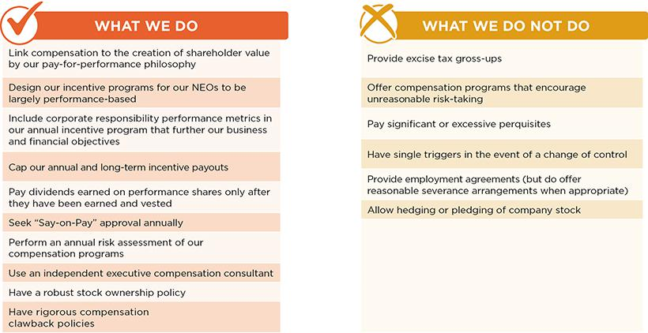

As required by Section 951 of Dodd-Frank and related SEC rules, you are being asked to approve an advisory resolution on the compensation of our named executive officers. This proposal, commonly known as a “say on pay” proposal, gives you the opportunity to endorse or not endorse our fiscal year 2025 compensation program and policies for our named executive officers as disclosed in this proxy statement. Although this advisory vote is non-binding, our Board and Compensation Committee will review the voting results and take them into account when considering future executive compensation arrangements. The next say-on-pay vote is scheduled for the 2027 Annual Meeting.

OUR BOARD RECOMMENDS A VOTE “FOR” APPROVAL, ON AN ADVISORY BASIS, OF THE

2025 COMPENSATION OF THE COMPANY’S NAMED EXECUTIVE OFFICERS AS DESCRIBED IN THIS PROXY STATEMENT UNDER THE HEADINGS “COMPENSATION DISCUSSION AND ANALYSIS” AND “EXECUTIVE COMPENSATION.”

REGENCY CENTERS | 2026 PROXY STATEMENT | 25

Table of Contents

| Compensation Discussion and Analysis

Compensation Discussion and Analysis

Letter from Our Compensation Committee Chair

On behalf of the Compensation Committee of the Board of Directors of Regency Centers, I am pleased to present an overview of the Company’s compensation programs and pay for our Named Executive Officers (NEOs) in 2025.

2025 marked another year of significant financial growth, operational achievements and investment success for Regency Centers, under the exceptional leadership of our executive team. The team achieved an impressive increase in Same Property Net Operating Income (NOI) of 5.3%, while Nareit Funds From Operations (FFO) per share grew by nearly 8% and Core Operating Earnings per share increased by nearly 7%. The Company executed 8 million square feet of new and renewal leases, achieving cash rent spreads of nearly 11% and GAAP rent spreads at a record 21%. Additionally, management started approximately $318 million in development and redevelopment projects, bringing three-year total starts to over $825 million. The Company also acquired approximately $538 million of high-quality shopping centers, significantly expanding our portfolio. These outstanding results enabled the Regency Centers Board of Directors to announce a dividend increase of over 7% on the Company’s common stock in the fourth quarter of 2025. With a premium portfolio of over 480 primarily grocery-anchored centers in thriving trade areas, an industry-leading balance sheet, and a talented team across 26 offices nationwide, Regency Centers is well-positioned to continue growing and building long term value for our shareholders.

The Compensation Committee ensures the interests of our executive team align with those of our shareholders by linking short- and long-term incentive compensation opportunities to the achievement of measurable financial and strategic goals. Our executive compensation programs are designed such that performance-based pay constitutes the significant majority of their total potential compensation. We set rigorous financial and non-financial targets to reward achievements as well as to retain, develop and motivate our key people.

The committee has historically focused on Core Operating Earnings per Share as the primary financial metric by which to measure the short-term performance of our top executives. We continue to believe it represents the best measure of operating and financial performance of the business and the Company.

The Company’s impressive performance in 2025 resulted in management achieving Core Operating Earnings per Share of $4.41. As a result, based on performance multipliers previously set by the committee, the executive team earned a short-term incentive payout of 1.50 times target. This multiple reflects meaningful financial outperformance by the Company against the objectives set by the committee, as discussed in more detail in the following Compensation, Discussion and Analysis (CD&A).

In addition, the Compensation Committee continued to emphasize corporate responsibility as the key non-financial performance metric, given its importance to the Company’s sustainable operational and financial success. The committee regularly reviews progress against management’s corporate responsibility objectives, which were measured both qualitatively and quantitatively, and determined that the executive team achieved its objectives in this area, as further described in the CD&A.

A significant portion of our NEOs’ target total direct compensation is paid in long-term incentives, and a significant portion of these long-term incentives is paid in performance shares tied to three-year relative total shareholder return (TSR), because we believe they appropriately align our executives with the interest of our shareholders in sustained financial performance and long-term value creation. Based on our relative TSR versus the FTSE Nareit shopping center index for the 2023 – 2025 performance period, our NEOs earned 90% of the target performance share award, as further described in the CD&A. While the Company performed extremely well during this period financially, operationally and with respect to its investments program, three-year relative TSR performance fell short in relation to the index. The outcome demonstrates the intended alignment our NEOs have with our shareholders. The Compensation Committee granted a new tranche of awards for the 2025 – 2027 performance period to continue to align executive long term compensation opportunities with the interests of our investors.

26 | REGENCY CENTERS | 2026 PROXY STATEMENT

Table of Contents

Compensation Discussion and Analysis |

As a committee, we approached our work in 2025 with the same robust governance and oversight we have always applied to our compensation responsibilities. We will continue to closely monitor our executive compensation programs, and balance our objective to incentivize, motivate and retain our NEOs while doing our best to align compensation outcomes with the interests of our investors. Our overarching objective is that our compensation programs drive the behaviors and results the Board expects and that are in the best interests of our Company and you, our shareholders.

I encourage all shareholders to read our CD&A. It provides an overview of our executive compensation programs and the underlying philosophy used to develop them, as well as information about the 2025 objectives the Compensation Committee set for our executive team. We appreciate the trust you have placed in us and thank you for your investment in Regency Centers.

Sincerely,

Deirdre J. Evens

Chair of Compensation Committee

REGENCY CENTERS | 2026 PROXY STATEMENT | 27

Table of Contents

| Compensation Discussion and Analysis

Our Named Executive Officers


Martin E. Stein, Jr. | Lisa Palmer | Michael J. Mas | Alan T. Roth | Nicholas A.
Executive Chairman | President and Chief | Executive Vice | East Region | Wibbenmeyer
of the Board | Executive Officer | President, Chief | President and Chief | West Region
 |  | Financial Officer | Operating Officer | President and Chief
 |  |  |  | Investment Officer

For information with respect to Mr. Stein and Ms. Palmer, please refer to Proposal 1: Election of Directors, in this proxy statement.

Michael J. Mas, age 50, has been our Executive Vice President, Chief Financial Officer since August 2019. Prior to that, Mr. Mas had served as Managing Director of Finance since February 2017. He served as Senior Vice President of Capital Markets from January 2013 to January 2017. Prior to that, Mr. Mas served as Vice President of Capital Markets and JV Portfolio Management from December 2004 to December 2012. Before joining our Company in 2003, he worked with Deloitte & Touche LLP as Manager for Assurance and Advisory services, supervising professional accountants providing client services in Southeast Florida. Mr. Mas holds a Bachelor of Business Administration from the University of North Florida and a M.B.A. from Florida Atlantic University. He is a member of ICSC and Nareit.

Alan T. Roth, age 51, has been our East Region President and Chief Operating Officer since January 2024. Before that, Mr. Roth served as our Executive Vice President, National Property Operations and East Region President from January 2023 to December 2023. Prior to that, Mr. Roth served as Senior Managing Director, East Region from September 2020 to December 2022. Prior to that, Mr. Roth served as Managing Director from January 2016 to September 2020. Prior to that, he served as Senior Vice President and Senior Market Officer of the Mid-Atlantic and Northeast Portfolio, overseeing more than eight million square feet at sixty-eight shopping centers. Before that, Mr. Roth held the position of Vice President and Regional Officer. Before joining our Company as a leasing agent in 1997, Mr. Roth handled tenant representation, shopping center leasing and land sales for Midland Development Group. Mr. Roth holds a Bachelor of Science from Kelley School of Business at Indiana University. He is a member of ICSC, serves on the Planning Committee for ICSC Open Air Conference and is a member of Nareit.

Nicholas A. Wibbenmeyer, age 45, has been our West Region President and Chief Investment Officer since January 2024. Before that,

Mr. Wibbenmeyer served as our Executive Vice President, West Region President from January 2023 to December 2023. Prior to that, Mr. Wibbenmeyer served as Senior Managing Director, West Region from September 2020 to December 2022. Prior to that, he served as Managing Director from January 2016 to September 2020. Prior to that, he served as Senior Vice President and Senior Market Officer. Before that, Mr. Wibbenmeyer held the position of Vice President of Investments and Regional Officer. Before joining our Company in 2005 as Manager of Investments, Upper Midwest, Mr. Wibbenmeyer served as a retail broker for Mid-America Real Estate Group. Mr. Wibbenmeyer holds a Bachelor of Business Administration from the University of Notre Dame. He is a member of ICSC, ULI and YPO.

Our Compensation Philosophy

Our compensation program is designed to attract, motivate and retain high-performing, industry-leading executives capable of driving achievement of our key financial and strategic objectives. We compensate our executives through a mix of base salary, annual cash incentives and long-term equity compensation, with an emphasis on the use of performance-based incentives as a very significant portion of total compensation. Our compensation program is designed to be competitive with comparable employers and to align the interests of management with our shareholders by awarding performance-based compensation to incentivize the achievement of specific key objectives.

28 | REGENCY CENTERS | 2026 PROXY STATEMENT

Table of Contents

Compensation Discussion and Analysis |

Oversight of Compensation

The Compensation Committee of our Board (“Compensation Committee” or “the committee”) is responsible for determining and implementing our executive compensation philosophy, designing our executive compensation program, evaluating compensation against the market and approving the material terms of executive compensation arrangements for our NEOs, including incentive plan participants, award opportunities, performance goals and compensation earned under our incentive plans. The committee routinely consults with its independent compensation consultant and other advisors in making its decisions, as it deems appropriate. The NEOs are not present during the committee’s discussions of their respective compensation. The committee is comprised entirely of independent directors as defined by Nasdaq Stock Market listing requirements.

The Compensation Committee evaluates the performance of both the Executive Chairman and the President & CEO and reviews such evaluation with the full Board. With respect to our other NEOs, the committee considers the input of the President & CEO as to their performance assessments and recommended compensation arrangements. The compensation of all NEOs is subject to the final approval of the committee, and compensation of both the Executive Chairman and President & CEO, respectively, is recommended by the committee to the full Board for its consideration and approval.

The committee utilizes outside advisors from Semler Brossy, the committee’s independent compensation consultant, to provide benchmarking, analysis, advice and counsel regarding competitive pay levels, pay program design and evolving trends and practices, primarily with respect to peers and REIT industry participants. Representatives from Semler Brossy attend meetings of the committee and participate in its executive sessions as requested and are available to communicate directly with the committee Chair and its members outside of meetings.

The Compensation Committee considers all factors relevant to the consultant’s independence from management, including those identified by Nasdaq Stock Market listing requirements, and has determined that Semler Brossy has no conflicts of interest and is independent.

2025 Say on Pay Results and Shareholder Engagement

Our Board and Compensation Committee value the views and input of our shareholders and are committed to ongoing engagement on executive compensation practices. The committee specifically considers the results from the annual shareholder advisory vote on executive compensation. At the Company’s 2025 annual meeting of shareholders, about 92% of the votes on the advisory resolution on executive compensation were cast in favor of our executive compensation. We believe these very favorable voting results and similar results over the past several years for our Say on Pay vote demonstrate continued strong shareholder support for our programs and their implementation.

Targeted Level of Compensation

We endeavor to set total direct compensation, which consists of base salary, annual cash incentives and the value of long-term (equity-based) incentives, at target performance levels in range of the expected median of peer companies, as described on the following page, while also taking into account various factors including the experience level and responsibilities of each individual executive and competitive market conditions. Annual increases in base salary, cash incentives, long term incentives and total direct compensation may be more robust when total direct compensation is below the median, and more moderated when it is more than 10% above the median or exceeds the 60th percentile for the peer group. Actual compensation earned by our top executives, including our NEOs, can be highly variable from year to year due to heavy weighting toward performance-based incentive compensation rather than fixed components.

REGENCY CENTERS | 2026 PROXY STATEMENT | 29

Table of Contents

| Compensation Discussion and Analysis

To evaluate and set total direct compensation, the committee utilizes a peer group analysis of total direct compensation for similar positions prepared annually by the committee’s independent compensation consultant. The key principals by which the peer group is selected and annually updated are that companies be leaders in the REIT industry (but not limited to the shopping center sector) and comparable in size, generally based on total market capitalization ranging from half to double our size. Working with the committee’s independent compensation consultant, the committee evaluates the appropriateness of the group annually based on a variety of factors, including merger and acquisition and other similar corporate changes, company size and asset class focus, and adjusts the peer group as the committee deems appropriate after considering the facts and circumstances. After evaluating the peer group for 2026, the committee removed Kilroy Realty and replaced it with AvalonBay Communities to maintain a balanced, appropriately comparable peer group for Regency.

 | Reviewed in 2024 for | Reviewed in 2025 for
Peer Company | Setting 2025 Compensation | Setting 2026 Compensation

Agree Realty Corporation

American Homes 4 Rent

AvalonBay Communities, Inc.

Boston Properties, Inc.

Brixmor Property Group, Inc

Camden Property Trust

Equity Lifestyle Properties, Inc.

Essex Property Trust, Inc.

Federal Realty Investment Trust

Host Hotels & Resorts, Inc.

Invitation Homes Inc.

Kilroy Realty Corporation

Kimco Realty Corporation

Kite Realty Group Trust

NNN REIT, Inc. (formerly National

Retail Properties, Inc.)

Sun Communities, Inc.

The Macerich Company

UDR, Inc.

Vornado Realty Trust

30 | REGENCY CENTERS | 2026 PROXY STATEMENT

Table of Contents

Compensation Discussion and Analysis |

Compensation Committee Actions & Decisions

During 2025 and early 2026, the Compensation Committee took the following actions and made the following decisions:

Assessed 2025 performance and approved annual incentives for NEOs


Reviewed the overall executive compensation philosophy for the Company, in preparation for 2026 program design consideration

In conjunction with Nominating and Governance Committee, agreed on corporate responsibility metrics to be included in the 2026 annual incentive plan

Approved payouts for the 2023 – 2025 long-term performance unit incentive plan based on relative TSR

Determined 2026 short- and long-term incentive plans and targets for NEOs

Reviewed market competitiveness and adjusted NEO base salaries for 2025 and 2026

Benchmarked, reviewed and modified the peer group to assist in making 2026 compensation decisions

Reviewed independent director compensation and recommended changes for 2026 to the Board

Elements of Compensation

In designing our compensation program, we believe the pay of our NEOs should be predominantly performance-based because these individuals have the greatest ability to drive our Company’s operating and financial results and, therefore, value creation for our shareholders. The charts below summarize the designed allocation of the 2025 target compensation opportunity for our President and CEO and our other NEOs (excluding our Executive Chairman), respectively, based upon the three primary components of our NEO compensation program (base salary, annual cash incentive and long-term incentive).
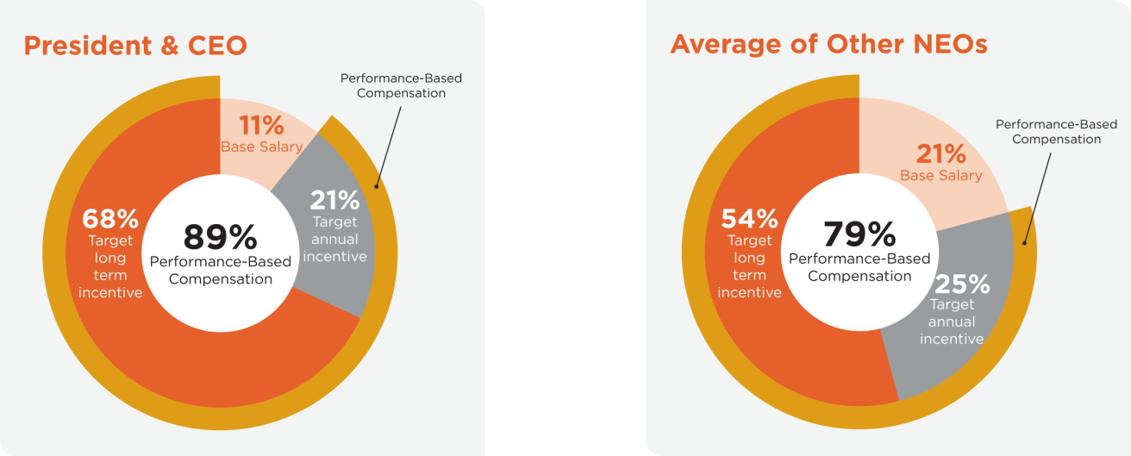

REGENCY CENTERS | 2026 PROXY STATEMENT | 31

Table of Contents

| Compensation Discussion and Analysis

Base Salary

Base salaries are reviewed annually. Several factors are considered in determining salary adjustments, including market competitiveness, the roles and responsibilities of the executives, individual contributions to the Company’s success, an analysis of position requirements and the executives’ prior experience and accomplishments. Slightly larger increases for Mr. Roth and Mr. Wibbenmeyer were intended to align them more closely with market pay for comparable senior leadership positions.

Named Executive Officers | 2024 Base Salary | 2025 Base Salary | % Increase
Martin E. Stein, Jr. | $500,000 | $500,000 | 0.0%
Executive Chairman | $500,000 | $500,000 | 0.0%
Lisa Palmer | $1,030,000 | $1,050,000 | 1.9%
President and Chief Executive Officer | $1,030,000 | $1,050,000 | 1.9%
Michael J. Mas | $620,000 | $640,000 | 3.2%
Executive Vice President, Chief Financial Officer | $620,000 | $640,000 | 3.2%
Alan T. Roth | $600,000 | $625,000 | 4.2%
East Region President and Chief Operating Officer | $600,000 | $625,000 | 4.2%
Nicholas A. Wibbenmeyer | $600,000 | $625,000 | 4.2%
West Region President and Chief Investment Officer | $600,000 | $625,000 | 4.2%

Annual Cash Incentives — Overview

The Compensation Committee sets rigorous performance goals to align pay with performance. A number of factors are considered, including prior year performance, current business and economic environment, competitive compensation benchmarking, peer performance and the Company’s key financial and strategic objectives. The Company pays an annual cash incentive based on achievement of specified key corporate objectives. For 2025, the annual cash incentive framework for our NEOs was based 80% on Core Operating Earnings per Share and 20% on achievement of corporate responsibility objectives except for Mr. Stein, who, as Executive Chairman, did not have an annual cash incentive opportunity in 2025.

Core Operating Earnings per Share

The Compensation Committee believes that Core Operating Earnings per Share is the financial metric most representative of management’s ability to achieve the Company’s annual financial plan, as reviewed and approved by our Board, and the Company’s ability to make distributions to shareholders on a sustainable basis. It also serves as an important indicator of growth in our net asset value. The performance criteria for the Core Operating Earnings per Share metric are set forth in the following table. Performance between levels are interpolated, and payouts for performance below the “Low” performance level, if any, would be made only at the discretion of the Compensation Committee.

In addition, to incentivize our NEOs to act in the long-term interests of the Company and its shareholders, the committee may exercise its discretion to modify the calculation of Core Operating Earnings per Share so as not to penalize (or overly-benefit) our NEOs for taking actions that may have a negative (or positive) impact on Core Operating Earnings per Share in the short term, such as the sale of assets and debt reduction, but are beneficial to the Company’s long-term positioning and prospects.

32 | REGENCY CENTERS | 2026 PROXY STATEMENT

Table of Contents

Compensation Discussion and Analysis |

2025 Performance Criteria for Annual Cash Incentive

Core Operating Earnings per Share (80% Weight at Target)

 | Multiple of | 2025
 | Multiple of | Core Operating
Performance Level | Target | Earnings Per Share
Maximum | 2.00 | $4.51
 | 1.50 | $4.41
 | 1.20 | $4.35
Target | 1.00 | $4.27
 | 0.75 | $4.17
Underperform | 0.50 | $4.07
Below Underperform | Determined at the discretion | <$4.07
Below Underperform | of the Compensation Committee | <$4.07

Corporate Responsibility

The Company’s commitment to its Four Pillars of Corporate Responsibility is discussed on page 5. Premised on Regency’s Core Values (see page 1), the Compensation Committee believes these to be integral to the Company’s business strategy and financial performance, as well as our ongoing and future success. As such, annual progress towards corporate responsibility objectives is measured by the committee (with input from the Board’s Nominating and Governance Committee), and 20% of our NEOs’ annual incentive is tied to their achievement. The corporate responsibility portion of the annual incentive is paid out at target if achievement of appropriate progress toward corporate responsibility objectives is achieved. In addition, because of the committee’s view of the relationship of corporate responsibility progress to asset and business sustainability and financial performance, in the event appropriate progress is at or above target and there is outperformance of the key financial metrics, the corporate responsibility portion of the annual incentive is awarded at the same multiple as such metrics – in this case, for Core Operating Earnings per Share for NEOs. In the event that the key financial metrics pay out at less than target, then the corporate responsibility portion of the annual incentive will not pay out at more than target. The committee considers qualitative and quantitative measures of progress in evaluating progress toward our corporate responsibility objectives.
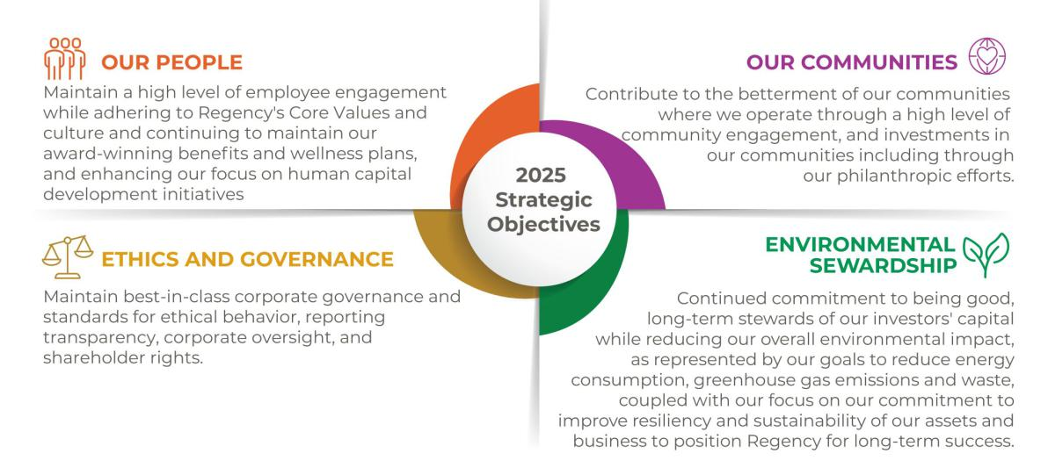

REGENCY CENTERS | 2026 PROXY STATEMENT | 33

Table of Contents

| Compensation Discussion and Analysis

The committee solicits data and other information from senior management to use in forming its own view of the Company’s performance against specific Corporate Responsibility objectives, as well as from the Nominating and Governance Committee, which has been delegated oversight responsibilities by the Board over the Company’s Corporate Responsibility program and initiatives.

Annual Incentive — 2025 Results v. 2025 Incentive Plan Goals

Led by our NEOs, the Company enjoyed meaningful outperformance in Core Operating Earnings per Share. Performance results and the resulting cash awards are presented in the following tables.

2025 Performance Results for Annual Cash Incentives*

 | Performance | Resulting Multiple of
Performance Metric | Level | Target Earned
Core Operating Earnings Per Share | $4.41 | 1.50
Corporate Responsibility (ESG) | Achieved | 1.50

* See discussion on pages 32 and 33.

2025 Cash Targets and Resulting Cash Incentives Earned

 |  | Target |  |  |  | Actual
 |  |  |  |  | Core Operating
 |  |  | Total |  | Earnings Per | Corporate | Total Actual
 | Core Operating | Corporate | Annual |  | Share: | Responsibility | Cash
 | Earnings Per | Responsibility | Incentive |  | Actual | Actual Cash | Incentive
Name | Share: Target | Target | Target |  | Cash Earned | Earned | Earned
Martin E. Stein, Jr.⁽¹⁾ | $0 | $0 | $0 |  | $0 | $0 | $0
Lisa Palmer | $1,560,000 | $390,000 | $1,950,000 |  | $2,340,000 | $585,000 | $2,925,000
Michael J. Mas | $820,000 | $205,000 | $1,025,000 |  | $1,230,000 | $307,500 | $1,537,500
Alan T. Roth | $500,000 | $125,000 | $625,000 |  | $750,000 | $187,500 | $937,500
Nicholas A. Wibbenmeyer | $500,000 | $125,000 | $625,000 |  | $750,000 | $187,500 | $937,500

(1) Mr. Stein’s compensation package does not currently provide him with an annual cash incentive opportunity.

Long-Term Incentives — Overview

The Compensation Committee believes that equity awards with multi-year performance and vesting periods reinforce the alignment of the interests of executives with shareholder value creation. As such, our long-term incentive awards are structured in this way for NEOs. We also have the ability under our Omnibus Incentive Plan to grant various types of equity awards, including restricted stock awards and performance share awards, to provide incentives for NEOs and others in management to work to create shareholder value over the long-term. In addition, the multi-year nature of the performance and vesting periods encourages retention of our executives.

The committee has authority and flexibility to determine eligible participants, the types and terms and conditions of awards. Awards are structured consistent with our compensation philosophy in that they provide opportunities for achievement and exceedance of the Company’s performance expectations. In 2025, the committee used two different types of stock-based awards to promote equity ownership by the participants and to emphasize the importance of relative total shareholder return. Performance share awards are earned subject to the achievement of performance goals approved by the committee as described below. Restricted share awards are earned subject to the participant’s continued employment with us.

2025 Long-Term Incentive Weighting at Target

Long-Term Incentive Component | NEOs at Target
Performance Shares: 2025 – 2027 Relative Total Shareholder Return (TSR) | 80%
Time-based Restricted Shares | 20%

34 | REGENCY CENTERS | 2026 PROXY STATEMENT

Table of Contents

Compensation Discussion and Analysis |

Long-Term Incentives — Performance Shares

Performance goals are established for a multi-year performance period to tie incentive compensation to long-term results. Following the end of the period, performance is calculated versus targets and reviewed by the Compensation Committee, awards are determined, and the corresponding number of shares vest. Dividend equivalents are accrued during the performance period and will vest when the underlying share award vests. No shares or dividends are earned if performance levels are not achieved at or in excess of threshold levels.

2025 Performance Share Awards

Performance shares awarded in 2025 are based on relative total shareholder return goals over the 2025 – 2027 performance period. We believe total shareholder return is akin to a scorecard for our investors, and it is a discerning measure of how our executives and our Company have performed over an extended period.

The performance share goals for the 2025 long-term incentive plan, which are set in relation to the FTSE Nareit Equity Shopping Centers Index, are outlined below and articulated in terms of three-year aggregate performance. Total shareholder return considers stock price growth as well as reinvestment of dividends. Performance between levels will be interpolated and the determination of the vesting of such performance shares will take place after the end of 2027.

2025 – 2027 Performance Criteria for Total Shareholder Return

(Relative to FTSE Nareit Equity Shopping Centers Index)

 | Performance | Multiple of
Cumulative 3-Year Performance vs. Index | Level | Target
+20% | Maximum | 2.00
+10% |  | 1.50
0% | Target | 1.00
-10% |  | 0.50
-20% | Threshold | 0.00

Performance shares awarded to our NEOs in 2023, 2024 and 2025, respectively, are set forth in the table for outstanding equity awards at fiscal year-end 2025 on page 42 in this proxy statement.

The performance shares awarded for the 2023 – 2025 performance period were measured based on the same performance criteria as the 2025 – 2027 awards. Our NEOs earned 90% of the target performance share award, which was based upon total shareholder return for the 2023 – 2025 performance period versus the FTSE Nareit Equity Shopping Centers Index. Our relative total shareholder return for this performance period was 21% versus 23% for the FTSE Nareit Equity Shopping Centers Index.

Scorecard for Relative Total Shareholder Return Performance

 | FTSE Nareit Equity |  | % of Target
Performance Period | Shopping Centers | Regency | Payout
2021—2023 | 58% | 59% | 105%
2022—2024 | 21% | 15% | 70%
2023—2025 | 23% | 21% | 90%

REGENCY CENTERS | 2026 PROXY STATEMENT | 35

Table of Contents

| Compensation Discussion and Analysis

Long-Term Incentives — Restricted Shares / Stock Rights Awards

A restricted share award is a grant of stock that vests based on continued service over time. Restricted shares are used to motivate and retain employees as well as promote employee stock ownership. The restricted share awards we grant are time-based and vest in equal installments over a four-year period, subject to continued employment with Regency. We also refer to them as “stock rights awards” because we do not issue the shares until the vesting conditions have been satisfied. We do not currently use stock options, stock appreciation rights, or similar option-like instruments as part of our compensation package. Our stock-based awards are full-value shares that vest based upon continued service.

Name Grant Value

In February 2025, we granted restricted shares to Mr. Stein, Ms. Palmer, Mr. Mas, Mr. Roth and Mr. Wibbenmeyer representing 20% of their total 2025 long-term equity incentive target as follows:

Martin E. Stein, Jr. | $150,000
Lisa Palmer | $1,250,000
Michael J. Mas | $392,000
Alan T. Roth | $300,000
Nicholas A. Wibbenmeyer | $300,000

Restricted shares awarded to our NEOs in 2025 are set forth in the Grant of Plan Based Awards table on page 41 in this proxy statement.

401(k) Profit-Sharing Plan

We encourage all employees to save for retirement. To provide employees with the opportunity to save for retirement on a tax-deferred basis, we sponsor a 401(k) profit-sharing plan pursuant to which we match employee contributions at 100% up to $5,000 for 2025. The Compensation Committee has the right to approve additional contributions in its discretion, as it deems appropriate.

For 2025, because of the Company’s strong financial performance, the Compensation Committee approved an incremental discretionary profit-sharing award totaling $3.5 million, and the pool of funds is distributed pro-rata to all eligible employees subject to the application of a presumed salary cap of $76,000. We review our Company match, employee participation levels and communication programs throughout the year to ensure that this benefit remains competitive with comparable companies as well as national benchmarks.

Compensation on Termination of Employment

While we do not offer employment agreements to our NEOs, we believe providing severance protection is important for retention purposes, as many companies that we compete with for talent offer it, particularly in connection with a change of control. Accordingly, our NEOs have severance and change of control agreements that provide the right to receive severance compensation if they are terminated without cause or they leave for good reason, as such terms are defined in the agreements. In a change of control situation, the agreements provide for severance using a “double trigger,” i.e., severance is payable only if a change of control occurs and the officer is terminated without cause or leaves for “good reason” (as described under Executive Compensation – Potential Payments Upon Termination or Change-in-Control on page 44) within two years after the change of control. We believe that such compensation gives our named executive officers incentive (1) to stay with the Company despite the possibility of losing employment after a change of control and (2) to focus on obtaining the best possible value for shareholders in a change of control transaction.

The agreements also provide that severance payments are subject to recoupment as required by any recoupment or “clawback” policy approved by our Board or similar requirement imposed by law. The Company has robust executive compensation clawback policies; see “Recoupment/Clawback Policies” in the next section.

For details on compensation on termination of employment, including death, disability and retirement, see “Executive Compensation – Potential Payments Upon Termination or Change-in-Control” on page 44 of this proxy statement.

36 | REGENCY CENTERS | 2026 PROXY STATEMENT

Table of Contents

Compensation Discussion and Analysis |

Recoupment/Clawback Policies

The Board has approved and the Company has implemented a Restatement Clawback Policy (the “Restatement Clawback Policy”), a copy of which has been filed with the Company’s annual report on Form 10-K and which also can be located on our website at https://investors.regencycenters.com. The Restatement Clawback Policy (with all capitalized but undefined terms in this paragraph used as defined in the Restatement Clawback Policy) has been drafted to comply with the requirements of the applicable rules of the SEC, including, without limitation, Rule 10D-1 promulgated under the Securities Exchange Act of 1934, as amended, and applicable listing standard of the Nasdaq Stock Market, the exchange on which the Company is listed. Under the Restatement Clawback Policy, if the Company issues an accounting restatement of its financial statements due to the Company’s material noncompliance with any financial reporting requirement under U.S. securities laws, the Board (or committee of the Board designated by the Board) shall, unless the Board or a Board committee determines it to be Impracticable, take reasonably prompt action to recoup all Recoverable Compensation received by Covered Persons during the Applicable Period. Pursuant to the Restatement Clawback Policy, the Company is not permitted to indemnify any Covered Person for any compensation that the Covered Person is required to reimburse or forfeit pursuant to the Policy.

In addition to the Restatement Clawback Policy, under a separate Misconduct Clawback Policy, if the Board or applicable committee determines that any officer of the Company has committed an act or acts constituting fraud, gross negligence or intentional misconduct, the Board or committee has the authority in its sole discretion, upon evaluating the associated costs and benefits, to recover any incentive compensation received by any covered person during the three fiscal years preceding the period from the date on which the misconduct first occurred or thereafter, calculated on a pre-tax basis. Recovery of such incentive compensation shall not be the Company’s exclusive remedy for any such misconduct.

In making any such determination relating to clawback of incentive compensation under the Misconduct Clawback Policy, the Board or applicable committee may consider such factors as it deems appropriate, including, without limitation (1) the practicability of obtaining such recovery and the costs to the Company and/or its shareholders of pursuing such recovery, (2) the likelihood of success of enforcement under governing law versus the cost and effort involved, (3) whether the assertion of a claim may prejudice other interests of the Company, including in any related proceeding or investigation,

- any pending legal proceeding relating to any applicable fraud gross negligence or intentional misconduct, and (5) any other factors deemed relevant by the Board or committee.

Risk Consideration in our Compensation Program

The Compensation Committee and Board believe that our compensation policies and practices are reasonable and align our employees’ interests with those of our shareholders. In addition, the committee and Board believe that our compensation policies and practices are not reasonably likely to have a material adverse effect on the Company. The committee believes that the fact that our executive officers have their annual and long-term incentive compensation tied to financial metrics and corporate responsibility objectives (in the case of annual incentives), as well as relative total shareholder return (in the case of long-term incentive awards) as compared to a peer group index, encourages actions that focus on both annual and longer-term profitability and value creation for the benefit of shareholders. Our stock ownership policy and our policy prohibiting hedging and pledging transactions relating to our Company stock further align the interest of our senior officers with the long-term interests of our shareholders. Moreover, there are significant checks in place within our compensation structure so that employees whose compensation may have a shorter-term focus are closely managed by employees and officers whose compensation is in large part based on the Company’s and its shareholders’ interests over the long term.

Compensation Committee Interlocks and Insider Participation

During the last fiscal year, no member of the Compensation Committee had a relationship with Regency that required disclosure under Item 404 of Regulation S-K. No executive officer of the Company served as: (i) a member of the Compensation Committee of another entity, one of whose executive officers served on the Compensation Committee of the Company; (ii) a member of the Board of Directors of another entity, one of whose executive officers served on the Compensation Committee of the Company; or (iii) a member of the Compensation Committee of another entity, one of whose executive officers served on the Board of the Company. None of the members of our Compensation Committee is an officer or employee of our Company, nor have they ever been an officer or employee of our Company.

REGENCY CENTERS | 2026 PROXY STATEMENT | 37

Table of Contents

| Compensation Discussion and Analysis

Stock Ownership Policy

Our stock ownership policy is designed to focus our senior officers and directors on long-term shareholder value creation. Our policy sets stock ownership targets for senior officers as a multiple of base salary and for non-employee directors as a multiple of their annual retainer (exclusive of fees for committee service).
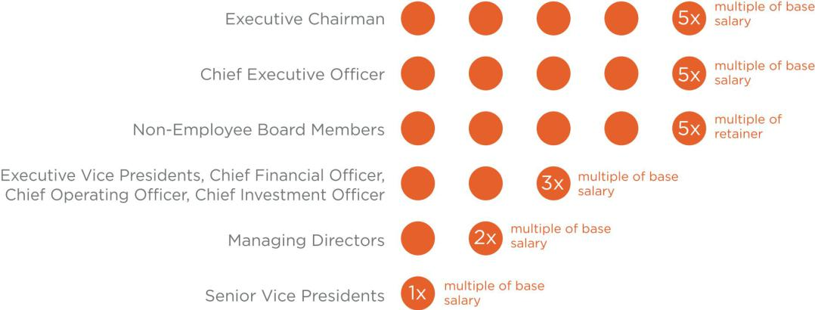

The targets, which are measured based on the Company’s trailing 36-month average common stock price, are to be achieved by directors and senior officers over a maximum five-year period. Our stock ownership policy also requires all covered participants to retain 25% of the shares they receive as direct compensation (on a pre-tax basis) after being hired, promoted or elected into such positions so long as they remain a senior officer or director. With respect to Senior Vice Presidents, the retention requirement only applies until the Senior Vice President meets his or her stock ownership target.

Policy Prohibiting Hedging and Pledging of Our Stock

We have adopted a stringent policy that prohibits our officers and directors from engaging in hedging transactions or arrangements designed to lock in the value of their holdings of our securities, as well as short sales and the trading of options in our securities. This prevents our officers and directors from engaging in transactions involving our securities without having the full risks and rewards of ownership.

We also prohibit our officers and directors from holding our securities in a margin account or pledging our securities as collateral for a loan.

Policy Statement on Insider Trading

We have adopted a Policy Statement on Insider Trading that governs the purchase, sale, and/or other dispositions of our securities by directors, officers and employees that is reasonably designed to promote compliance with insider trading laws, rules and regulations and Nasdaq Stock Market listing standards.

Deductibility of Compensation

To the extent allowable by applicable law, executive compensation will be deductible by the Company for federal income tax purposes. However, the Compensation Committee may design compensation program components that are not deductible. In addition, in December 2020, the Internal Revenue Service released final regulations under Internal Revenue Code (IRC) section 162(m), which limit the deductibility of certain executive compensation amounts. Because we intend to qualify as a REIT under the IRC, we generally distribute 100% of our net taxable income each year and, as a result, do not pay U.S. federal income tax. As such, we do not expect limitations on executive compensation deductions to have a material impact on us. In addition, we expense base salaries and annual bonuses awarded in the year they are earned. In accordance with Accounting Standards Committee (ASC) Topic 718, we expense the value of equity awards granted over the vesting period of such grants.

38 | REGENCY CENTERS | 2026 PROXY STATEMENT

Compensation Committee Report |

Compensation Committee Report

The following Report of our Compensation Committee (this “Compensation Committee Report”) does not constitute soliciting material and should not be deemed filed or incorporated by reference into any other previous or future filings by us under the Securities Act of 1933, as amended (the Securities Act), or the Exchange Act, except to the extent that we specifically incorporate this Compensation Committee Report by reference therein.

For the year ended December 31, 2025, the Compensation Committee reviewed and discussed the Compensation Discussion and Analysis section of this proxy statement with our management. Based on this review and discussion, the Compensation Committee recommended to our Board that the Compensation Discussion and Analysis be included in this proxy statement.

Submitted by the Compensation Committee of the Board of Regency Centers Corporation.

Deirdre J. Evens, Chair

Gary E. Anderson
C. Ronald Blankenship

Kristin A. Campbell

REGENCY CENTERS | 2026 PROXY STATEMENT | 39

| Executive Compensation

Executive Compensation

Summary Compensation Table

The following table summarizes the compensation of each named executive officer (“NEO”) for 2025, 2024 and 2023. The amounts reported for stock awards may not represent the amounts that the NEOs will actually realize from the awards. Whether, and to what extent, a named executive officer realizes value will depend on Regency’s performance, stock price and continued employment.

SUMMARY COMPENSATION TABLE FOR 2025

 |  |  |  | Non-Equity
 |  |  | Stock | Incentive Plan | All Other
Name and Principal Position⁽¹⁾ | Year | Salary | Awards⁽²⁾ | Compensation⁽³⁾ | Compensation⁽⁴⁾ | Total
Martin E. Stein, Jr. | 2025 | $500,000 | $851,905 | $0 | $40,828 | $1,392,733
Executive Chairman | 2024 | $500,000 | $712,882 | $0 | $40,628 | $1,253,510
of the Board | 2023 | $500,000 | $1,034,858 | $0 | $40,728 | $1,575,586
Lisa Palmer | 2025 | $1,050,000 | $7,099,098 | $2,925,000 | $18,334 | $11,092,432
President and Chief | 2024 | $1,030,000 | $5,702,941 | $2,805,000 | $21,322 | $9,559,263
Executive Officer | 2023 | $1,000,000 | $5,536,318 | $2,712,500 | $20,217 | $9,269,035
Michael J. Mas | 2025 | $640,000 | $2,226,325 | $1,537,500 | $15,574 | $4,419,399
Executive Vice President, | 2024 | $620,000 | $1,805,910 | $1,470,000 | $15,630 | $3,911,540
Chief Financial Officer | 2023 | $600,000 | $1,759,195 | $1,116,000 | $17,078 | $3,492,273
Alan T. Roth | 2025 | $625,000 | $1,703,810 | $937,500 | $21,438 | $3,287,748
East Region President and | 2024 | $600,000 | $1,330,713 | $900,000 | $14,270 | $2,844,983
Chief Operating Officer | 2023 | $500,000 | $1,134,858 | $775,000 | $17,126 | $2,426,984
Nicholas A. Wibbenmeyer | 2025 | $625,000 | $1,703,810 | $937,500 | $14,470 | $3,280,780
West Region President and | 2024 | $600,000 | $1,330,713 | $900,000 | $13,580 | $2,844,293
Chief Investment Officer | 2023 | $500,000 | $1,134,858 | $775,000 | $13,680 | $2,423,538

- Alan T. Roth was promoted to Senior Managing Director, East Region effective January 1, 2022 and was again promoted to Executive Vice President, National Property Operations and East Region President, effective January 1, 2023. He was then appointed on January 1, 2024 to East Region President and Chief Operating Officer. Nicholas A. Wibbenmeyer was promoted to Executive Vice President, West Region President, effective January 1, 2023 and was then appointed on January 1, 2024 to West Region President and Chief Investment Officer.

- The amounts in this column represent the aggregate grant date fair value computed in accordance with FASB ASC Topic 718 for restricted share awards and performance-based and market-based performance share awards. We use a Monte Carlo simulation model to value market-based awards, i.e., for performance awards tied to relative total shareholder return. Our model estimates the fair value of the award based on our data and that of the FTSE Nareit Equity Shopping Centers Index.

2025 Stock Awards. The goals for performance share awards granted in 2025 based upon total shareholder return are entirely market-based as compared to other publicly traded companies in our sector, as represented by the FTSE Nareit Equity Shopping Centers Index.

The awards granted on February 4, 2025, assumed (a) stock price volatility of 23.8% for Regency and 23.3% for the index, (b) risk-free interest rates of 4.25%, (c) Regency’s beta versus the index of 0.941, and (d) no dividend yield assumption given that the award includes dividend equivalents that are earned only to the extent that the underlying shares are earned. Based on the performance goals and these capital market assumptions, the market-based awards issued on February 4, 2025, were valued at $83.97 per share using the Monte Carlo model.

The 2025 stock awards also include the grant date fair value of restricted share awards to Ms. Palmer and Messrs. Stein, Mas, Roth and Wibbenmeyer.

- The amounts in this column represent the annual cash bonus payable for 2025 performance as discussed in the CD&A on page 34.

- The amounts in this column for 2025 consist of the following: (a) a $12,400 contribution to our 401(k) and profit-sharing plan for each NEO; (b) life insurance premiums of $28,428 for Mr. Stein, $5,934 for Ms. Palmer, $3,174 for Mr. Mas and Mr. Roth, and $2,070 for Mr. Wibbenmeyer; and (c) executive physical reimbursements of $5,864 for Mr. Roth.

Grants of Plan-Based Awards

As described in the Compensation Discussion & Analysis section of this proxy statement, annual cash incentive awards under our 2025 incentive plan were based on Core Operating Earnings per Share and achievement of our Corporate Responsibility objectives by our NEOs during the year ended December 31, 2025. Mr. Stein’s compensation package does not currently provide him with an annual cash incentive opportunity. As determined by the Compensation Committee, annual cash incentive awards were awarded at 1.5 times the target level under the 2025 annual incentive plan.

40 | REGENCY CENTERS | 2026 PROXY STATEMENT

Executive Compensation |

Equity awards that may be earned under our 2025 long-term incentive plan are issued under our Omnibus Incentive Plan. Our 2025 incentive plan provides for issuance to the NEOs of performance share awards that are based on specified thresholds for relative total shareholder return during 2025 through 2027.

Each performance share award provides for a specific number of shares depending on the extent to which the performance levels are achieved. No performance shares will be earned if the threshold levels are not achieved. Earned awards will vest, if at all, at the end of the performance period, and will be paid in shares. Dividend equivalents will vest when the underlying share award vests and will be paid in shares, as if dividends paid on unvested shares at the same rate as paid on our common stock were reinvested annually.

The following table sets forth information about plan-based awards granted to our NEOs during 2025, all of which were made under our 2025 incentive plan. Threshold amounts reflect the amounts that can be earned at minimum performance by our NEOs.

GRANTS OF PLAN BASED AWARDS DURING 2025

 |  | Estimated Possible Payouts Under |  |  |  | Estimated Future Payouts
 |  | Non-Equity Incentive Plan |  |  |  | Under Equity Incentive Plan
 |  |  | Awards |  |  |  | Awards |  |  | All Other | Grant
 |  |  |  |  |  |  |  |  |  | Stock | Date
 | Grant Date |  |  |  |  |  |  |  |  | Awards: | Fair
 | of Equity |  |  |  |  |  |  |  |  | # | Value
 | Incentive | Threshold | Target | Maximum |  | Threshold | Target | Maximum |  | of Shares | of Stock
Name | Plan Awards | ($) | ($) | ($) |  | (#) | (#) | (#) |  | of Stock | Awards
Martin E. Stein. Jr. | 2/4/25 | — | — | — |  | — | — | — |  | — | —
 | 2/4/25⁽¹⁾ | — | — | — |  | 4,180 | 8,359 | 16,718 |  | — | $701,905⁽²⁾
 | 2/4/25⁽³⁾ | — | — | — |  | — | — | — |  | 2,090 | $150,000⁽³⁾
Lisa Palmer | 2/4/25⁽⁴⁾ | $975,000 | $1,950,000 | $3,900,000 |  | — | — | — |  | — | —
 | 2/4/25⁽¹⁾ | — | — | — |  | 34,829 | 69,657 | 139,314 |  | — | $5,849,098⁽²⁾
 | 2/4/25⁽³⁾ | — | — | — |  | — | — | — |  | 17,414 | $1,250,000⁽³⁾
Michael J. Mas | 2/4/25⁽⁴⁾ | $512,500 | $1,025,000 | $2,050,000 |  | — | — | — |  | — | —
 | 2/4/25⁽¹⁾ | — | — | — |  | 10,923 | 21,845 | 43,690 |  |  | $1,834,325⁽²⁾
 | 2/4/25⁽³⁾ | — | — | — |  | — | — | — |  | 5,461 | $392,000⁽³⁾
Alan T. Roth | 2/4/25⁽⁴⁾ | $312,500 | $625,000 | $1,250,000 |  | — | — | — |  | — | —
 | 2/4/25⁽¹⁾ | — | — | — |  | 8,359 | 16,718 | 33,436 |  | — | $1,403,810⁽²⁾
 | 2/4/25⁽³⁾ | — | — | — |  | — | — | — |  | 4,179 | $300,000⁽³⁾
Nicholas A. Wibbenmeyer | 2/4/25⁽⁴⁾ | $312,500 | $625,000 | $1,250,000 |  | — | — | — |  | — | —
 | 2/4/25⁽¹⁾ | — | — | — |  | 8,359 | 16,718 | 33,436 |  | — | $1,403,810⁽²⁾
 | 2/4/25⁽³⁾ | — | — | — |  | — | — | — |  | 4,179 | $300,000⁽³⁾

- The amounts shown represent the range of stock awards that may be earned under our 2025 long-term incentive plan during 2025 through 2027 based on relative total shareholder return as against the FTSE Nareit Equity Shopping Centers Index. The threshold level represents 50% of target, but there can be a payout interpolated between 0% and 50% depending on performance. The amounts are based upon $71.78, which was the closing market price per share of our common stock on the grant date. Any earned award, together with dividend equivalents on the earned awards, will vest on February 4, 2028, and be paid in shares. For additional information, see “Compensation Discussion and Analysis” in this proxy statement.

- We use a Monte Carlo simulation model to value market-based awards, i.e., for performance awards based upon relative total shareholder return. Our model estimates the fair value of the award based on our data and that of the FTSE Nareit Equity Shopping Centers Index. The February 4, 2025 awards assumed (a) stock price volatility of 23.8.% for Regency and 23.3% for the index,
(b) risk-free interest rates of 4.25%, (c) Regency’s beta versus the index of 0.941, and (d) no dividend yield assumption given that the award includes dividend equivalents that are earned only to the extent that the underlying shares are earned. Based on the performance goals and these capital markets assumptions, the market-based awards granted on February 4, 2025 were valued at $83.97 per share on the probable outcome of the performance conditions as of the grant date of such awards (which was at target) and were determined as of the grant date using the Monte Carlo model.

- The amounts shown are for restricted share awards granted in 2025 that vest 25% per year over four years beginning in 2026.
- The amount shown represents the range of possible cash incentive awards that could have been earned under our 2025 incentive plan for our Core Operating Earnings per Share and Corporate Responsibility performance in 2025.

REGENCY CENTERS | 2026 PROXY STATEMENT | 41

| Executive Compensation

Outstanding Equity Awards

The following table sets forth information about outstanding equity awards held on December 31, 2025 by our NEOs. The amounts include unvested dividend equivalent units earned as of December 31, 2025.

OUTSTANDING EQUITY AWARDS AT FISCAL YEAR END 2025

 |  |  |  | Stock Awards
 |  |  | Equity Incentive | Equity Incentive
 |  |  | Plan Awards: | Plan Awards:
 |  |  | Number of Unearned | Market or Payout
 | Number of Shares | Market Value of | Shares, Units or | Value of Unearned
 | or Units of Stock | Shares or Units of | Other Rights That | Shares, Units or
 | That Have Not | Stock That Have | Have Not Vested | Other Rights That
Name | Vested (#)⁽¹⁾ | Not Vested ($)⁽²⁾ | (#) | Have Not Vested ($)⁽²⁾
Martin E. Stein, Jr. | 18,819 | $1,299,076 | 10,345⁽³⁾ | $714,115
 |  |  | 12,908⁽⁴⁾ | $891,039
Lisa Palmer | 110,213 | $7,608,003 | 82,754⁽³⁾ | $5,712,509
 |  |  | 107,567⁽⁴⁾ | $7,425,350
Michael J. Mas | 34,816 | $2,403,348 | 26,205⁽³⁾ | $1,808,931
 |  |  | 33,733⁽⁴⁾ | $2,328,589
Alan T. Roth | 24,071 | $1,661,621 | 19,310⁽³⁾ | $1,332,969
 |  |  | 25,816⁽⁴⁾ | $1,782,078
Nicholas A. Wibbenmeyer | 24,043 | $1,659,688 | 19,310⁽³⁾ | $1,332,969
 |  |  | 25,816⁽⁴⁾ | $1,782,078

(1) These represent restricted stock and performance share awards, which vest as follows:
Mr. Stein (#) | Ms. Palmer (#) | Mr. Mas (#) | Mr. Roth (#) | Mr. Wibbenmeyer (#) | Vesting Dates
1,138 | 4,064 | 1,179 | 1,729 | 1,701 | 100% on February 1, 2026
11,932 | 63,838 | 20,285 | 11,932 | 11,932 | 100% on February 2, 2026
1,657 | 8,867 | 2,818 | 2,487 | 2,487 | 50% per year on February 2, 2026
 |  |  |  |  | and 2027
1,939 | 15,517 | 4,913 | 3,621 | 3,621 | 33 1/3% per year on February 6, 2026,
 |  |  |  |  | 2027, and 2028.
2,152 | 17,927 | 5,622 | 4,302 | 4,302 | 25% per year on February 4, 2026,
 |  |  |  |  | 2027, 2028 and 2029

- The amounts in this column have been computed based on $69.03 per share, which is the closing price of our common stock on December 31, 2025, and include unvested dividend equivalent units as of that date. The actual value realized by the executive will depend on the market value of our common stock on the date that the awards vest and the actual number of shares that vest.
- Amounts shown represent performance at target, as of December 31, 2025, for performance-based awards granted in 2024 with a performance period from 2024 through 2026.
- Amounts shown represent performance at 150% of target, which is the next higher level of performance that exceeds actual performance as of December 31, 2025, for performance-based awards granted in 2025 with a performance period from 2025 through 2027.

42 | REGENCY CENTERS | 2026 PROXY STATEMENT

Executive Compensation |

Options Exercises and Stock Vested in 2025

Our NEOs do not have any stock options outstanding and did not exercise any stock options in 2025. The following table sets forth information about the vesting of both stock rights (i.e., restricted stock) and performance-based equity awards for our NEOs in 2025.

 |  | Stock Awards
 | Number of | Value
 | Shares | Value
 | Acquired on | Realized on
 | Vesting⁽¹⁾ | Vesting⁽²⁾
Name | (#) | ($)
Martin E. Stein, Jr. | 18,182 | $1,288,922
Lisa Palmer | 65,301 | $4,629,188
Michael J. Mas | 20,035 | $1,420,281
Alan T. Roth | 10,644 | $754,553
Nicholas A. Wibbenmeyer | 10,560 | $748,598

- The shares in this column include dividend equivalents issued in shares at the same time that the underlying shares vested.
- The amounts in this column have been computed based on the closing price of our common stock on the vesting date.

Summary of Our Non-Qualified Deferred Compensation Plans

We do not have any defined benefit pension plans. However, we maintain two non-qualified deferred compensation plans that permit directors and a select group of management and other highly compensated employees to defer compensation they receive from us, in accordance with procedures established by the committee under the applicable plan. We also may make matching contributions to participant accounts, but to date have not done so. We established the second of the two plans in 2005 to comply with changes made at that time to the Internal Revenue Code, including the addition of Code Section 409A. Since establishment of the 2005 plan, we have required that all contributions be made under the 2005 plan, but we continue to maintain the pre-2005 plan for contributions made to it prior to establishment of the 2005 plan. The two plans are substantially the same, except for differences in the 2005 plan due to the aforementioned changes to the Internal Revenue Code.

Deferral elections must be made before the calendar year to which they relate and remain effective for the entire calendar year. All types of compensation may be deferred under the 2005 plan other than compensation from the exercise of stock options (which we do not currently utilize) and base salary.

We maintain a separate account for each participant in each plan and credit the participant’s contributions to the account. Each account is adjusted for investment gains and losses determined by assuming that the account is invested, in the percentages designated by the participant, in hypothetical investment options offered under the plans, including shares of our common stock. These hypothetical investment options are the same options that we offer under our 401(k) and profit-sharing plan to all eligible employees. However, participants in the deferred compensation plans have no right to require that the plan invest in the investments they designate. Rather, investment gains and losses on the hypothetical investment options serve as the method of measuring the total amount of our obligation to the participant under the plans. We also maintain a so-called rabbi trust to hold funds set aside under the plan, although the assets of the trust are subject to the claims of our unsecured general creditors in the event of our insolvency or bankruptcy.

Participant contributions under the plans are fully vested upon contribution. Amounts deferred under the plans, as adjusted for earnings, are not subject to income tax until actually paid to the participant. Participants will receive distributions of their account balances on (1) death, (2) disability, (3) termination of employment (subject to any deferral required by Section 409A of the Internal Revenue Code), or (4) the date elected in advance by the participant. Payments to a participant can be made either in a lump sum payment on the applicable distribution date or in annual installments over two to ten years beginning on the applicable distribution date. We make distributions in cash, except for account balances deemed invested in our common stock, in which case, we make the distributions in shares.

REGENCY CENTERS | 2026 PROXY STATEMENT | 43

| Executive Compensation

The following table sets forth information about participation by our NEOs in our deferred compensation plans.

NON-QUALIFIED DEFERRED COMPENSATION FOR 2025

 | Executive | Registrant | Aggregate | Aggregate | Aggregate
 | Contributions | Contributions | Earnings | Withdrawals/ | Balance at
Name | in Last FY | in Last FY⁽¹⁾ | in Last FY⁽²⁾ | Distributions | Last FYE⁽³⁾
Martin E. Stein, Jr. | — | — | ($384,410) | — | $12,659,610
Alan T. Roth | $58,130 | — | $206,744 | $218,146 | $1,814,485
Nicholas A. Wibbenmeyer | $274,486 | — | ($42,209) | $468,266 | $1,668,412

- We have the right to make, but have not to date made, matching contributions.
- Earnings or losses on non-qualified deferred compensation do not appear in the Summary Compensation Table because they are not deemed above market.
- Includes contributions from salary or non-equity incentive plan compensation reported in the Summary Compensation Table in prior years’ proxy statements for the year earned to the extent the officer was a “named executive officer” for such proxy statement.

Potential Payments Upon Termination or Change-in-Control

Each of our NEOs has a severance and change of control agreement dated as of January 1, 2023, except that Ms. Palmer’s agreement was amended on November 6, 2024 (each, and as amended in the case of Ms. Palmer, an “Agreement”). Each Agreement automatically renewed on January 1, 2025, and will renew each January 1 thereafter, for an additional one-year term, unless either party gives written notice of non-renewal at least 90 days before the end of the then-current term. The following describes the compensation that will be payable to our NEOs on termination of employment under these Agreements.

The severance benefits that an NEO may receive if the NEO’s employment terminates under certain conditions differ depending on whether a termination occurs (a) within a two year period following a Change of Control (as defined in the Agreement, with the two-year period following a Change of Control being referred to as the “Change of Control Period”), or (b) in the absence of a Change of Control or outside the Change of Control Period, in each case as described below. A Change of Control is defined generally as certain acquisitions of 30% or more of our stock, certain changes in a majority of the members of our Board, certain mergers and similar transactions resulting in a majority change in ownership of our stock, or the sale of all or substantially all of our assets, or shareholder approval of a complete liquidation or dissolution.

If an NEO is terminated without “Cause” (as defined in the Agreement) or the NEO terminates his or her employment for “Good Reason” (also as defined in the Agreement), in either case absent a Change of Control or outside the Change of Control Period, then the NEO will receive a cash lump sum payment equal to the sum of (i) twenty four (24) months for Ms. Palmer, eighteen (18) months for Mr. Stein, and twelve (12) months for each of Messrs. Mas, Roth and Wibbenmeyer, respectively, of base salary, (ii) 200% for Ms. Palmer, 150% for Mr. Stein, and 100% for each of Messrs. Mas, Roth and Wibbenmeyer, respectively, of the NEO’s average annual cash bonus, if any, paid with respect to the three full calendar years prior to termination of employment and (iii) the replacement cost of twenty four (24) months for Ms. Palmer, eighteen (18) months for Mr. Stein, and twelve (12) months for each of Messrs. Mas, Roth and Wibbenmeyer, respectively, of medical benefits, calculated as if such NEO elected COBRA continuation coverage. “Cause” is defined generally as certain actions with respect to a felony, certain conduct constituting gross misconduct or gross negligence, certain breaches of the Agreement, certain conduct that could reasonably be expected to cause harm to our reputation, certain improper or violent conduct toward employees or third parties, certain breaches of law, policy or similar arrangements and certain failures to meet management expectations. “Good Reason” is defined generally as certain changes of duties, certain changes to compensation, certain mandatory relocations and certain other material breaches of the Agreement.

If, during the Change of Control Period, an NEO is terminated without Cause or the NEO terminates his or her employment for Good Reason, then the NEO will receive a cash lump sum payment equal to the sum of (i) thirty six (36) months (in the case of Ms. Palmer) and twenty four (24) months (in the case of each of Messrs. Stein, Mas, Roth and Wibbenmeyer) of base salary, (ii) 300% (in the case of Ms. Palmer) and 200% (in the case of each of Messrs. Stein, Mas, Roth and Wibbenmeyer) of the NEO’s average annual cash bonus, if any, paid with respect to the three full calendar years prior to termination of employment, (iii) the replacement cost of thirty six (36) months (in the case of Ms. Palmer) and twenty four (24) months (in the case of each Messrs. Stein, Mas, Roth and Wibbenmeyer) of medical benefits, calculated as if such NEO elected COBRA

44 | REGENCY CENTERS | 2026 PROXY STATEMENT

Executive Compensation |

continuation coverage, and (iv) a pro-rated portion of the NEO’s target annual bonus applicable to the year in which such termination occurred. If such severance payments, or any other payments made to an NEO in connection with a Change of Control, would be subject to the excise tax on “excess parachute payments” imposed by Section 4999 of the Internal Revenue Code, then such NEO will either pay the excise tax or have his or her payments capped at a level so there would be no excise tax depending upon which option provides the NEO with the greatest benefit on an after-tax basis.

Pursuant to each Agreement, the NEO’s receipt of any severance benefits is expressly conditioned on the NEO executing, and not revoking, a release of claims against the Company and its subsidiary, Regency Centers, L.P. The Agreements also include a confidentiality covenant and a covenant prohibiting the NEO from soliciting employees and customers to leave the Company for one year after termination of employment.

Under the terms of the Company’s Omnibus Incentive Plan and award agreements entered into by each NEO and the Company, in the event of a termination without Cause or the NEO’s resignation for Good Reason that is not related to a Change of Control, the NEO’s unvested equity awards that vest solely on the basis of time that were granted prior to 2025 will vest on a pro-rated basis and the NEO’s performance shares will be earned on a pro-rated basis based on the level of achievement as of such date of termination. Unvested equity awards that vest solely on the basis of time that were granted in 2025 will fully vest.

Upon a qualifying termination of employment after a Change of Control, time-vesting awards would vest in full and performance shares would vest in full with performance deemed achieved at the greater of actual performance to-date or target, except when Regency or any surviving entity ceases to be a public company, in which case unvested equity awards are cashed out and performance shares are cashed out at their fair market value as of the date of the Change of Control with interest through the payment date.

If the NEO retires and provides specified advance notice before retiring, or if the NEO dies or terminates employment because of disability, all unvested restricted share awards that vest based on continued employment will vest immediately on the date of such retirement or termination. The NEO will remain eligible to receive performance shares awarded under our equity incentive plans before his or her retirement if the Company achieves the stated performance goals during the remainder of the performance period, as if the NEO had not retired. To qualify for these benefits on retirement, the NEO must retire after a specified age or with a combination of age plus years of service, depending on the benefit in question, as well as give Regency the required number of years of advance notice of retirement.

REGENCY CENTERS | 2026 PROXY STATEMENT | 45

| Executive Compensation

The following table illustrates the additional compensation that we estimate would have been payable to each of our NEOs on termination of employment under each of the circumstances described above, assuming the termination occurred on December 31, 2025. The amounts shown are estimates and do not necessarily reflect the actual amounts that these individuals would receive on termination of employment.

ESTIMATED ADDITIONAL COMPENSATION TRIGGERED BY TERMINATION OF EMPLOYMENT

IF TERMINATED ON THE LAST BUSINESS DAY OF 2025(1)

 | Salary and |  |  | Early
 | Salary and |  |  | Vesting
 | Cash Bonus | Salary and | Health | of Stock
Name | (Multiple) | Cash Bonus⁽²⁾ | Benefits⁽³⁾ | Grants | Total
Termination by Regency Without Cause or by the Executive for Good Reason:
Martin E. Stein, Jr. | (1.5x) | $750,000 | $41,302 | $1,846,502 | $2,637,803
Lisa Palmer | (2.0x) | $7,553,333 | $25,245 | $12,211,310 | $19,789,889
Michael J. Mas | (1.0x) | $1,908,500 | $36,461 | $3,855,179 | $5,800,140
Alan T. Roth | (1.0x) | $1,406,400 | $36,461 | $2,733,455 | $4,176,316
Nicholas A. Wibbenmeyer | (1.0x) | $1,403,133 | $36,461 | $2,731,503 | $4,171,098
Qualifying Retirement, Death or Disability:
Martin E. Stein, Jr. | n/a | — | — | $2,499,087⁽⁴⁾ | $2,499,087⁽⁴⁾
Lisa Palmer | n/a | — | — | $17,408,013⁽⁴⁾ | $17,408,013⁽⁴⁾
Michael J. Mas | n/a | — | — | $5,491,371⁽⁴⁾ | $5,491,371⁽⁴⁾
Alan T. Roth | n/a | — | — | $3,981,650⁽⁴⁾ | $3,981,650⁽⁴⁾
Nicholas A. Wibbenmeyer | n/a | — | — | $3,979,699⁽⁴⁾ | $3,979,699⁽⁴⁾
Change of Control:
Martin E. Stein, Jr. | (2.0x) | $1,000,000 | $55,069 | $2,666,616 | $3,721,684
Lisa Palmer | (3.0x) | $13,280,000 | $37,868 | $18,765,765 | $32,083,633
Michael J. Mas | (2.0x) | $4,842,000 | $72,922 | $5,919,935 | $10,834,857
Alan T. Roth | (2.0x) | $3,437,800 | $72,922 | $4,301,496 | $7,812,218
Nicholas A. Wibbenmeyer | (2.0x) | $3,431,267 | $72,922 | $4,299,544 | $7,803,732

- The value of equity awards that vest early is based on the closing price of our common stock on December 31, 2025, the last business day of fiscal 2025. The table does not include amounts payable under our non-qualified deferred compensation plans, which are described above under “Summary of Our Non-Qualified Deferred Compensation Plans.” Year-end accrued account balances under these plans are shown in the non-qualified deferred compensation table included elsewhere in this proxy statement. The table also does not include account balances under our 401(k) and profit-sharing plan, in which our executives participate on the same basis as all other participants.

- Cash bonus has been computed based on cash incentive compensation paid in 2022, 2023 and 2024 (the three years preceding the date of termination) plus the 2025 target multiple assuming a change of control termination.
- Medical, dental and vision insurance payments have been estimated based on current COBRA rates.
- The amounts shown include performance shares that would vest in 2025, 2026 or 2027, as applicable, to the extent that the Company achieves the identified performance goals for those years. The values assume a payout level equal to target. Actual values paid will be based on actual performance. For qualifying retirement, death or disability terminations, performance shares would vest and pay out under the terms of each applicable award and the Omnibus Incentive Plan.

46 | REGENCY CENTERS | 2026 PROXY STATEMENT

Executive Compensation |

Pay Versus Performance Table

The following tables and discussion summarize the relationship between NEO compensation actually paid (“Compensation Actually Paid”) and our financial performance results for our last four completed fiscal years, calculated in the manner required by Item 402(v) of Regulation S-K. The tables and the associated narrative and graphical disclosure should be viewed together for a more complete presentation of such relationship over the time periods presented.

The calculations and analysis below do not necessarily reflect the Company’s approach to aligning executive compensation with performance. For information concerning the Company’s compensation philosophy and how the Company aligns executive compensation with financial performance, refer to the Compensation Discussion and Analysis on page 26 of this proxy statement.

 |  |  |  |  |  | Value of Initial Fixed $100
 |  | Summary |  |  |  | Investment Based On:
 |  | Compensation
 |  | Table Total for |  | Average | Average
 |  | Principal |  | Summary | Compensation |  | Peer Group |  |  |  | Core
 |  | Executive | Compensation | Compensation | Actually Paid | Total | Total |  | Net | Operating
 |  | Officer | Actually Paid to | Table Total for | to non-PEO | Shareholder | Shareholder |  | Income (in | Earnings Per
Year⁽¹⁾ |  | (PEO) | _{PEO}(2)(3) | non-PEO NEOs | _{NEOs}(2)(3) | Return⁽⁹⁾ | Return⁽⁹⁾ |  | thousands) | Share⁽¹⁰⁾
2025 |  | $11,092,432 | $11,270,326⁽⁴⁾ | $3,095,165 | $3,125,345⁽⁴⁾ | $184.91 | $182.01 |  | $540,951 | $4.41
2024 |  | $9,559,263 | $10,808,053⁽⁵⁾ | $2,713,582 | $3,048,249⁽⁴⁾ | $144.74 | $136.97 |  | $409,840 | $4.13
2023 |  | $9,269,035 | $9,530,042⁽⁶⁾ | $2,479,595 | $2,586,810⁽⁵⁾ | $125.99 | $117.03 |  | $370,867 | $3.93⁽¹¹⁾
2022 |  | $8,649,788 | $6,276,760⁽⁷⁾ | $2,291,627 | $1,608,823⁽⁶⁾ | $112.72 | $104.46 |  | $488,035 | $3.62⁽¹¹⁾
2021 |  | $7,026,315 | $14,742,502⁽⁸⁾ | $2,374,789 | $3,894,473⁽⁷⁾ | $130.41 | $119.43 |  | $366,288 | $3.68
(1) NEOs included in the above compensation columns reflect the following:
 | Year | PEO | Non-PEOs
 | 2025 | Ms. Palmer | Mr. Stein, Mr. Mas, Mr. Roth and Mr. Wibbenmeyer
 | 2024 | Ms. Palmer | Mr. Stein, Mr. Mas, Mr. Roth and Mr. Wibbenmeyer
 | 2023 | Ms. Palmer | Mr. Stein, Mr. Mas, Mr. Roth and Mr. Wibbenmeyer
 | 2022 | Ms. Palmer | Mr. Stein, Mr. Mas, Mr. James D. Thompson, and Mr. Roth
 | 2021 | Ms. Palmer | Mr. Stein, Mr. Mas, Mr. James D. Thompson, and Mr. Dan M. Chandler

- The dollar amounts reported represent the amount of “Compensation Actually Paid”, as computed in accordance with SEC rules, but do not reflect the actual amount of compensation received by our PEO (CEO) or other NEOs during the applicable year. Fair value or change in fair value, as applicable, of equity awards in the “Compensation Actually Paid” columns was determined by reference to (a) for restricted share awards, closing price on applicable year-end date(s) or, in the case of vesting dates, the actual vesting price, (b) for performance share awards that are not market based, the same valuation methodology as restricted share awards above except year-end values are multiplied times the probability of achievement as of each such date, and (c) for market-based performance share awards, the fair value calculated by a Monte Carlo simulation model as of the applicable year-end dates.

- For the portion of “Compensation Actually Paid” that is based on year-end stock prices, the following prices were used: $69.03, $73.93, $67.00, $62.50, $75.35 and $45.59, for year-end 2025, 2024, 2023, 2022, 2021 and 2020, respectively.

REGENCY CENTERS | 2026 PROXY STATEMENT | 47

| Executive Compensation

- 2025 “Compensation Actually Paid” to Ms. Palmer and the average “Compensation Actually Paid” to non-PEOs reflects the following adjustments from Total Compensation reported in the Summary Compensation Table:

 |  | Average
 | PEO | Non-PEO
Total Reported in 2025 Summary Compensation Table (SCT) | $11,092,432 | $3,095,165
Less, value of Stock Awards reported in SCT | ($7,099,098) | ($1,621,463)
Plus, Year-End value of Awards Granted in Fiscal Year that are Unvested and Outstanding | $7,007,243 | $1,600,467
Plus, Change in Fair Value of Prior Year awards that are Outstanding and Unvested | ($71,416) | ($22,853)
Plus, FMV of Awards Granted this Year and that Vested this Year | $0 | $0
Plus, Change in Fair Value (from prior year-end) of Prior Year awards that Vested this year | $341,165 | $74,029
Less Prior Year Fair Value of Prior Year awards that Failed to vest this year | $0 | $0
Total Adjustments | $177,894 | $30,180
Compensation Actually Paid for Fiscal Year 2025 | $11,270,326 | $3,125,345

- 2024 “Compensation Actually Paid” to Ms. Palmer and the average “Compensation Actually Paid” to non-PEOs reflects the following adjustments from Total Compensation reported in the Summary Compensation Table:

 |  | Average
 | PEO | Non-PEO
Total Reported in 2024 Summary Compensation Table (SCT) | $9,559,263 | $2,713,582
Less, value of Stock Awards reported in SCT | ($5,702,941) | ($1,295,055)
Plus, Year-End value of Awards Granted in Fiscal Year that are Unvested and Outstanding | $7,340,943 | $1,667,006
Plus, Change in Fair Value of Prior Year awards that are Outstanding and Unvested | $185,673 | $52,457
Plus, FMV of Awards Granted this Year and that Vested this Year | $0 | $0
Plus, Change in Fair Value (from prior year-end) of Prior Year awards that Vested this year | ($574,885) | ($89,740)
Less Prior Year Fair Value of Prior Year awards that Failed to vest this year | $0 | $0
Total Adjustments | $1,248,790 | $334,667
Compensation Actually Paid for Fiscal Year 2024 | $10,808,053 | $3,048,249

- 2023 “Compensation Actually Paid” to Ms. Palmer and the average “Compensation Actually Paid” to non-PEOs reflects the following adjustments from Total Compensation reported in the Summary Compensation Table:

 |  | Average
 | PEO | Non-PEO
Total Reported in 2023 Summary Compensation Table (SCT) | $9,269,035 | $2,479,595
Less, value of Stock Awards reported in SCT | ($5,536,918) | ($1,265,942)
Plus, Year-End value of Awards Granted in Fiscal Year that are Unvested and Outstanding | $5,517,908 | $1,263,196
Plus, Change in Fair Value of Prior Year awards that are Outstanding and Unvested | $216,704 | $72,835
Plus, FMV of Awards Granted this Year and that Vested this Year | $0 | $0
Plus, Change in Fair Value (from prior year-end) of Prior Year awards that Vested this year | $63,313 | $37,126
Less Prior Year Fair Value of Prior Year awards that Failed to vest this year | $0 | $0
Total Adjustments | $261,007 | $107,215
Compensation Actually Paid for Fiscal Year 2023 | $9,530,042 | $2,586,810

48 | REGENCY CENTERS | 2026 PROXY STATEMENT

Executive Compensation |

- 2022 compensation “Actually Paid” to Ms. Palmer and the average Actually Paid to non-PEOs reflects the following adjustments from Total Compensation reported in the Summary Compensation Table:

 |  | Average
 | PEO | Non-PEO
Total Reported in 2022 Summary Compensation Table (SCT) | $8,649,788 | $2,291,627
Less, value of Stock Awards reported in SCT | ($5,184,152) | ($1,212,490)
Plus, Year-End value of Awards Granted in Fiscal Year that are Unvested and Outstanding | $4,567,311 | $1,085,215
Plus, Change in Fair Value of Prior Year awards that are Outstanding and Unvested | ($1,288,996) | ($384,424)
Plus, FMV of Awards Granted this Year and that Vested this Year | $0 | $0
Plus, Change in Fair Value (from prior year-end) of Prior Year awards that Vested this year | ($467,191) | ($171,104)
Less Prior Year Fair Value of Prior Year awards that Failed to vest this year | $0 | $0
Total Adjustments | ($2,373,028) | ($682,803)
Compensation Actually Paid for Fiscal Year 2022 | $6,276,760 | $1,608,823

- 2021 compensation “Actually Paid” to Ms. Palmer and the average Actually Paid to non-PEOs reflects the following adjustments from Total Compensation reported in the Summary Compensation Table:

 |  | Average
 | PEO | Non-PEO
Total Reported in 2021 Summary Compensation Table (SCT) | $7,026,315 | $2,374,789
Less, value of Stock Awards reported in SCT | ($3,950,257) | ($1,420,337)
Plus, Year-End value of Awards Granted in Fiscal Year that are Unvested and Outstanding | $7,830,287 | $2,153,181
Plus, Change in Fair Value of Prior Year awards that are Outstanding and Unvested | $2,664,658 | $790,463
Plus, FMV of Awards Granted this Year and that Vested this Year | $0 | $0
Plus, Change in Fair Value (from prior year-end) of Prior Year awards that Vested this year | $1,171,500 | $608,353
Less Prior Year Fair Value of Prior Year awards that Failed to vest this year | $0 | ($611,977)
Total Adjustments | $7,716,187 | $1,519,684
Compensation Actually Paid for Fiscal Year 2021 | $14,742,502 | $3,894,473

- “Peer Group Total Shareholder Return” means as reflected by the FTSE Nareit Shopping Center Index. Each year reflects the cumulative value of a $100 investment, including reinvestment of dividends, if such amount had been invested on December 31, 2020.
- Core Operating Earnings per Share is a non-GAAP financial measure. See Appendix A for reconciliations of GAAP to non-GAAP financial measures.
- For 2023 and 2022, Adjusted Core Operating Earnings Per Share was utilized as the Company’s Selected Measure, to eliminate the impact of COVID-related collections and/or prior period recoveries. See Appendix A of the respective Proxy Statement for reconciliations of GAAP to non-GAAP financial measures.

REGENCY CENTERS | 2026 PROXY STATEMENT | 49

| Executive Compensation

Pay Versus Performance Descriptive Disclosure

We believe the “Compensation Actually Paid” in each of the four years reported above and over the four-year cumulative period is reflective of the Compensation Committee’s emphasis on “pay-for-performance”, as the “Compensation Actually Paid” varied year over year, primarily due to the result of our relative total shareholder return and levels of achievement against pre-established performance goals under our annual and long-term incentive plans.
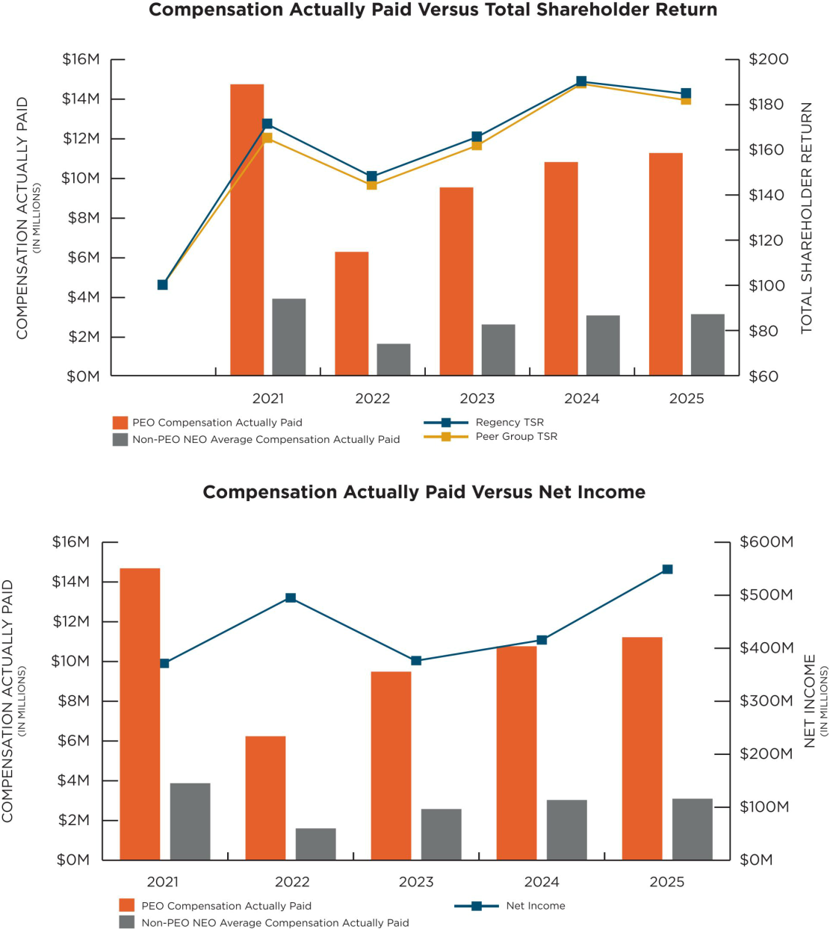

50 | REGENCY CENTERS | 2026 PROXY STATEMENT

Executive Compensation |
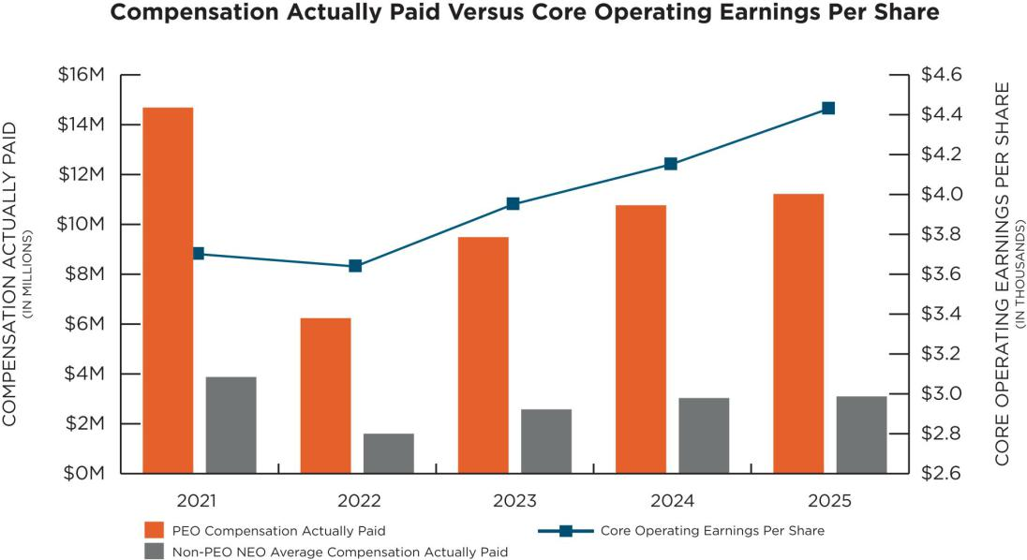

The following unranked list reflects the Company’s most important performance measures used by our Company to link Compensation Actually Paid for fiscal 2025 to our performance. Each of these financial performance measures is further described and defined in the Compensation Discussion and Analysis section of this proxy statement.

Most Important Performance Measures for 2025

Core Operating Earnings Per Share (Company-Selected Measure)

Corporate Responsibility Objectives

Relative Total Shareholder Return

CEO Pay Ratio

We have estimated the ratio of our 2025 CEO’s total compensation to the median annual total compensation of all employees (except our CEO). In

determining the median employee, we considered taxable compensation totals in 2025. We identified the “Median Employee” based on the taxable

compensation of all full-time, part-time, and temporary employees employed by Regency on December 31, 2025. Then, we calculated the Median

Employee’s compensation under the Summary Compensation Table rules. Our CEO in 2025, Ms. Palmer, had an annual total compensation of

$11,092,432 and our Median Employee had an annual total compensation of $154,922. Therefore, we estimate that our CEO’s annual total compensation

in 2025 is 72 times that of the median of the annual total compensation of all of our employees.

REGENCY CENTERS | 2026 PROXY STATEMENT | 51

Table of Contents

| Audit Committee Report

Audit Committee Report

The following Report of our Audit Committee (this “Audit Committee Report”) does not constitute soliciting material and should not be deemed filed or incorporated by reference into any other previous or future filings by us under the Securities Act of 1933, as amended, or the Securities Exchange Act of 1934, as amended, except to the extent we specifically incorporate this Audit Committee Report by reference therein.

The Audit Committee assists the Board in its general oversight of the Company’s financial reporting, internal controls and audit functions. The Audit Committee operates under a written charter adopted by the Board. A copy of its charter can be found on the Company’s website at https://investors.regencycenters.com. The directors who serve on the Audit Committee have no direct financial or personal ties to the Company (other than director compensation and equity ownership as described in this proxy statement) and are all “financially literate” and “independent” for purposes of the Nasdaq Stock Market listing requirements applicable to Audit Committee members. The Board has determined that each of Deirdre J. Evens, Thomas W. Furphy, Karin M. Klein, Peter D. Linneman, Mark J. Parrell, and James H. Simmons, III are Audit Committee financial experts as defined by the rules of the SEC. The Board has determined that none of the Audit Committee members has a relationship with the Company that may interfere with the member’s independence from the Company and its management.

Management is responsible for the Company’s internal controls and financial reporting process. The Audit Committee met with management, KPMG LLP, the Company’s independent registered public accounting firm and internal auditors four times during the year to consider and discuss the adequacy of the Company’s internal controls and the objectivity of its financial reporting. In addition, the Audit Committee was on call as needed by management and KPMG LLP to meet with or discuss any issues arising during the course of the year. At the end of each quarterly meeting, the Audit Committee met privately with both KPMG LLP and the internal auditors, each of whom has unrestricted access to the Audit Committee.

The Audit Committee has extensively reviewed and discussed the consolidated financial statements with management and the independent registered public accounting firm. Management is responsible for the preparation, presentation and integrity of the Company’s financial statements; accounting and financial reporting principles; establishing and maintaining disclosure controls and procedures; establishing and maintaining internal control over financial reporting; evaluating the effectiveness of disclosure controls and procedures; evaluating the effectiveness of internal control over financial reporting; and evaluating any change in internal control over financial reporting that has materially affected, or is reasonably likely to materially affect, internal control over financial reporting. The independent registered public accounting firm is responsible for performing an independent audit of the consolidated financial statements and expressing an opinion on the conformity of those financial statements with accounting principles generally accepted in the United States of America, as well as expressing an opinion on the effectiveness of internal control over financial reporting.

The Audit Committee supervises the relationship between the Company and its independent registered public accounting firm, including making decisions about their appointment or removal, reviewing the scope of their audit services, approving non-audit services, approving the lead partner selection, approving the fees for their services, and confirming their independence. The Audit Committee has discussed with KPMG LLP the matters required to be discussed by the applicable requirements of the Public Company Accounting Oversight Board (“PCAOB”) and the SEC. In addition, the Audit Committee has received the written disclosures and the letter from KPMG LLP required by applicable requirements of the PCAOB regarding KPMG LLP’s communications with the Audit Committee concerning independence and has discussed with KPMG LLP the independent registered public accounting firm’s independence. KPMG LLP has served as the Company’s independent registered public accounting firm since 1993.

In addition, the Audit Committee reviewed key initiatives and programs aimed at maintaining and strengthening the effectiveness of the Company’s internal controls over financial reporting and disclosure controls and procedures. As part of this process, the Audit Committee continues to monitor the scope and adequacy of the Company’s internal auditing program, review staffing levels and steps taken to maintain the effectiveness of internal procedures and controls and oversees the implementation of the internal audit plan.

Based on these reviews and discussions, the Audit Committee recommended to the Board and the Board approved that the audited financial statements be included in Regency’s annual report on Form 10-K for the year ended December 31, 2025.

Submitted by the Audit Committee of the Board:

Karin M. Klein, Chair

Peter D. Linneman

Deirdre J. Evens

Thomas W. Furphy

Mark J. Parrell

James H. Simmons, III

52 | REGENCY CENTERS | 2026 PROXY STATEMENT

Table of Contents

Proposal Three: Ratification of Appointment of KPMG LLP |

Proposal Three: Ratification of Appointment of KPMG LLP as the Company’s Independent Registered Public Accounting Firm

Our Board has selected the firm of KPMG LLP to serve as our independent registered public accounting firm for the year ending December 31, 2026. KPMG LLP has served as our auditors since 1993. The Company and KPMG rotate KPMG’s lead audit engagement partner no less frequently than every five years. For this fiscal year ending December 31, 2026, the KPMG lead audit engagement partner for the Company is in his first year in his current role.

As part of its oversight responsibility, the Audit Committee, at least annually, evaluates our independent registered public accounting firm’s qualifications, performance and independence and reports its conclusions to our Board. This evaluation was considered when deciding whether or not to reappoint KPMG LLP for the year ending December 31, 2026. Our Board believes it is in the best interest of our Company and shareholders to retain KPMG LLP and has unanimously directed that the appointment of the independent registered public accounting firm be submitted for ratification by our shareholders at the Annual Meeting. Representatives of KPMG LLP will be present at the Annual Meeting and will be provided the opportunity to make a statement, if they so desire, and to respond to appropriate questions.

Shareholder ratification of the selection of KPMG LLP as our independent registered public accounting firm is not required by our articles of incorporation or bylaws. However, our Board is submitting ratification of the appointment of KPMG LLP to a shareholder vote as a matter of good corporate practice. If the shareholders do not ratify the appointment, the Audit Committee will reconsider whether or not to retain KPMG LLP. In such event, the Audit Committee may retain KPMG LLP notwithstanding the fact that the shareholders did not ratify the appointment or select another nationally recognized accounting firm without re-submitting the matter to a shareholder vote. Even if the appointment is ratified, the Audit Committee retains the right in its discretion to select a different nationally recognized accounting firm at any time during the year if it determines that such a change would be in the best interests of our shareholders and us.

All decisions regarding selection of independent registered public accounting firms and approval of accounting services and fees are made by our Audit Committee in accordance with the provisions of the Sarbanes-Oxley Act of 2002 and the rules and regulations of the SEC. There are no exceptions to the policy of securing pre-approval of the Audit Committee for any service provided by our independent registered public accounting firm.

The following table provides information relating to the fees billed or expected to be billed to Regency by KPMG LLP for the years ended December 31, 2025 and 2024:

 | 2025 | 2024
Audit fees⁽¹⁾⁽²⁾ | $2,380,000 | $2,110,147
Audit-related fees | $— | $—
Tax fees⁽³⁾⁽⁴⁾ | $518,130 | $450,290
All other fees | $— | $—

- Amounts include actual and estimated fees.

- Audit fees consists of fees for professional services for the audit of our consolidated financial statements (including Regency Centers Corporation and Regency Centers, L.P.) included in our annual report on Form 10-K and review of our condensed consolidated financial information included in our quarterly filings on Form 10-Q. Audit fees also include fees for all services required to comply with the standards of the Public Company Accounting Oversight Board (United States), fees associated with performing the integrated audit of internal controls over financial reporting (Sarbanes-Oxley Section 404 work), and fees for services associated with comfort letters, reviews of documents filed with the SEC, and consents on SEC registration statements.

- The Audit Committee discussed these services with KPMG LLP and determined that these services would not impair KPMG LLP’s independence.

- Consists of fees for tax consultation and tax compliance services.

OUR BOARD RECOMMENDS THAT OUR SHAREHOLDERS VOTE “FOR” THE PROPOSAL TO RATIFY THE APPOINTMENT OF KPMG LLP AS OUR INDEPENDENT REGISTERED PUBLIC ACCOUNTING FIRM FOR THE YEAR ENDING DECEMBER 31, 2026.

REGENCY CENTERS | 2026 PROXY STATEMENT | 53

Table of Contents

| Beneficial Ownership

Beneficial Ownership

Beneficial Ownership of Principal Shareholders

The following table shows each person known to Regency to be the beneficial owner of more than 5% of our common stock. Except as otherwise indicated, we believe the shareholders listed exercise sole voting and dispositive power over the shares. The percent of class shown below is based upon shares outstanding as of March 13, 2026.

 | Number of | Percent of
 | Shares | Percent of
Name⁽¹⁾ | Owned | Class
The Vanguard Group, Inc. | 28,058,356⁽²⁾
100 Vanguard Boulevard | 28,058,356⁽²⁾ | 15.19%
Malvern, PA 19355
BlackRock, Inc. | 18,420,218⁽³⁾
55 Hudson Yards | 18,420,218⁽³⁾ | 10.10%
New York, NY 10001
Norges Bank | 17,018,543⁽⁴⁾
P.O. Box 1179 Sentrum | 17,018,543⁽⁴⁾ | 9.21%
NO 0107 Oslo Norway
State Street Corporation | 12,892,463⁽⁵⁾
One Lincoln Street | 12,892,463⁽⁵⁾ | 6.98%
Boston, MA 02111
JPMorgan Chase & Co. | 10,843,223⁽⁶⁾
383 Madison Avenue | 10,843,223⁽⁶⁾ | 5.90%
New York, NY 10179

- Information presented in this table and related notes has been obtained from reports filed by the beneficial owner with the SEC.

- Information is as of December 31, 2023 and is based on a report on Schedule 13G filed with the SEC on February 13, 2024 by The Vanguard Group, Inc. According to the information provided in the Schedule 13G, The Vanguard Group, Inc. has shared voting power over 361,904 shares, sole dispositive power over 27,188,510 shares and shared dispositive power over 869,846 shares.

- Information is as of March 31, 2025 and is based on a report on Schedule 13G filed with the SEC on April 28, 2025 by BlackRock, Inc. According to the information provided in the Schedule 13G, BlackRock, Inc. has sole voting power over 16,532,579 shares and sole dispositive power over 18,420,218 shares.

- Information is as of December 31, 2023 and is based on a report on Schedule 13G filed with the SEC on February 5, 2024 by Norges Bank. According to the information provided in the Schedule 13G, Norges Bank has sole voting power over 17,018,543 shares and sole dispositive power over 17,018,543 shares.

- Information is as of December 31, 2023 and is based on a report on Schedule 13G filed with the SEC on January 29, 2024 by State Street Corporation. According to the information provided in the Schedule 13G, State Street Corporation has shared voting power over 8,129,090 shares and shared dispositive power over 12,868,055 shares.

- Information is as of September 30, 2024 and is based on a report on Schedule 13G filed with the SEC on October 15, 2024 by JPMorgan Chase & Co. According to the information provided in the Schedule 13G, JPMorgan Chase & Co. has sole voting power over 8,709,772 shares and sole dispositive power over 10,536,730 shares.

54 | REGENCY CENTERS | 2026 PROXY STATEMENT

Table of Contents

Beneficial Ownership |

Beneficial Ownership of Directors and Executive Officers

The following table shows information relating to the beneficial ownership of our common stock as of March 13, 2026, of each director and nominee, each of the executive officers named in the summary compensation table included in this proxy statement, and all directors, nominees and executive officers as a group. As of March 13, 2026, we had 183,083,369 shares of common stock of Regency Centers Corporation issued and outstanding. Except as otherwise indicated, the shareholders listed exercise sole voting and dispositive power over the shares. No shares have been pledged as security by directors, nominees or executive officers. Unless otherwise indicated, the address of each director, nominee or executive officer is c/o: One Independent Drive, Suite 114, Jacksonville, Florida 32202.

 | Number of
 | Shares | Right to | Percent of
Name | Owned⁽¹⁾ | Acquire⁽²⁾ | Class
Martin E. Stein, Jr. | 595,295⁽³⁾ | — |  | *
Gary E. Anderson | 1,421 | 1,736 |  | *
Bryce Blair | 31,196 | 1,736 |  | *
C. Ronald Blankenship | 112,351 | 1,875 |  | *
Kristin A. Campbell | 4,990 | 1,736 |  | *
Deirdre J. Evens | 20,732 | 1,736 |  | *
Thomas W. Furphy | 12,509 | 1,736 |  | *
Karin M. Klein | 23,198 | 1,736 |  | *
Peter D. Linneman | 53,600 | 1,736 |  | *
Lisa Palmer | 157,942 | — |  | *
Mark J. Parrell | 0 | 0 |  | *
James H. Simmons, III | 6,242 | 1,736 |  | *
Michael J. Mas | 54,849 | — |  | *
Alan T. Roth | 25,519 | — |  | *
Nicholas A. Wibbenmeyer | 40,995 | — |  | *
All directors, nominees and executive officers as a group (a total of 15 persons) | 1,140,839 | 15,763 | 1.0%
* Less than one percent

- Excludes shares that may be acquired by directors or executive officers through the future vesting of restricted stock or stock rights awards or stock option exercises.

- Shares that may be acquired through the vesting of restricted stock or stock rights awards or stock option exercises within 60 days as of March 13, 2026.

- Includes 185,382 shares held in Regency’s non-qualified deferred compensation plan and 215 shares held in Regency’s Dividend Reinvestment Plan. Also includes the following shares over which Mr. Stein is deemed to have either individual or shared voting and/or investment power:
110,263 shares held by The Regency Group, Inc. All of the outstanding stock of The Regency Group, Inc. is owned by Mr. Stein and members of his family. 157,892 shares held by The Regency Group II, which is organized as a general partnership. Mr. Stein is a general partner of the partnership.

4,000 shares held by the Wellhouse Trust. Mr. Stein is a trustee and a beneficiary of the trust.

6,460 shares held by the Joan Wellhouse Irrevocable Trust, of which Mr. Stein is a co-trustee and a beneficiary of the trust.

REGENCY CENTERS | 2026 PROXY STATEMENT | 55

Table of Contents

| Shareholder Proposals and Communications with the Board of Directors

Shareholder Proposals and Communications with the Board of Directors

There are no shareholder proposals for consideration at our 2026 Annual Meeting of Shareholders. Shareholders who may wish to submit proposals, including director nominations, for consideration at our next annual meeting of shareholders expected to be held in May of 2027, may do so as follows:

Shareholder Proposals

To submit a shareholder proposal for inclusion in our proxy statement for our 2027 Annual Meeting, a shareholder must submit the proposal in accordance with Rule 14a-8 under the Exchange Act, and such proposal must be received by our Secretary by no later than November 25, 2026.

To submit a shareholder proposal for our 2027 Annual Meeting (other than a shareholder proposal for inclusion in the proxy statement in accordance with Rule 14a-8 under the Exchange Act), a shareholder must submit the proposal in accordance with our bylaws, and such proposal must be received by our Secretary by no earlier than January 6, 2027 (which is 120 calendar days prior to the anniversary of our 2026 Annual Meeting) and no later than February 5, 2027 (which is 90 calendar days prior to the first anniversary of our 2026 Annual Meeting). Please refer to Section 3.15 of our bylaws for more information regarding submission of a shareholder proposal other than pursuant to Rule 14a-8 under the Exchange Act.

Proposals must be sent to our Secretary at our office at:

One Independent Drive, Suite 114, Jacksonville, Florida 32202.

Shareholder Recommendations for Potential Director Nominees

Shareholders who wish to nominate a candidate for election to our Board at our 2026 Annual Meeting must submit notice of such nominations in accordance with our bylaws, and such nominations must be received by our Secretary by no earlier than January 6, 2027 and no later than February 5, 2027. The mailing envelope should contain a clear notation indicating that the enclosed letter is a “Shareholder Nomination for Director.” Please refer to Section 3.15 of our bylaws for detailed information regarding director candidate nominations, including specific requirements with respect to submissions.

In addition, if a shareholder wishes to nominate a candidate for election to our Board at our 2027 Annual Meeting and elects to have such candidate included in our proxy statement for our 2027 Annual Meeting pursuant to our proxy access bylaw, such nomination must comply with the notice, disclosure, eligibility and other requirements described in Section 3.18 of our bylaws and such nominations must be received by our Secretary by no later than November 25, 2026. In addition to satisfying the foregoing requirements under our bylaws, to comply with the universal proxy rules, stockholders who intend to solicit proxies in support of director nominees other than nominees by our Board must provide notice that sets forth the information required by Rule 14a-19 under the Exchange Act.

Any nominations must be sent to our Secretary at our office at:

One Independent Drive, Suite 114, Jacksonville, Florida 32202.

Communication with the Board

Interested parties who wish to communicate with our Board or with a particular director, including our independent Lead Director, may send a letter to the Secretary at our offices at One Independent Drive, Suite 114, Jacksonville, Florida 32202. The mailing envelope should contain a clear notation indicating that the enclosed letter is a “Board Communication” or “Director Communication.” All such letters should identify the author and clearly state whether the intended recipients are all members of the Board or certain specified individual directors. After receipt, communications will generally be forwarded to the Chairman of the Board, the whole Board, the lead independent director or specific directors as the Corporate Secretary deems appropriate based on the content of, and the matters raised in, the communications. Communications that are unrelated to the duties and responsibilities of the Board or are unduly hostile, threatening, potentially illegal or similarly unsuitable will not be forwarded. Responses to letters and any communications that are excluded are maintained by the Company and are available to any director upon request.

56 | REGENCY CENTERS | 2026 PROXY STATEMENT

Table of Contents

Frequently Asked Questions Regarding Our Annual Meeting |

Frequently Asked Questions Regarding Our Annual Meeting

- What are the procedures for attending and participating in the virtual Annual Meeting?

All shareholders are welcome to attend the Annual Meeting. The 2026 Annual Meeting will be virtual-only, held exclusively online. The platform for the virtual Annual Meeting includes functionality that affords authenticated shareholders comparable meeting participation rights and opportunities they would have at an in-person meeting. Instructions to access and log-in to the virtual Annual Meeting are provided below, and once admitted, shareholders may view reference materials, submit questions and vote their shares by following the instructions that will be available on the virtual meeting website.

To be admitted to the 2026 Annual Meeting, go to www.virtualshareholdermeeting.com/REG2026 and enter the 16-digit control number on your Notice of Internet Availability of Proxy Materials or proxy card.

Online access to the Annual Meeting will open at 7:45 AM Eastern Time on Wednesday, May 6, 2026 to allow time for you to log-in prior to the start of the live audio webcast of the Annual Meeting at 8:00 AM Eastern Time. If you are unable to locate your Notice of Internet Availability of Proxy Materials or proxy card containing your 16-digit control number or otherwise to log-in as an authenticated shareholder, you may opt to participate in the Annual Meeting as a “guest,” in which case you will be able to hear the audio webcast but will not be able to utilize the question, voting or other functionality noted above. If you experience technical difficulties accessing or during the meeting, please call the technical support telephone number posted on the virtual meeting website.

- Why did I receive these materials?

Our Board is soliciting proxies for our 2026 Annual Meeting of Shareholders. You are receiving this proxy statement because you owned shares of our common stock on the record date, March 13, 2026, and that entitles you to vote at our Annual Meeting of Shareholders, which will be held exclusively online on May 6, 2026 at 8:00 am, Eastern Time at

www.virtualshareholdermeeting.com/REG2026. By use of a proxy, you can vote whether or not you attend in the Annual Meeting. This proxy statement describes the matters on which we would like you to vote your shares and provides information on those matters so that you can make an informed decision.

- What information is contained in this proxy statement?

The information in this proxy statement relates to the proposals to be voted on at the Annual Meeting, the voting process, our Board, the compensation of

our directors and executive officers and other information that the SEC requires us to provide annually to our shareholders.

- What is a record date and who is entitled to vote at the Annual Meeting?

A record date is the date, as of the close of business on which, shareholders of record are entitled to notice of and to vote at a meeting of shareholders. The record date for the 2026 Annual Meeting is March 13, 2026 and was established by our Board as required under the laws of Florida, our state of

incorporation. Thus, owners of record of shares of Regency Centers Corporation common stock as of the close of business on March 13, 2026 are entitled to receive notice of and to vote at the 2026 Annual Meeting and at any adjournments or postponements thereof.

- How many votes do I have?

Each outstanding share of our common stock you owned as of the record date will be entitled to one

vote for each matter considered at the Annual Meeting. There is no cumulative voting.

REGENCY CENTERS | 2026 PROXY STATEMENT | 57

Table of Contents

| Frequently Asked Questions Regarding Our Annual Meeting

- How do I vote?

If you are a holder of record (that is, your shares are registered in your own name with our transfer agent), you can vote: by proxy prior to and without attending the Annual Meeting; or online during the virtual Annual Meeting at www.virtualshareholdermeeting.com/REG2026. We urge you to vote by proxy prior to the Annual Meeting even if you plan to attend the virtual Annual Meeting so that we will know as soon as possible that enough votes will be present for Regency to hold the Annual Meeting. Our Board has designated Martin E. Stein, Jr., Lisa Palmer, Michael J. Mas and each or any of them, as proxies to vote the shares of common stock solicited on its behalf. You can vote by proxy prior to the Annual Meeting by any of the following methods:

Voting by Telephone or by the Internet. If you are a registered shareholder (that is, if you own shares in your own name and not through a broker, bank or other nominee that holds shares for your account in a “street name” capacity), you may vote by proxy by using either the telephone or Internet methods of voting. Proxies submitted by telephone or through the Internet must be received by 11:59 p.m., Eastern Time, on May 5, 2026. Please see the Notice of Internet Availability or proxy card for instructions on how to access the telephone and Internet voting systems.

Voting by Mail. Each shareholder electing to receive shareholder materials by mail may vote by mail by using the accompanying proxy card. When you return a proxy card by mail that is properly signed

and completed, the shares represented by your proxy will be voted as you specify on the proxy card.

If you hold your shares in “street name,” we have supplied copies of our proxy materials for the Annual Meeting to the broker, bank or other nominee holding your shares of record and they have the responsibility to send these proxy materials to you. You must either direct the bank, broker or other nominee as to how to vote your shares. Please refer to the voter instruction cards used by your bank, broker or other nominee for specific instructions on methods of voting, including by telephone or the Internet.

Your shares will be voted as you indicate. If you return your signed and dated proxy card but you do not indicate your voting preferences on one or more of the proposals to be considered at the Annual Meeting, or if you otherwise do not indicate your voting preference via phone or internet on one or more of the proposals to be considered at the Annual Meeting, then your shares will not be voted with respect to any proposal other than the ratification of our auditors. The Board and management do not intend to present any matters at this time at the Annual Meeting other than those outlined in the notice of the Annual Meeting. If any other matters are properly brought before the Annual Meeting or any adjournments or postponements thereof, your shares will be voted at the discretion of the proxy holders.

- Can I revoke my proxy or change my vote?

Yes. If you are a shareholder of record, you may revoke your proxy or change your vote at any time before your shares are voted at the Annual Meeting by filing a notice of revocation with the Secretary of the Company or mailing a proxy bearing a later date, submitting your proxy again by telephone or over the Internet. For shares you hold beneficially in “street name,” you may revoke your proxy or change your vote by submitting new voting

instructions to your broker, bank or other nominee or, if you have obtained a “brokers proxy” from your broker, bank or other nominee giving you the right to vote your shares, by attending and voting your shares at the Annual Meeting. In either case, the powers of the proxy holders will be suspended if you attend the Annual Meeting and so request, although attending the Annual Meeting will not by itself revoke a previously granted proxy.

- What vote is required to approve each item?

For Proposal 1: Election of Directors, you may vote “FOR,” “AGAINST” or “ABSTAIN” with respect to each nominee. In uncontested elections, directors are elected by a majority of the votes cast at the meeting. Votes cast includes votes against but exclude abstentions and broker non-votes with respect to a nominee’s election. Abstentions are not considered votes cast and will have no effect on whether these proposals are approved or nominees

elected. Our bylaws provide that the current term for a director in an uncontested election who does not receive the vote of the majority of the votes cast with respect to such director’s election shall expire on the date that is the earlier of (i) 90 days from the date on which the voting results are determined or (ii) the date on which an individual is selected by the Board of Directors to fill the office held by such director.

58 | REGENCY CENTERS | 2026 PROXY STATEMENT

Table of Contents

Frequently Asked Questions Regarding Our Annual Meeting |

For Proposal 2: Advisory Vote on Executive Compensation, which is commonly referred to as a “say-on-pay” vote and non-binding on our Board, you may vote “FOR,” “AGAINST” or “ABSTAIN”. Although the vote is non-binding, our Board and Compensation Committee will consider the voting results in connection with their ongoing evaluation of our executive compensation program. This proposal will be approved if the votes cast “FOR” exceed the votes cast “AGAINST” the proposal.

For Proposal 3: Ratification of Appointment of KPMG LLP as the Company’s Independent Registered Public Accounting Firm for fiscal 2026, you may vote “FOR,” “AGAINST” or “ABSTAIN”. This proposal will be approved if the votes cast “FOR” exceed the votes cast “AGAINST” the proposal.

If you hold your shares in street name, your broker, bank or other nominee is permitted to vote your shares on Proposal 3: Ratification of Appointment of KPMG LLP as the Company’s Independent Registered Public Accounting Firm without receiving voting instructions from you. In contrast, all other proposals are “non-discretionary” items. This means brokerage firms that have not received voting instructions from their clients on these proposals may not vote on them. These so-called “broker non-votes” will be included in the calculation of the number of votes considered to be present at the meeting for purposes of determining a quorum, but will not be considered in determining the number of votes necessary for approval and will have no effect on the outcome of any of the proposals.

- What constitutes a quorum?

A quorum is the minimum number of shares that must be represented in person or by proxy for our Company to conduct the 2026 Annual Meeting. The attendance in person or by proxy of holders of a majority of the shares of common stock entitled to vote at the 2026 Annual Meeting will constitute a quorum to hold the 2026 Annual Meeting. Shareholders who attend the 2026 Annual Meeting

that are admitted pursuant to the instructions to join the virtual meeting as an authenticated shareholder will be considered to be attending the meeting in person. If you grant your proxy over the Internet, by telephone or by your proxy card, your shares will be considered present at the 2026 Annual Meeting and counted toward the quorum.

- Will shareholders be asked to vote on any other matters?

To the knowledge of the Company and its management, shareholders will vote only on the matters described in this proxy statement. However, if any other matters are properly brought before the

Annual Meeting or any adjournments or postponements thereof, your shares will be voted at the discretion of the proxy holders.

- How are we soliciting proxies?

We are soliciting proxies on behalf of our Board and will pay all expenses associated with this solicitation. In addition to mailing these proxy materials, certain of our officers and other employees may, without compensation other than their regular compensation, solicit proxies through further mailing or personal conversations, or by telephone or other

electronic means. We will also, upon request, reimburse brokers and other persons holding stock in their names, or in the names of nominees, for their reasonable out-of-pocket expenses for forwarding proxy materials to the beneficial owners of our stock and to obtain proxies.

- If I previously signed up to receive shareholder materials, including proxy statements and annual reports, by mail and now wish to access these materials via the Internet or via electronic delivery in the future, what should I do?

You can help us achieve a substantial reduction in our printing and mailing costs by choosing to receive shareholder materials by means other than mail. If you choose to receive your proxy materials by accessing the Internet, then before next year’s annual meeting of shareholders, you will receive a

Notice of Internet Availability of Proxy Materials when the proxy materials and annual report are available over the Internet.

If you choose instead to receive your proxy materials via electronic delivery, you will receive an email containing the proxy materials.

REGENCY CENTERS | 2026 PROXY STATEMENT | 59

Table of Contents

| Frequently Asked Questions Regarding Our Annual Meeting

- How can I obtain paper copies of the proxy materials, annual report on Form 10-K and other financial information?

Shareholders can access our 2026 proxy statement, our annual report on Form 10-K and our other filings with the SEC as well as our corporate governance and other related information on the Investors page of our website at www.regencycenters.com.

The content of our website is not incorporated by reference into this proxy statement or in any other report or document we file with the SEC, and any references to our website are intended to be inactive textual references only.

The SEC’s rules permit us to deliver a single Notice of Internet Availability of Proxy Materials or single set of Annual Meeting materials to one address shared by two or more of our shareholders. This delivery method is referred to as “householding” and can result in significant cost savings. To take advantage of this opportunity, we have delivered only one notice, proxy statement and annual report to multiple shareholders who share an address, unless we received contrary instructions from the impacted shareholders prior to the mailing date.

We agree to deliver promptly, upon written or oral request, a separate copy of the notice or annual meeting materials, as requested, to any shareholder at the shared address to which a single copy of those documents was delivered.

A stockholder may request a separate copy of the applicable materials by contacting the address set forth in this section. Eligible stockholders of record receiving multiple copies of our proxy materials can also request householding by contacting us in the same manner.

Your election to receive your proxy materials by accessing the Internet or by electronic delivery will remain in effect for all future shareholder meetings unless you revoke it before the meeting by following the instructions on the Notice of Internet Availability of Proxy Materials or by calling or sending a written request addressed to:

Regency Centers Corporation

Attn: Joni Reiser

One Independent Drive, Suite 114

Jacksonville, Florida 32202

(904) 598-7761

If you hold your shares in an account at a brokerage firm or bank participating in a “street name” program, you can sign up for electronic delivery of proxy materials in the future by contacting your broker.

- What should I do if I receive more than one set of voting materials?

You may receive more than one set of voting materials, including multiple copies of this proxy statement, proxy cards or voting instruction cards. For example, if you hold your shares in more than one brokerage account, you may receive a separate voting instruction card for each brokerage account

in which you hold shares. If you are a shareholder of record and your shares are registered in more than one name, you will receive more than one proxy card. Please vote your shares applicable to each proxy card and voting instruction card that you receive.

- Where can I find a list of shareholders entitled to vote at the Annual Meeting?

The names of shareholders of record entitled to vote at the Annual Meeting will be available to

shareholders at our corporate office for a period of 10 days prior to and during the Annual Meeting.

- Where can I find the voting results of the Annual Meeting?

The Company will announce the preliminary voting results at the Annual Meeting and intends to release the final results in a Form 8-K filed with the SEC

within four business days following the Annual Meeting.

60 | REGENCY CENTERS | 2026 PROXY STATEMENT

Table of Contents

Appendix A—Definitions and Reconciliations of GAAP and Non-GAAP Financial Measures |

Appendix A—Definitions and Reconciliations of GAAP and Non-GAAP Financial Measures

Defined Terms

In addition to the required GAAP presentations, the Company uses certain non-GAAP financial measures, as it believes these measures improve the understanding of the Company’s operational results. The Company believes these non-GAAP financial measures provide useful information to its Board of Directors, management and investors regarding certain trends relating to its financial condition and results of operations. Management uses these non-GAAP financial measures to compare its performance to that of prior periods for trend analyses, purposes of determining management incentive compensation and budgeting, forecasting and planning purposes. Management continually evaluates the usefulness, relevance, limitations, and calculation of the Company’s reported non-GAAP financial measures to determine how best to provide relevant information to the public, and thus such reported measures could change.

The Company does not consider non-GAAP financial measures an alternative to financial measures determined in accordance with GAAP, rather they supplement GAAP measures by providing additional information the Company believes to be useful to our shareholders. The principal limitation of these non-GAAP financial measures is that they may exclude significant expense and income items that are required by GAAP to be recognized in our Consolidated Financial Statements. In addition, they reflect the exercise of management’s judgment about which expense and income items are excluded or included in determining these non-GAAP financial measures. In order to compensate for these limitations, reconciliations of the non-GAAP financial measures used to their most directly comparable GAAP measures are provided. Non-GAAP financial measures should not be relied upon in evaluating the financial condition, results of operations, or future prospects of the Company.

NON-GAAP FINANCIAL MEASURES INCLUDE THE FOLLOWING:

- Core Operating Earnings is an additional performance measure we use because the computation of Nareit Funds from Operations (“Nareit FFO”) includes certain non-comparable items that affect our period-over-period performance. Core Operating Earnings excludes from Nareit FFO:

(i) transaction related income or expenses, (ii) gains or losses from the early extinguishment of debt, (iii) certain non-cash components of earnings derived from straight-line rents, above and below market rent amortization, and debt and derivative mark-to-market amortization, and (iv) other amounts as they occur. We provide reconciliations of both Net Income Attributable to Common Shareholders to Nareit FFO and Nareit FFO to Core Operating Earnings.

- Nareit EBITDAre is a measure of REIT performance, which the National Association of Real Estate Investment Trusts (“Nareit”) defines as net income, computed in accordance with GAAP, excluding (i) interest expense, (ii) income tax expense, (iii) depreciation and amortization, (iv) gains on sales of real estate, (v) impairments of real estate, and (vi) adjustments to reflect the Company’s share of unconsolidated partnerships and joint ventures.

- Nareit Funds From Operations (“Nareit FFO”) is a commonly used measure of REIT performance, which Nareit defines as net income, computed in accordance with GAAP, excluding gains on sales and impairments of real estate, net of tax, plus depreciation and amortization, and after adjustments for unconsolidated real estate investment partnerships and joint ventures. We compute Nareit FFO for all periods presented in accordance with Nareit’s definition.

- Companies use different depreciable lives and methods, and real estate values historically fluctuate with market conditions. Since Nareit FFO excludes depreciation and amortization and gains on sale and impairments of real estate, it provides a performance measure that, when compared year over year, reflects the impact on operations from trends in percent leased, rental rates, operating costs, acquisition and development activities, and financing costs. This provides a perspective of our financial performance not immediately apparent from net income determined in accordance with GAAP. Thus, Nareit FFO is a supplemental non-GAAP financial measure of our operating performance, which does not represent cash generated from operating activities in accordance with GAAP; and, therefore, should not be considered a substitute measure of cash flows from operations. We provide a reconciliation of Net Income Attributable to Common Shareholders to Nareit FFO.

REGENCY CENTERS | 2026 PROXY STATEMENT | A-1

Table of Contents

| Appendix A—Definitions and Reconciliations of GAAP and Non-GAAP Financial Measures

- Net Operating Income (“NOI”) is the sum of base rent, percentage rent, termination fee income, tenant recoveries, other lease income, and other property income, less operating and maintenance expenses, real estate taxes, ground rent, termination expense, and uncollectible lease income. NOI excludes straight-line rental income and expense, above and below market rent and ground rent amortization, tenant lease inducement amortization, and other fees. We also provide disclosure of NOI excluding termination fees, which excludes both termination fee income and expenses.

- Management believes that NOI is a useful measure for investors because it provides insight into the core operations and performance of our properties, independent of the capital structure, financing activities, and non-operating factors. By focusing on property-level performance, NOI allows investors to compare the performance of our real estate assets across periods and with those of other REIT peers in the industry, facilitating a clearer understanding of trends in occupancy, rental income, and operating expense management. In addition to its relevance for investors, management uses NOI as a key performance metric in making operational and strategic decisions. NOI is used to evaluate income generated from shopping centers (i.e., return on assets) and to guide decisions on capital investments. These decisions may include acquisitions, redevelopments, and investments in capital improvements.

- Operating EBITDAre begins with Nareit EBITDAre and excludes certain non-cash components of earnings derived from straight-line rents and above and below market rent amortization. We provide a reconciliation of Net income to Nareit EBITDAre to Operating EBITDAre.

- Pro Rata information includes 100% of our consolidated properties plus our economic share (based on our ownership interest) in our unconsolidated real estate investment partnerships. We provide Pro-rata financial information because we believe it assists investors and analysts in estimating our economic interest in our consolidated and unconsolidated real estate investment partnerships, when read in conjunction with our reported results under GAAP. We believe presenting our Pro-rata share of assets, liabilities, operating results, and other metrics, along with certain other non-GAAP financial measures, makes comparisons of our operating results to those of other REITs more meaningful. The Pro-rata information provided is not, nor is it intended to be, presented in accordance with GAAP. The Pro-rata supplemental details of assets and liabilities and supplemental details of operations reflect our proportionate economic ownership of the assets, liabilities, and operating results of the properties in our portfolio. The Pro-rata information is prepared on a basis consistent with the comparable consolidated amounts and is intended to more accurately reflect our proportionate economic interest in the assets, liabilities, and operating results of properties in our portfolio. We do not control the unconsolidated real estate investment partnerships, and the Pro-rata presentations of the assets and liabilities, and revenues and expenses do not represent our legal claim to such items. The partners are entitled to profit or loss allocations and distributions of cash flows according to the operating agreements, which generally provide for such allocations according to their invested capital. Our share of invested capital establishes the ownership interests we use to prepare our Pro-rata share.

The presentation of Pro-rata information has limitations which include, but are not limited to, the following:

- The amounts shown on the individual line items were derived by applying our overall economic ownership interest percentage determined when applying the equity method of accounting and do not necessarily represent our legal claim to the assets and liabilities, or the revenues and expenses; and

- Other companies in our industry may calculate their Pro-rata interest differently, limiting the comparability of Pro-rata information.

Because of these limitations, the Pro-rata financial information should not be considered independently or as a substitute for our financial statements as reported under GAAP. We compensate for these limitations by relying primarily on our GAAP financial statements, using the Pro-rata information as a supplement.

- Pro Rata Same Property NOI is a key non-GAAP financial measure commonly used by REITs to evaluate operating performance. It is calculated on a proportionate ownership basis for properties held during the comparable reporting periods, excluding revenue and expenses related to non-same properties during the applicable periods. We believe this measure provides investors with a useful and consistent comparison of our operating performance and trends. We use Pro-rata Same Property NOI as a supplemental measure to assess property-level performance, excluding the effects of corporate-level expenses, financing costs, and non-operating activities. This measure allows investors to evaluate trends in revenue and expense growth for properties that have been consistently operated during the periods.

A-2 | REGENCY CENTERS | 2026 PROXY STATEMENT

Table of Contents

Appendix A—Definitions and Reconciliations of GAAP and Non-GAAP Financial Measures |

OTHER DEFINED TERMS:

The following terms, as defined, are commonly used by management and the investing public to understand, and evaluate our operational results, and are included in this document:

- Development Completion is a Property in Development that is deemed complete upon the earlier of: (i) 90% of total estimated net development costs have been incurred and percent leased equals or exceeds 95%, or (ii) the property features at least two years of anchor operations. Once deemed complete, the property is termed a Retail Operating Property.

- A Non-Same Property is any property, during either calendar year period being compared, that was acquired, sold, a Property in Development, a Development Completion, or a property under, or being positioned for, significant redevelopment that distorts comparability between periods. Non-retail properties and corporate activities, including the captive insurance program, are part of Non-Same Property.

- Property In Development includes properties in various stages of ground-up development.

- Property In Redevelopment includes Retail Operating Properties under redevelopment or being positioned for redevelopment. Unless otherwise indicated, a Property in Redevelopment is included in the Same Property pool.

- Redevelopment Completion is a Property in Redevelopment that is deemed complete upon the earlier of: (i) 90% of total estimated project costs have been incurred and percent leased equals or exceeds 95% for the Company owned GLA related to the project, or (ii) the property features at least two years of anchor operations, if applicable.

- Retail Operating Property is any retail property not termed a Property in Development. A retail property is any property where the majority of the income is generated from retail uses.

- Same Property is a Retail Operating Property that was owned and operated for the entirety of both calendar year periods being compared. This term excludes Properties in Development, prior year Development Completions, and Non-Same Properties. Properties in Redevelopment are included unless otherwise indicated.

- Same Property NOI is provided because we believe the measure provides investors with additional information regarding the operating performances of comparable assets. Same Property NOI excludes all development, non-same property and corporate level revenues and expenses. The Company also provides disclosure of NOI excluding termination fees, which excludes both termination fee income and expense.

- Shop Space is space under 10,000 square feet in a Retail Operating Property.

REGENCY CENTERS | 2026 PROXY STATEMENT | A-3

Table of Contents

| Appendix A—Definitions and Reconciliations of GAAP and Non-GAAP Financial Measures

Reconciliation of Net Income Attributable to Common Shareholders to Nareit FFO and Core Operating Earnings (in thousands)

For the Periods Ended December 31, 2025 and 2024

 | 2025 | 2024
Reconciliation of Net Income Attributable to Common Shareholders to Nareit FFO:
Net Income Attributable to Common Shareholders | $513,810 | 386,738
Adjustments to reconcile to Nareit FFO⁽¹⁾:
Depreciation and amortization (excluding FF&E) | 430,684 | 422,581
Gain on sale of real estate, net of tax | (100,444) | (35,069)
Provision for impairment of real estate | 4,606 | 14,304
Exchangeable operating partnership units | 7,069 | 2,338
Nareit FFO | $855,725 | 790,892
Reconciliation of Nareit FFO to Core Operating Earnings:
Nareit FFO | $855,725 | 790,892
Adjustments to reconcile to Core Operating Earnings⁽¹⁾:
Merger transition costs | — | 7,718
Loss on early extinguishment of debt | — | 180
Straight-line rent | (27,319) | (22,980)
Uncollectible straight-line rent | 1,299 | 2,446
Above/below market rent amortization, net | (23,087) | (23,431)
Debt and derivative mark-to-market amortization | 6,631 | 5,837
Core Operating Earnings | $813,249 | 760,662
Net Income Attributable to Common Shareholders per Share (Diluted) | $2.82 | 2.11
Weighted Average Shares For Net Income Attributable to Common Shareholders per Share (Diluted) | 182,234 | 183,040
Nareit FFO per Share (Diluted) | $4.64 | 4.30
Core Operating Earnings per Share (Diluted) | $4.41 | 4.13
Weighted Average Shares For Nareit FFO and Core Operating Earnings per Share (Diluted) | 184,538 | 184,139

(1) Includes Regency’s consolidated entities and its Pro-rata share of unconsolidated real estate partnerships, net of Pro-rata share attributable to noncontrolling interests. A-4 | REGENCY CENTERS | 2026 PROXY STATEMENT

Table of Contents

Appendix A—Definitions and Reconciliations of GAAP and Non-GAAP Financial Measures |

Reconciliation of Net Income Attributable to Common Shareholders to Pro-Rata Same Property NOI (in thousands)

For the Periods Ended December 31, 2025 and 2024

 | 2025 | 2024
Net Income attributable to common Shareholders | $513,810 | 386,738
Less:
Management, transaction, and other fees | (28,358) | (27,874)
Other⁽¹⁾ | (53,842) | (49,944)
Plus:
Depreciation and amortization | 405,044 | 394,714
General and administrative | 99,407 | 101,465
Other operating expense | 8,849 | 10,867
Other expense, net | 175,613 | 154,260
Equity in income of investments in real estate partnerships excluded from NOI⁽²⁾ | (24,223) | 54,040
Net income attributable to noncontrolling interests | 13,491 | 9,452
Preferred stock dividends | 13,650 | 13,650
NOI | 1,123,441 | 1,047,368
Less non-same property NOI⁽³⁾ | (23,633) | (2,678)
Same Property NOI | $1,099,808 | 1,044,690
% change | 5.3%
Same Property NOI without Termination Fees | $1,092,860 | 1,038,218
% change | 5.3%
Same Property NOI without Termination Fees or Redevelopments | $932,848 | 896,483
% change | 4.1%

- Includes straight-line rental income and expense, net of reserves, above and below market rent amortization, other fees, and noncontrolling interests.
- Includes non-NOI income and expenses incurred at our unconsolidated real estate partnerships, such as, but not limited to, straight-line rental income, above and below market rent amortization, depreciation and amortization, interest expense, and real estate gains and impairments.
- Includes revenues and expenses attributable to Non-Same Properties, Properties in Development, corporate activities, and noncontrolling interests.

REGENCY CENTERS | 2026 PROXY STATEMENT | A-5

Table of Contents

| Appendix A—Definitions and Reconciliations of GAAP and Non-GAAP Financial Measures

Reconciliation of Net Income to Nareit EBITDAre and Operating EBITDAre (in thousands) For the Periods Ended December 31, 2025 and 2024

 | 2025 | 2024
Reconciliation of Net Income to Nareit EBITDAre:
Net Income | $540,951 | 409,840
Adjustments to reconcile to Nareit EBITDAre⁽¹⁾:
Interest expense | 228,794 | 211,660
Income tax expense | 764 | 924
Depreciation and amortization | 436,792 | 428,425
Gain on sale of real estate | (100,444) | (35,069)
Provision for impairment of real estate | 4,606 | 14,304
Nareit EBITDAre | $1,111,463 | 1,030,084
Reconciliation of Nareit EBITDAre to Operating EBITDAre:
Nareit EBITDAre | $1,111,463 | 1,030,084
Adjustments to reconcile to Operating EBITDAre⁽¹⁾:
Merger transition costs | — | 7,718
Loss on early extinguishment of debt | — | 180
Straight-line rent, net | (26,181) | (21,270)
Above/below market rent amortization, net | (23,069) | (23,436)
Operating EBITDAre | $1,062,213 | 993,276
(1) Includes Regency’s consolidated entities and its Pro-rata share of unconsolidated real estate partnerships.
A-6 | REGENCY CENTERS | 2026 PROXY STATEMENT

Table of Contents
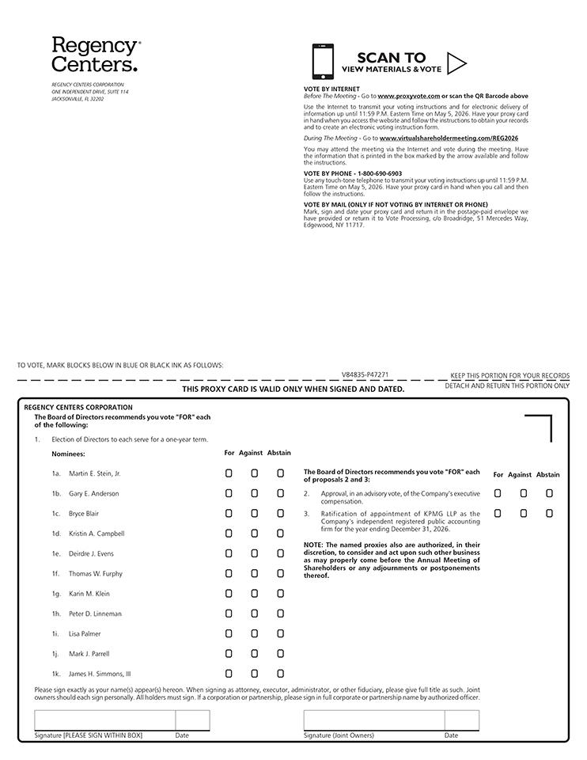

Table of Contents


